**Text Classification**

**What is Text Classification?**

Text classification involves assigning predefined categories (labels) to pieces of text (e.g., sentences, paragraphs). It can be:

* **Binary** (e.g., spam vs. not spam)
* **Multi-class** (e.g., 1-star to 5-star ratings)
* **Multi-label** (e.g., sentiment + topic detection)

**Use Cases**

1. **Social Media Analysis**: e.g., classify tweets about a product into positive, neutral, or negative.
2. **Service Routing**: route chat messages to the appropriate support agent.
3. **Spam Detection**: block unwanted messages in email or comment sections.
4. **Sentiment Analysis**: classify emotions (positive, negative, neutral).
5. **Topic Classification**: identify what topic the text is about.
6. **Harmful Content Detection**: identify racism, sexism, slurs.
7. **Textual Entailment**: compare two text sections to determine relationships (entailment, contradiction, etc.).

**How Text Classification Works**

* **Input**: Raw text (sentence, paragraph, or a pair of texts for entailment).
* **Output**: Class label(s).
* **Labeling**: Classes are represented by numerical labels (e.g., 0 for negative, 1 for positive), but these map to real-world meanings.

**Simple Approach: Lexicon-Based Sentiment Classification**

* Use a **sentiment dictionary** of positive and negative words.
* Score the text based on the occurrence and frequency of these words.

**Examples:**

1. **“The movie was really great. It was a lot of fun.”**
   * Words like "great" and "fun" are positive → works well.
2. **“The movie was not great. It was quite bad.”**
   * Challenges:
     + Negation: “not great” (flips the meaning).
     + Mixed sentiment: presence of both positive ("great") and negative ("bad").
3. **“The director, however well intended, did not take sufficient care of the underlying complexities.”**
   * Complex structure makes word-by-word scoring ineffective.

**Challenges in Lexicon-Based Classification**

1. **Negation Handling**: Understanding what the word “not” negates (e.g., "not good").
2. **Mixed Sentiments**: Sentences with both positive and negative words.
3. **Complex Phrasing**: Long or nuanced sentences.
4. **Idiomatic Expressions**: Context-dependent meanings (e.g., “sick” can be good or bad).
5. **Rare Words**: Words like “pernicious” may not be in the sentiment dictionary but carry strong sentiment.
6. **Context Sensitivity**: Word meanings can shift based on context (e.g., sarcasm, irony).

**Earlier Text Classification Approaches With Neural Networks**

**1. Introduction: Text Classification with Neural Networks**

* Text classification is a task where we assign a label to a piece of text (e.g., positive/negative, spam/ham, topic categories).
* Earlier approaches used neural network architectures to handle this task.
* The general strategy:
  + Use **word embeddings** to convert words into vectors.
  + Feed these vectors into a **neural network** for classification.

**2. Word Embeddings: What and Why**

* **Word embeddings** are numerical vector representations of words or tokens.
* They help because:
  + Neural networks require numerical inputs, and vectors are suitable for that.
  + Similar words get **similar vectors** — meaning the angle between two such vectors is small.
  + This similarity helps reduce **sparsity** in text data, unlike one-hot encodings where words are unrelated.
* Embeddings can be:
  + **Pre-trained** (e.g., Word2Vec, GloVe).
  + **Trained from scratch** on the specific task at hand.

**3. Deep Averaging Networks (DANs)**

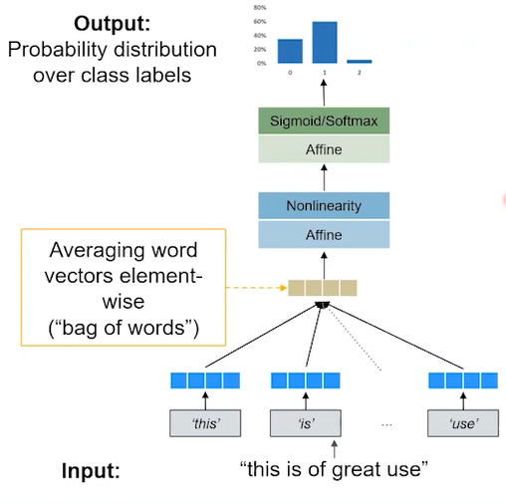

* A simple and early neural net architecture for text classification.
* Despite the name, it's very straightforward.

**How it works:**

1. **Tokenization**: Break the sentence into words/tokens.  
   Example:  
   Input: “This is of great use”  
   Tokens: [“This”, “is”, “of”, “great”, “use”]
2. **Word Vector Mapping**:  
   Each token is mapped to a word vector (embedding).
3. **Averaging**:
   * Take the **element-wise average** of all word vectors.
   * For each dimension, average across all words’ vectors to form one **average vector**.
   * This vector represents the overall meaning of the input sentence.
4. **Feed to Neural Network**:
   * The average vector is input to one or more **hidden layers**.
   * Each hidden layer applies an **affine transformation**:
     + Multiply by weight matrix W, add bias b, apply non-linearity (like ReLU).
   * Final output layer produces **logits** (raw scores for each class).
   * Apply:
     + **Softmax** for multi-class classification.
     + **Sigmoid** for binary classification.
   * Output: probability distribution over the possible classes.

**Benefits of DANs:**

* Can use **pre-trained** or **trainable** word vectors.
* Reduces sparsity since similar words train the model similarly.
* **Fast and simple** to train.
* **Generic** architecture — works not just for sentiment analysis but for many classification problems.
* Doesn’t rely on manually created dictionaries or rule-based features.

**Limitations of DANs:**

* Still a **bag-of-words** approach:
  + **Ignores word order**.
  + “Good, not bad” and “Bad, not good” produce the same result, which is problematic.
* Cannot understand **phrases**, grammar, or **dependencies** between words.

**4. Hierarchical Models (Recursive Neural Networks)**

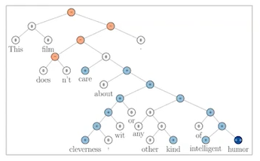

* Introduced around **2012–2013** by **Richard Socher** and colleagues at Stanford.
* Designed to **preserve sentence structure** and better capture meaning.

**Key idea:**

* Build a **binary parse tree** to represent sentence structure.
* Instead of averaging all word vectors, combine them hierarchically.
* Useful for tasks like **sentiment analysis** where phrase meaning matters.

**How it works:**

1. Start with word vectors.
2. Build a **binary tree** of how words group together.
   * Example:  
     Sentence: “This film doesn’t care about cleverness with any other kind of intelligent humor.”
     + “Intelligent” qualifies “humor” → they are grouped.
     + These sub-phrases are combined upward into a full tree.
3. Each **node** in the tree has a **vector representation**:
   * Combine the child nodes’ vectors using a neural net layer:
     + Concatenate the two vectors → apply weight matrix W → add bias → apply non-linearity.
   * This gives a new vector for the parent node.
4. **Recursive application**:
   * Repeat the combination process up the tree until reaching the top (sentence level).
5. **Classification**:
   * At each node (word or phrase), apply another weight matrix to get **logits** (class scores).
   * Apply **Softmax** to get class probabilities (e.g., sentiment polarity).
   * So you can get not only sentence-level classification but also **phrase-level predictions**.

**Benefits:**

* **Captures sentence structure** and **word dependencies**.
* Better handles nuanced phrases like:
  + “Good, not bad” vs. “Bad, not good”.
* Can **score sub-phrases**, not just the whole sentence.

**Challenges:**

* **More complex** than DANs.
* Building the **parse tree** adds overhead.
* **Task-specific** — usually works for tasks with syntactic meaning like sentiment.
* Requires **treebank datasets** (annotated trees with sentiment or other labels).
* Not easy to generalize to all NLP problems.

**Terminology note:**

* In this context, "RNN" refers to **Recursive Neural Networks**, **not Recurrent Neural Networks**.

**5. Summary Comparison**

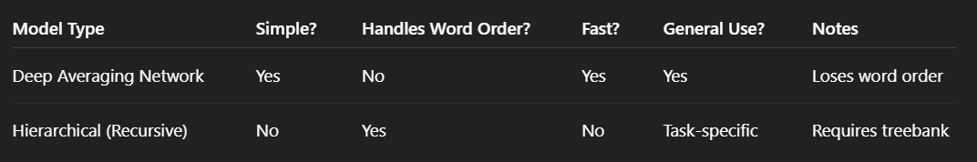

**CNN Architectures and Images: Intuition**

**Convolutional Neural Networks (CNNs) for Text Classification – Detailed Summary**

**1. CNNs and the Problem of Text Classification**

* CNNs became popular in the image recognition field but can also be applied to **text classification**.
* The idea is to **extract useful features** from chunks of text — for example, identifying patterns in phrases like:
  + "not great"
  + "this was not so good"
* These patterns often span multiple words — sometimes **2, 5, or even 10 words** — so the model should be able to capture features from such **multi-word sequences**.
* We also want the model to be **position-insensitive**:
  + It shouldn't matter whether "this was great" appears at the start, middle, or end of a sentence.
  + What matters is **that** the phrase is there — not **where** it is.

**2. General Strategy**

* Build a neural net structure that:
  + Scans the text for useful features no matter where they appear.
  + Uses **shared filters** across the sentence to extract patterns.
  + Adds **layers** to combine those features and perform classification.

**3. CNN Intuition from Images (Duck Classifier Example)**

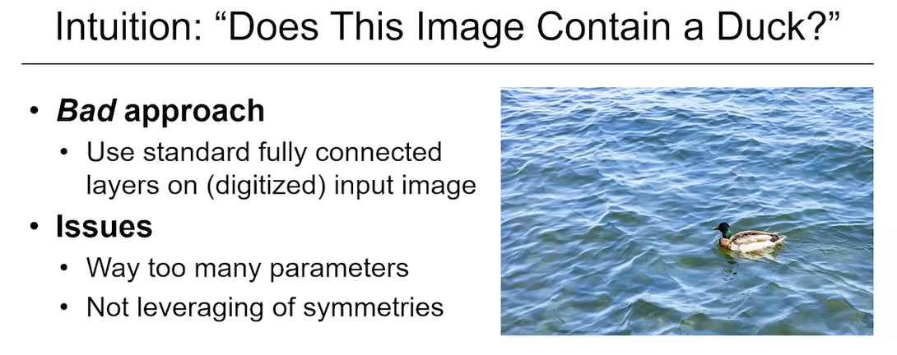

* Imagine classifying whether an image contains a **duck**.
* Suppose the image is 228x228 pixels with 3 color channels.
* A bad idea would be to flatten the whole image into one large vector and feed it to a neural network.
  + This loses spatial information.
  + It also creates **inefficiency** and ignores **image symmetries** (e.g., the duck could be anywhere).

**Better approach: Use Filters (Convolutions)**

* Use a small "filter" or "kernel" (e.g., a duck detector) that **slides over the image**.
* At each position, it checks: “Is there a duck here?”
* It **moves step by step** (called **stride**) and records the result.
* This creates a **feature map** — a smaller output that tells us **where** the filter found relevant features.

**4. How CNN Filters Work in Practice**

* The **same filter** is applied across **all parts of the image**.
  + This reduces the number of parameters.
  + This also leverages **symmetry** — the model treats the duck the same no matter where it is in the image.
* The **output** of this filtering is called a **feature map** — a matrix showing where features were detected.
* The **stride** controls how much the filter moves each time (e.g., one pixel at a time, or five).
* Resulting feature maps are usually **smaller** than the original image due to this movement.

**5. Multiple Filters and Layered Understanding**

* Instead of using just one filter (e.g., a "duck filter"), we can use **multiple filters**:
  + One filter detects **beaks**
  + Another detects **heads**
  + Another detects **necks**, and so on
* As each filter slides over the image, it **activates** when it sees its specific feature.
* These results are also saved into their **own feature maps**.

**Combining Features in the Next Layer**

* A **second layer** takes all the outputs from the first layer and looks for **combinations** of features.
  + For example, if one area has a head, a beak, a neck, and a tail — the system might now decide that it's likely a **duck**.
* So, the model can now recognize not just **parts**, but **whole objects** (or whole ideas in text).

**6. Efficiency and Parallelization**

* Even though the explanation talks about "sliding" filters step by step, in practice:
  + These operations are **parallelized**.
  + All filter applications at all positions can be computed at the same time, making CNNs very **efficient**.

**7. Translating This Intuition to Text**

* The same principles used for images can apply to **text**:
  + Instead of pixels, we have **word embeddings**.
  + A filter can look for certain **phrases** or **patterns** in the sequence of words.
  + The model scans through the sentence, applying the same filter at different positions.
  + This allows detection of phrases like:
    - “not bad”
    - “very happy”
    - “terrible service”
* Multiple filters can look for different kinds of patterns or phrases.
* Then, a second layer combines these to **predict the label** (e.g., sentiment, category).

**Summary**

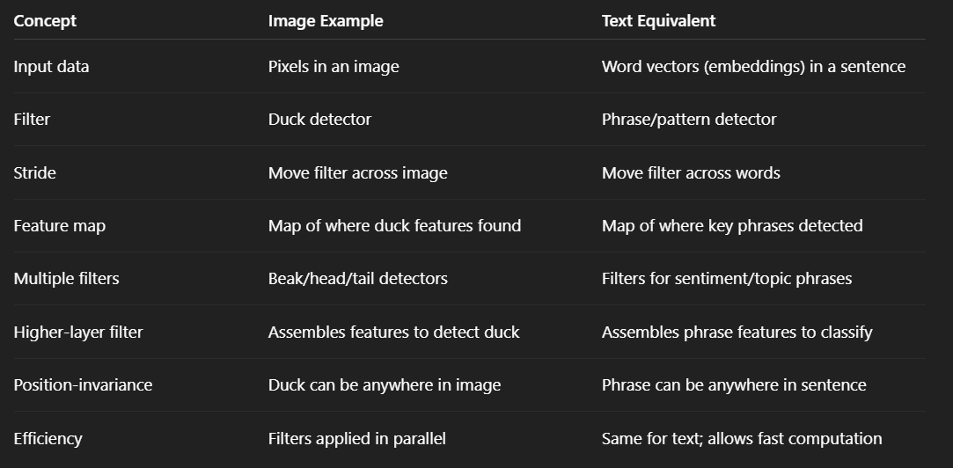

**CNN Architectures and Text: Intuition**

**1. Transition from Images to Text**

* Now that we’ve built an intuition for CNNs using **images**, we move to how CNNs are used for **text classification**.
* Example input:  
  *“This was not a great movie that I saw last night.”*
* Goal: Use CNNs to identify meaningful **phrases or features** in this text — such as **negative sentiment**.

**2. Step-by-Step Process of CNNs for Text**

1. **Tokenization**
   * First, we **tokenize** the sentence:  
     *“This was not a great movie that I saw last night”* →  
     ["This", "was", "not", "a", "great", "movie", "that", "I", "saw", "last", "night"]
   * This is standard preprocessing for almost all NLP tasks.
2. **Sliding Filters Over Text**
   * Imagine having a **filter** (learned by the model) designed to detect **negative sentiment**.
   * This filter looks at a **fixed-size chunk** (e.g., 5 words at a time) and slides across the token sequence.
   * Example of sliding:

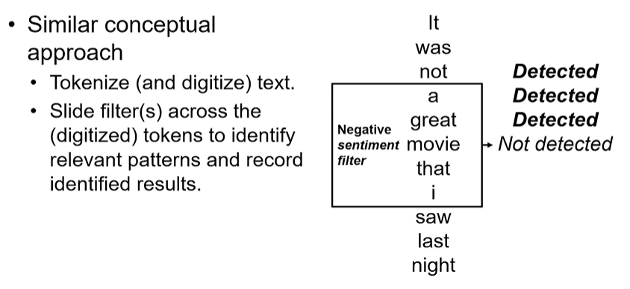

* + - "This was not a great" → Might detect negativity.
    - "Was not a great movie" → Likely negative.
    - "Not a great movie that" → Still negative.
    - "A great movie that I" → Likely **not** negative (so no detection).
    - Continue sliding...
  + At each step, the filter gives an **activation** (a response) depending on what it finds.

**3. Key Concepts in CNNs for Text**

* **Each filter** performs the **same operation** at every position.
  + That means if the phrase "this was great" appears at the beginning or end, it doesn’t matter — the **filter will still detect it**.
  + This helps achieve **position invariance**.
* **Multiple Filters with Different Sizes**
  + To detect various types of features, we typically use **many filters**:
    - Filters that look at 3-word sequences.
    - Filters that look at 5-word or even 7-word sequences.
  + Some patterns may appear in **short phrases**, others in **longer ones**.
  + Therefore, we almost **always use hundreds of filters of various sizes**.
* **Stride Size (Step Size)**
  + The **stride size** controls how far the filter moves at each step.
  + Example:
    - Stride = 1 → move by 1 word.
    - Stride = 2 → move by 2 words (fewer positions, less overlap).
  + This is a **hyperparameter** you can adjust.
* **Boundary Handling (Padding)**
  + What happens at the **edges** of the sentence?
    - Can the filter go past the first or last few words?
    - Do we **pad** the text to allow edge coverage?
  + These are decisions that affect model performance and will be discussed further in later sections.

**4. What Happens After Filters?**

* After filters extract their **activations** (i.e., they detect certain features at various positions), we move to the **next layers**:
  + These layers **combine** the detected features and **aggregate** the information.
  + The goal is to **summarize** what has been found across the entire text and use it to make a **classification decision** (e.g., positive or negative).

**5. Summary: CNNs for Text Classification**

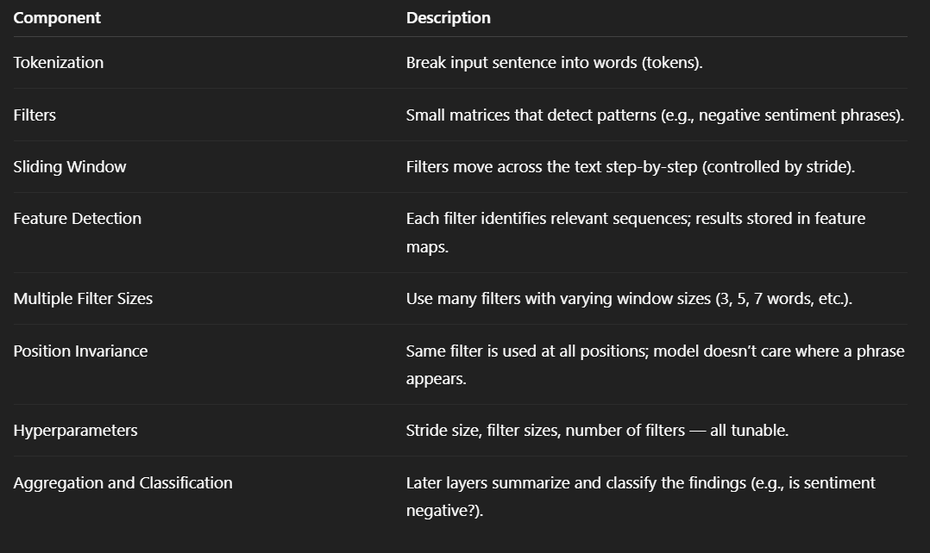

**6. Final Remarks**

* CNNs work well for text because they:
  + Detect meaningful **multi-word features**.
  + Are **efficient** due to shared weights and parallel operations.
  + Are **position-insensitive**, capturing patterns wherever they occur.
* Understanding both the **image and text examples** helps build strong intuition for how CNNs operate in different contexts.

**The Math of CNN Architectures: Convolutional Layers**

**1. Basic Setup of Convolutional Layers**

* Each **input example** is represented as a **d-dimensional matrix**.
  + In **images**, this typically means:  
    Height × Width × Color Channels (RGB)
* Each **filter (kernel)** is also a d-dimensional matrix.
  + The **kernel size** (denoted f) defines how much of the input the filter "sees" at a time.
* Filters are **slid** over the input.
  + At each position, the filter performs a computation and writes a result to an **output map** (called a **feature map**).
* The **filter contains the learnable weights and biases** — these are updated during training.
* **Important Note**:  
  In real implementations, there is **no actual loop** that slides the filter step by step.
  + The entire process is **parallelized**, making CNNs very efficient.

**2. Example: 1D Convolution with a Simple Filter**

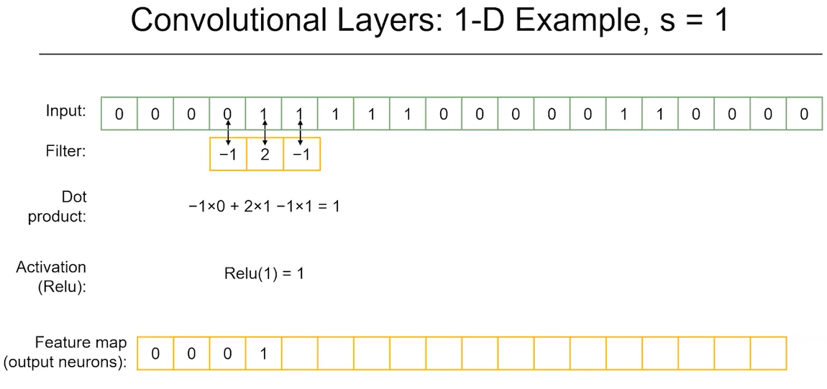

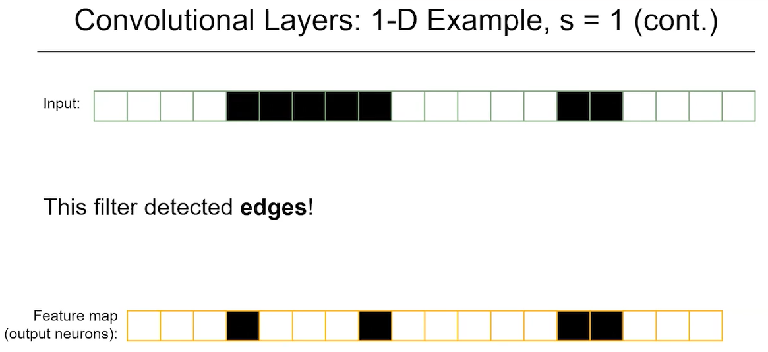

**Input:**

* A sequence of **0s and 1s**, for simplicity.
* Let's say the input is:  
  [0, 0, 0, 1, 1, 0, 1, 0, 0]

**Filter:**

* Kernel size = 3
* Weights = [-1, 2, -1]

**Convolution Step:**

* At each position, the filter performs a **dot product** with the values it overlaps:
  + Multiply corresponding values and sum them up.
  + This region of the input is called the **receptive field**.
* Example calculation:
  + Input segment: [0, 0, 0]
  + Filter: [-1, 2, -1]
  + Output: 0×-1 + 0×2 + 0×-1 = 0
  + Apply **ReLU activation**: ReLU(0) = 0
* As we **slide** across the input:
  + The filter may encounter [0, 1, 1] → 0×-1 + 1×2 + 1×-1 = 1 → ReLU(1) = 1
* Repeat across entire input.
* The final output is a **feature map** with these computed values.

**3. What Does This Feature Map Represent?**

* Visualize the output:
  + Use black for 1s, white for 0s.
  + You’ll see the filter is detecting **transitions**:
    - From white to black → rising edge
    - From black to white → falling edge
* In this case, the filter is acting like an **edge detector**.

**4. Using Multiple Filters**

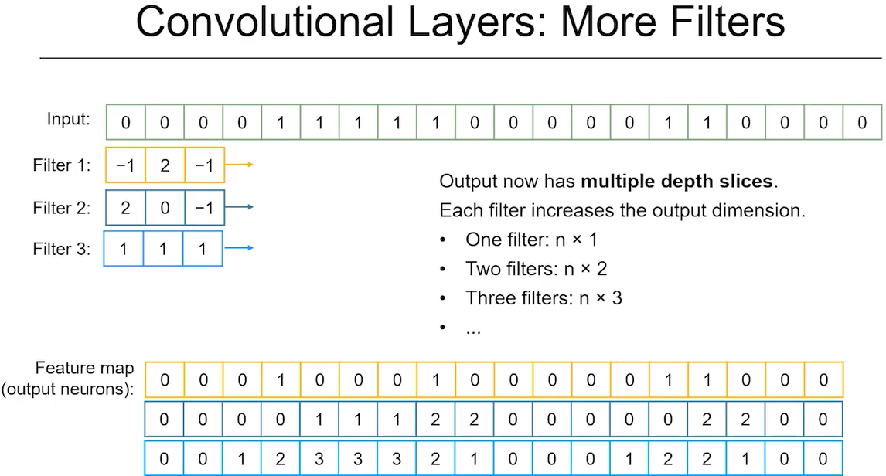

* In practice, CNNs don’t use just one filter — they use **many**.
* Each filter produces its own **feature map**.
* Example:
  + Filter 1: [-1, 2, -1] → Output: Feature Map A
  + Filter 2: [2, 0, -1] → Output: Feature Map B
  + Filter 3: [1, -1, 1] → Output: Feature Map C
* If input is length n:
  + With one filter → output is shape [n × 1]
  + With three filters → output becomes [n × 3]
  + This **adds a depth dimension** to the output.

**5. Next Convolutional Layer**

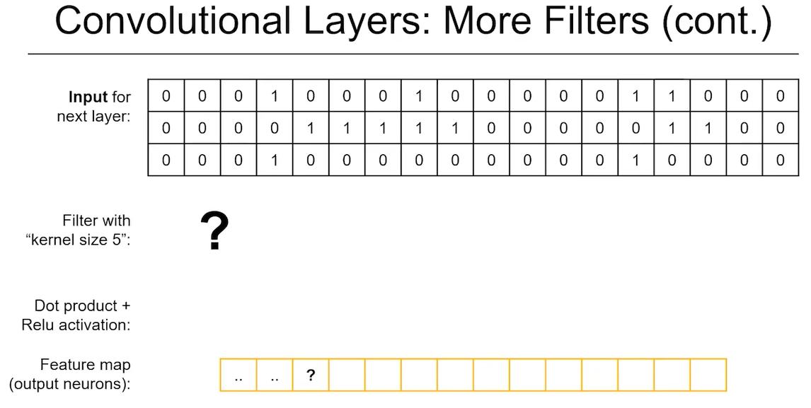

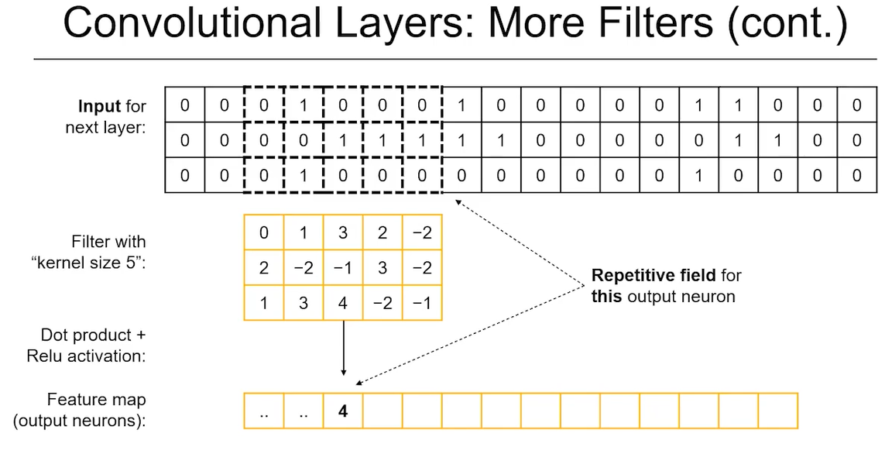

* Suppose we add a **new convolutional layer** on top of this multi-filter output.
* The new filters now have:
  + **Kernel size (e.g., 5)** → spans over 5 positions
  + **Access to all depth channels** of previous layer
* Example:
  + Receptive field in layer 1 contains values from Filter A, Filter B, Filter C
  + New filter looks at a 5×3 slice (length × depth)
  + Performs the same kind of weighted sum and activation
* This allows the new layer to **combine and integrate features** detected by lower layers.
  + Example: one filter finds a neck, another a beak, and so on — next layer combines these into a “duck” detection.

**6. 2D Convolution Example**

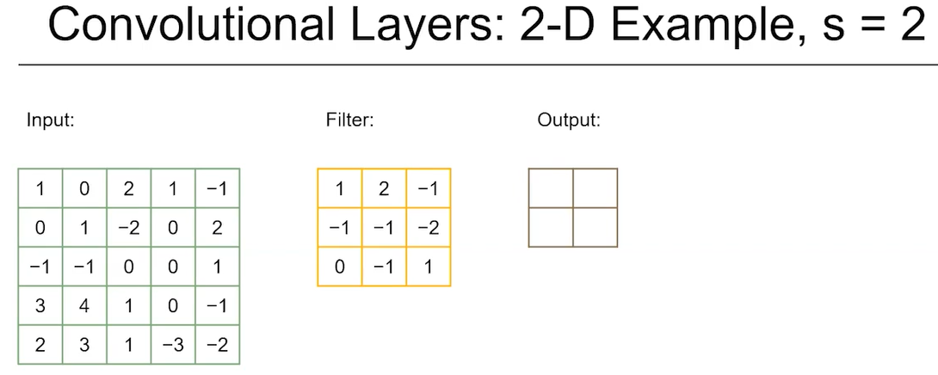

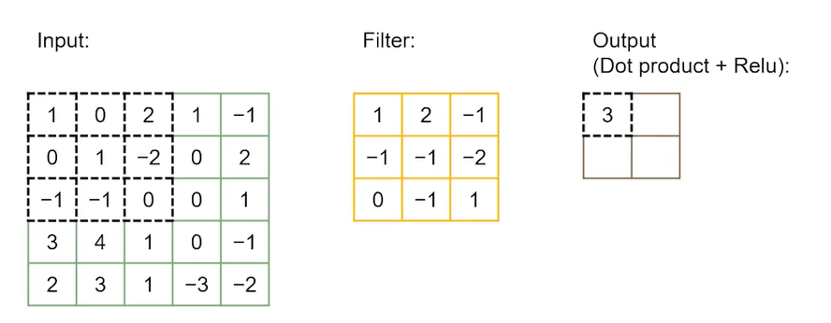

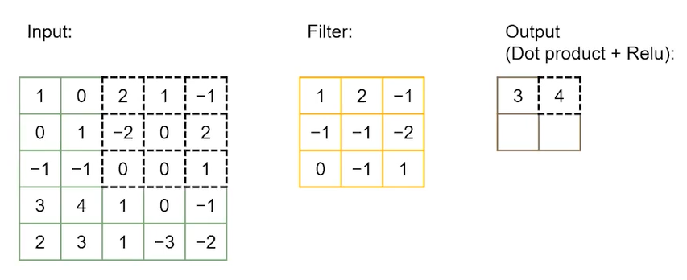

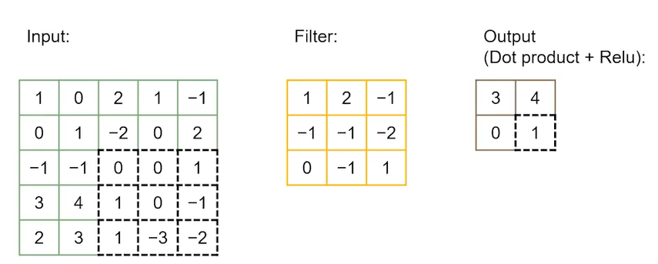

* Now imagine the input is a **2D matrix** (like an image, 5×5, for simplicity).

**Setup:**

* Kernel size: 3×3
* Stride size: 2
* No color channels for now (grayscale).

**Steps:**

1. Place filter on top-left 3×3 area.
2. Perform calculation:
   * Multiply corresponding values, sum them up.
   * Apply ReLU activation.
3. Slide filter **two steps** to the right → next calculation.
4. Then **two steps down** and repeat.

* Resulting output is a **reduced-size feature map** (lower resolution).
  + This helps reduce computation and focus on key areas.

**7. Padding and Boundary Handling**

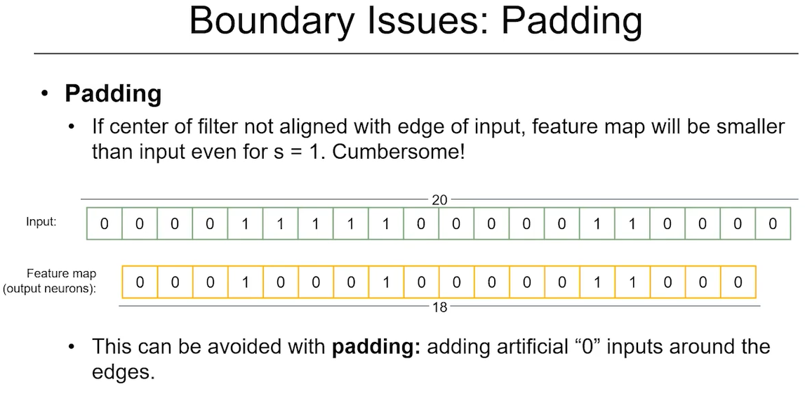

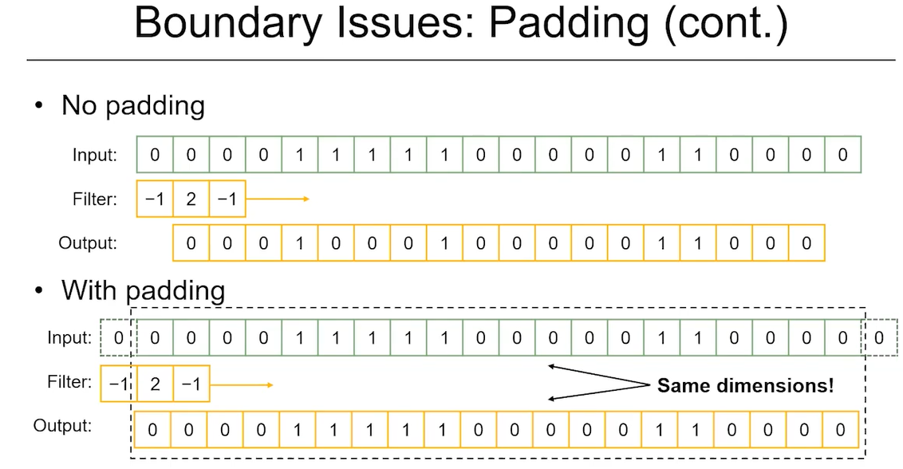

* **Problem**: Filters cannot go beyond edges of the input.
* Without padding:
  + Input size = 20
  + Filter size = 3
  + Output size = 18 (some edge values lost)
* **Padding** adds zeros to the start and end of the input:
  + Allows the filter to fully slide across the original input
  + Keeps the **output size equal to input size**

**Formula:**

To calculate **output size d**, use:

d = (n - f + 2p) / s + 1

Where:

* n = input length
* f = filter (kernel) size
* p = padding size (number of zeros added to each side)
* s = stride size

**Example:**

* Input size = 20, filter size = 3, padding = 0, stride = 1
* Calculation: (20 - 3 + 0)/1 + 1 = 18
* With padding = 1: (20 - 3 + 2)/1 + 1 = 20

**8. Summary: Key Concepts of CNN Math**

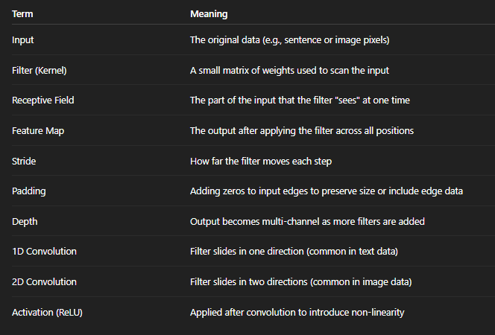

**The Math of CNN Architectures: Pooling and Classification Layers**

**1. CNN Layers Beyond Convolution**

After convolutional layers, two additional types of layers are essential in CNN architectures:

* **Pooling layers**
* **Classification layer** (final layer)

**2. Pooling Layers**

**What is Pooling?**

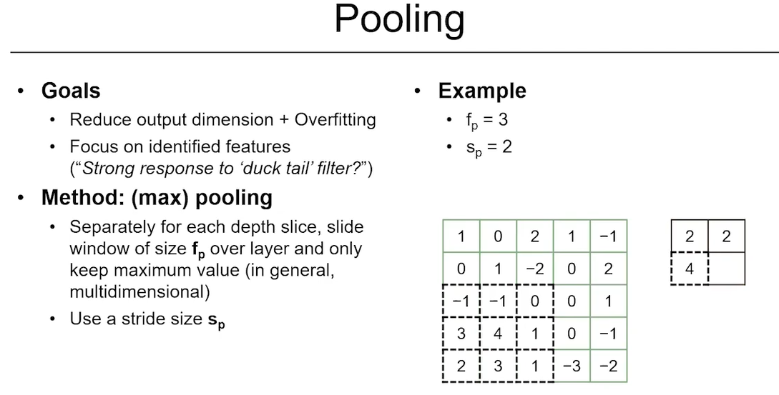

* Pooling **reduces the size** of the feature maps.
* It helps:
  + **Condense information** from the previous convolutional layer.
  + **Reduce overfitting** by simplifying the data.
  + **Focus** on the most important parts (key features).
  + Improve **computational efficiency**.

**How Pooling Works (e.g., Max Pooling):**

1. Define a pooling filter of size fp (e.g., 2×2).
2. Choose a **stride size** (how far the filter moves).
3. The filter **slides across each feature map**, just like a convolution filter, but:
   * It **does not learn** any weights.
   * It **simply computes** a statistic (e.g., the **maximum** value) from the region it covers.

**Example:**

* Suppose a filter looks at this 2×2 region:

[1, 0]

[2, -2]

* Max pooling would return the **largest value**, which is 2.
* As the filter slides:
  + Top right region → max = 2
  + Bottom left region → max = 4
  + Bottom right region → max = 1
* The output is a **smaller feature map**, summarizing the presence of strong features.

**Important Notes:**

* Pooling is applied **independently** to each feature map from the previous layer.
* It does **not track negative values** or weaker signals — it keeps only **strong activations**.
* This helps focus on **presence** of features rather than **absence**.

**3. Classification Layer**

**What Happens After Pooling?**

* After several convolutional and pooling layers, you’re left with a smaller, condensed representation of the input.
* To perform classification:

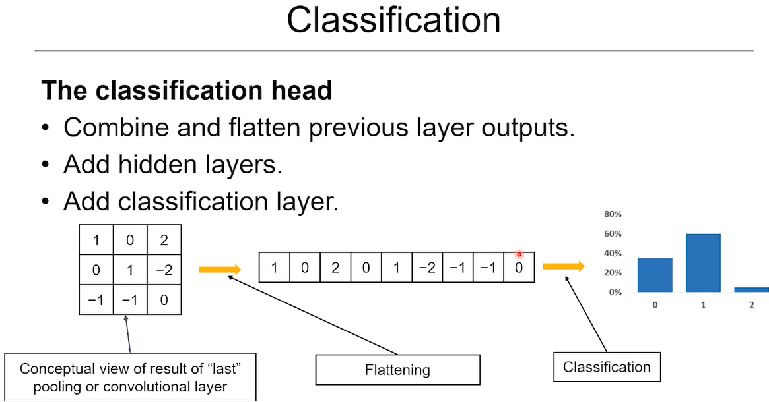

* 1. **Flatten** the final output (e.g., 3×3 matrix → 9-dimensional vector).
  2. Optionally, add **fully connected (dense) layers**.
  3. Apply a **final dense layer** to output logits (raw scores for each class).
  4. Use **Softmax** (or Sigmoid for binary) to get a **probability distribution** over classes.

**Summary:**

* CNN + Pooling layers → extract and condense features.
* Final dense layer → maps to class scores.
* This produces the model’s **predicted class probabilities**.

**4. Real-World Example: VGG-16 Architecture**

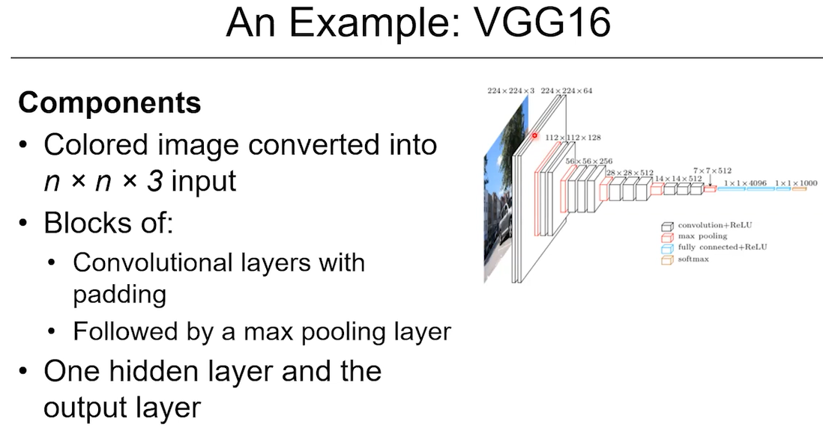

**Overview:**

* **VGG-16** is a classic CNN architecture used in image classification.
* Input: 224×224 RGB image → so shape is 224 × 224 × 3.

**Layer Structure:**

* Alternates between:
  + **Convolutional layers** (**white** boxes)
  + **Pooling layers** (**red** boxes)
* Observations:
  + Uses **padding** to maintain feature map size after convolution.
  + Applies **more filters** as the network goes deeper.
  + **Feature maps get smaller**, while **depth increases**.

**Final Layers:**

* Final output is reshaped into a **1×1×4096** vector (flattened representation).
* Last layer maps this to a **1×1000** vector (for 1000-class classification task, like ImageNet).

**5. Key Takeaways**

**a. Efficient Use of Parameters**

* Instead of connecting **every input pixel** to **every output neuron** (as in fully connected networks), CNNs:
  + Use **filters** that scan **local areas**.
  + Share the **same filter weights** across the input.
* This drastically reduces the number of parameters and improves learning.

**b. Feature Detection through Filters**

* Each filter learns to detect a **specific feature**:
  + e.g., edges, curves, textures (in images) or phrases, n-grams (in text).
* Filters are trained to look for **different features**, and many are used in parallel.

**c. Fast and Parallel Computation**

* Even though filters “slide” conceptually, there is **no for-loop** in practice.
* Operations are done in **parallel**, making CNNs fast, especially on GPUs/TPUs.

**d. Hyperparameters to Tune**

* You can choose:
  + Number of filters
  + Filter sizes (kernel sizes)
  + Stride values
  + Padding or no padding
  + Number of convolutional and pooling layers
* These choices affect the model’s performance and must be tuned based on the task.

**6. Overall Summary of CNN Pipeline**

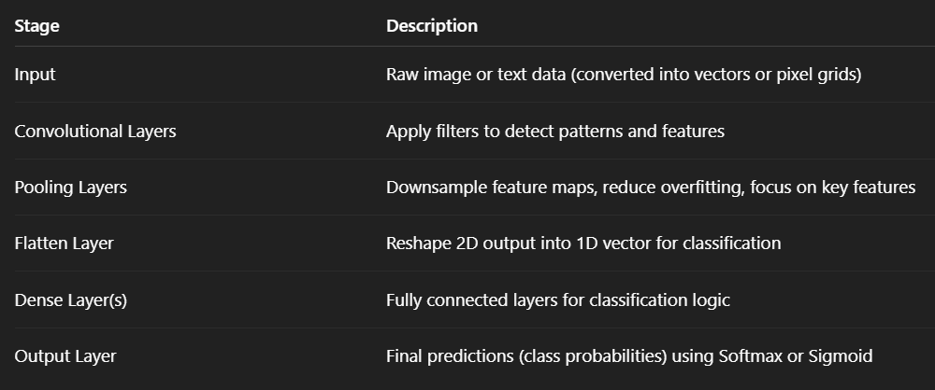

** Imagine an input image of dimension 300 x 300 x 3, where the last dimension represents the color channel. You now apply 100 filters of kernel size 5 x 5 without padding and using step size 1.

What is the dimension of the resulting feature map?

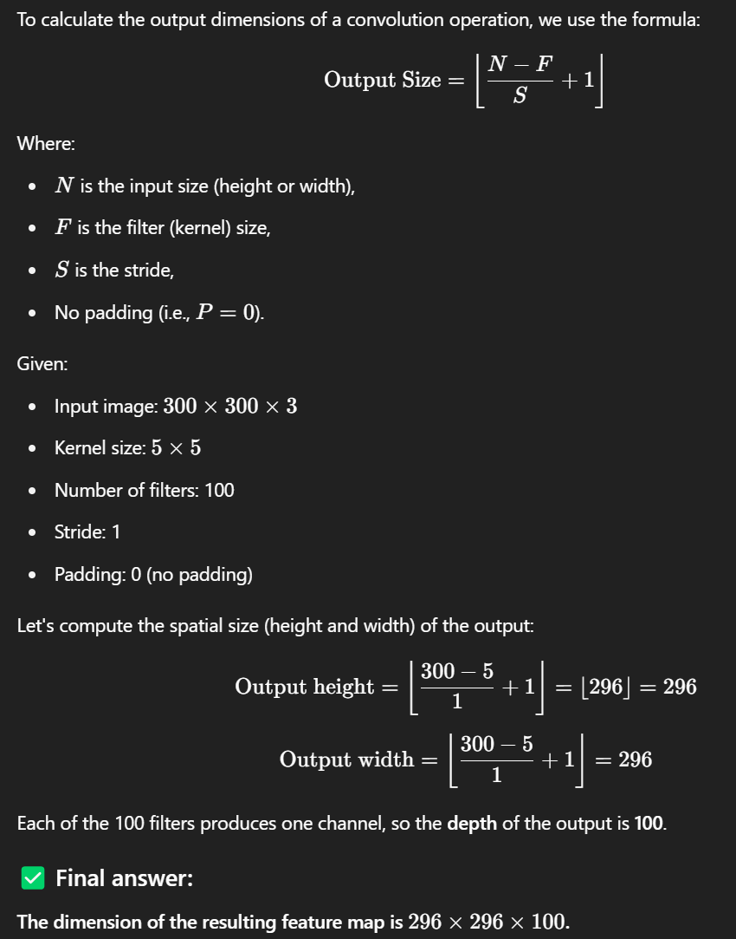

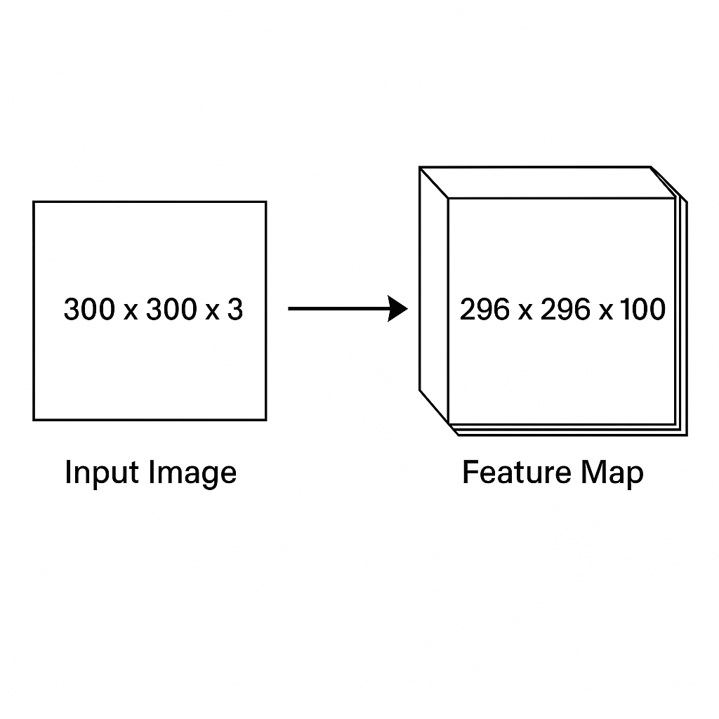

** If **padding** is used, it changes the output size of the convolution. The formula becomes:

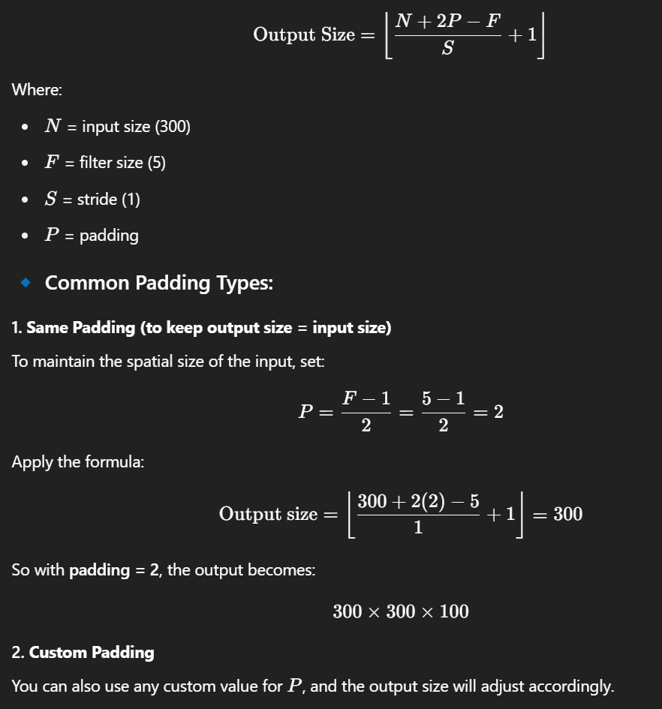

**Applying CNN Architectures to Text Classification**

**1. Purpose and Setup**

* The goal is to **classify text** such as:
  + *“I like this movie very much.”*
  + Into **categories** like: *positive*, *negative*, or *neutral*.
* CNNs can be used for this task by:
  + Extracting local patterns from the text using **filters**
  + Identifying key features like phrases or word combinations
  + Pooling the most relevant signals
  + Passing results into a **classification layer**

**2. Based on Kim (2014)**

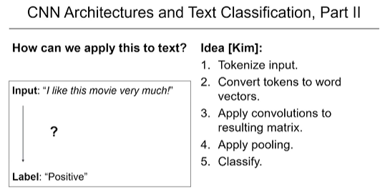

* The CNN approach for text classification was popularized by **Yoon Kim (2014)**.
* The steps are relatively straightforward and effective:
  1. **Tokenize** the sentence.
  2. Convert tokens into **word vectors** (embeddings).
  3. **Apply CNN filters** to extract features.
  4. **Apply pooling** (e.g., max pooling).
  5. Feed the results into a **classification layer**.

**3. CNN Pipeline for Text (Example)**

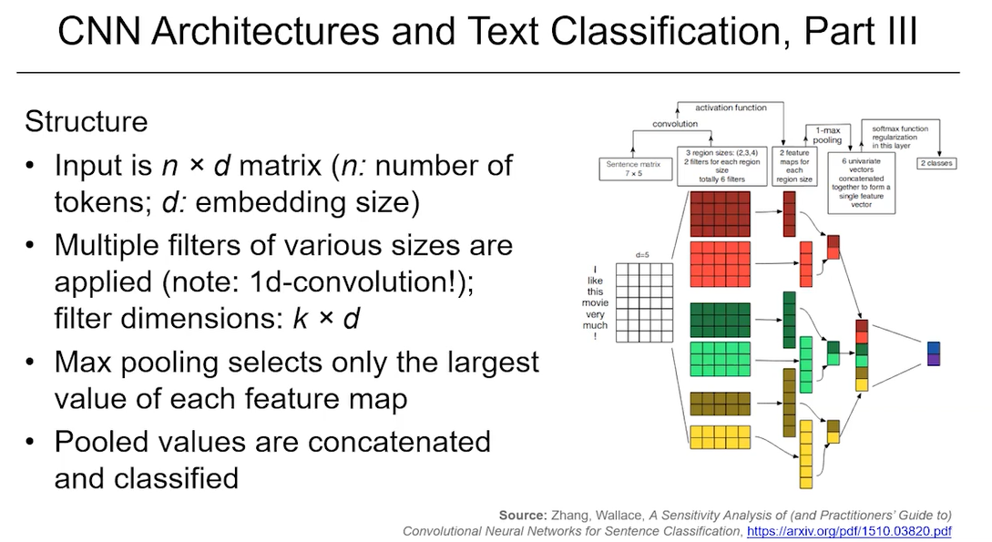

**Input Sentence:**

* *“I like this movie very much.”*

**Step 1: Embedding Layer**

* Each word is converted into a **d-dimensional vector**.
* All word vectors are stacked to form a **2D input matrix**:
  + Shape: number of words × embedding dimension (d)
  + For example: 6 words, embedding dimension = 5 → matrix shape = 6 × 5

**Step 2: Apply Convolution Filters**

* Example: Use a **filter of width 2** (kernel size 2, stride 1).
* The filter slides over the matrix to cover **2 words at a time**:
  + Position 1: words 1 & 2 → apply convolution → write to feature map
  + Position 2: words 2 & 3 → apply convolution → write to feature map
  + ...
  + Final output for kernel size 2: 6 positions → 5 valid convolution outputs

**Step 3: Feature Map**

* The result of applying the filter is a **feature map**.
* One filter → one feature map.
* Multiple filters → multiple feature maps.

**Step 4: Max Pooling**

* Max pooling is applied over each feature map.
* The **maximum value** in the entire map is selected:
  + Represents the **strongest detection** of that feature.
  + Ignores where in the sentence it appeared.
  + Produces **one value per filter**.

**Step 5: Multiple Filter Sizes**

* Use multiple filters with different sizes:
  + Example:
    - 2 filters of size 2 (bigrams)
    - 2 filters of size 3 (trigrams)
    - 2 filters of size 4 (4-grams)
* Larger filters produce **shorter feature maps** (due to fewer positions to slide).
* Each filter produces one pooled value → final vector length = number of filters.
* For 6 filters → final output vector has 6 values.

**4. Final Classification Layer**

* The pooled vector (e.g., 6 values) is **flattened** and used as input to a **classification layer**.
* Can apply:
  + **Fully connected (dense) layer(s)**
  + **Softmax activation** to predict class probabilities
* Example: Binary classification → output vector of size 2.

**5. Why Multiple Filters of Same Size?**

* Example: Two filters with kernel size 2.
* Even though the size is the same, they are **randomly initialized**.
* During training, they learn to detect **different features**:
  + One may focus on positive phrases like “very good”
  + Another may detect negative patterns like “not great”
* Filters with the same size **do not learn the same thing**.
  + Each learns unique sub-patterns based on backpropagation and training data.

**6. Evaluation and Performance**

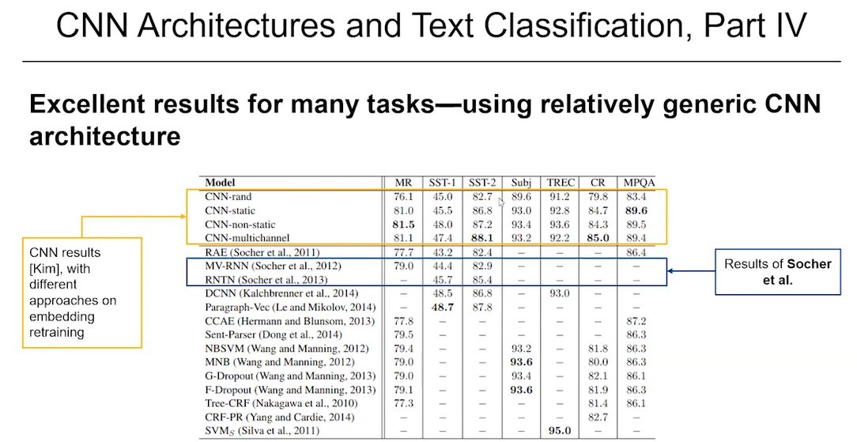

* Kim’s (2014) CNN model was tested on various datasets.
* It performed **extremely well** — often **state-of-the-art** or close.
* Compared to earlier approaches:
  + Recursive neural networks (e.g., Socher et al., 2012–13) required **parsing trees**.
  + CNNs require **no tree structures**, **no grammar rules**, and are much simpler.
  + The network **learns everything** automatically from the word vectors.

**7. Advantages of CNNs for Text**

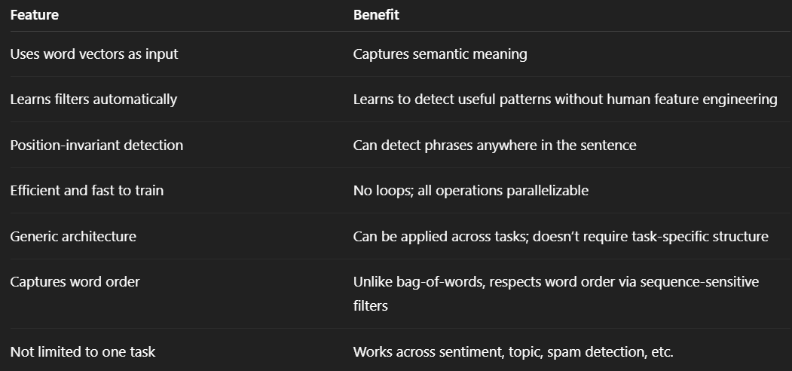

**8. Summary of CNN for Text Classification**

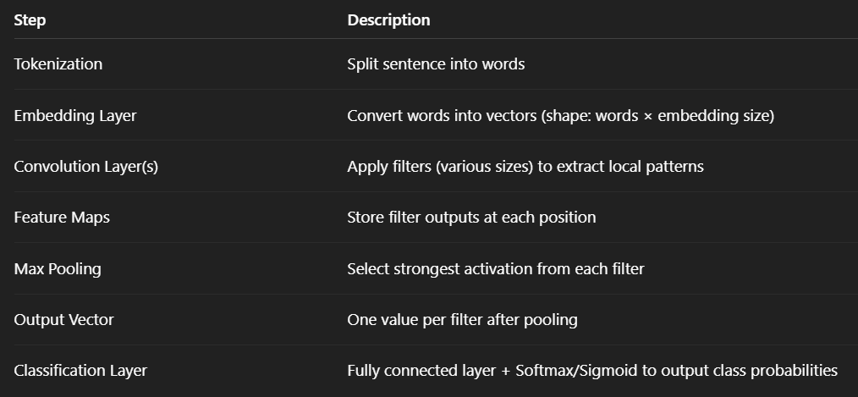

**\*\* Why would you possibly want multiple filters of the same size?**

Even though all filters may have the **same size** (e.g., 5×55 \times 55×5), they are **initialized with different weights**, meaning each one learns to detect **different patterns** or **features** in the input.

**🔹 Why Use Multiple Filters of the Same Size?**

1. **Capture Different Features:**
   * One filter might learn to detect **vertical edges**.
   * Another might focus on **horizontal lines**.
   * Another might respond to **texture**, **colors**, or **corners**.
   * All with the same spatial area (e.g., 5×55 \times 55×5) but detecting different things.
2. **Diversity in Feature Representation:**
   * Using many filters gives the model a **richer understanding** of the input image at each layer.
   * Think of them as **specialized detectors**, each contributing a different perspective.
3. **Depth Creation:**
   * Each filter produces one **feature map** (channel).
   * So using 100 filters creates a **depth of 100**, allowing downstream layers to work with a high-dimensional representation of the image.

Imagine 100 photographers, all taking a photo of the same object with the **same lens size** but using **different filters** (like infrared, night vision, sepia, etc.). Each captures something unique from the same view.

Different filters of the same size get initialized differently. Training through backpropagation will then enable them to learn different features.

**What is Backpropagation?**

**Backpropagation** is the **training algorithm** used to adjust the weights (including filter values) in neural networks, including CNNs. It’s how the network **learns** from data.

**Step-by-step:**

1. **Forward pass:**
   * Input goes through the CNN.
   * Filters convolve over the image.
   * You get an output (like class scores for cat vs. dog).
2. **Compute loss:**
   * The output is compared to the true label (e.g., using cross-entropy loss).
3. **Backward pass (Backpropagation):**
   * The network computes how much **each weight** (including those in the filters) contributed to the error.
   * It then **adjusts** each filter's weights slightly to reduce the error next time.
   * This is done using **gradient descent** and chain rule of calculus.

**What Happens in the Backward Pass (Mathematically)**

**1. Compute the Loss Gradient**

After the forward pass, we compute the **loss** (e.g., using cross-entropy).  
Backpropagation starts by computing the **gradient of the loss** L with respect to the network's outputs.

**2. Chain Rule: Gradients Propagate Back**

We use the **chain rule of calculus** to propagate gradients back through the layers.

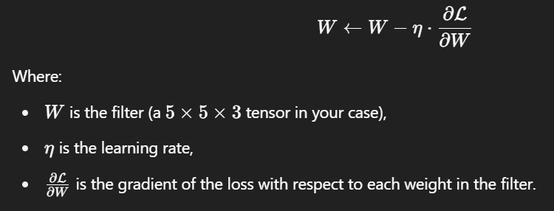

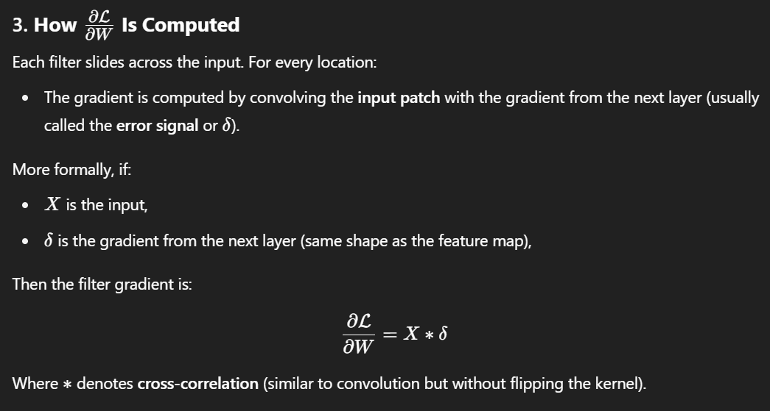

**4. Update Each Filter**

Each filter’s weights are adjusted by subtracting a small fraction of its gradient, moving in the direction that **reduces the loss**.

**\*\* Is max pooling used here in exactly the same way as it was for image classification?**

It is not the same. In CNN architectures for image classification, for each filter output, we generally use the maximum value within a patch and record this value for each patch. In this model for NLP classification we use the maximum across all output values for a given filter.

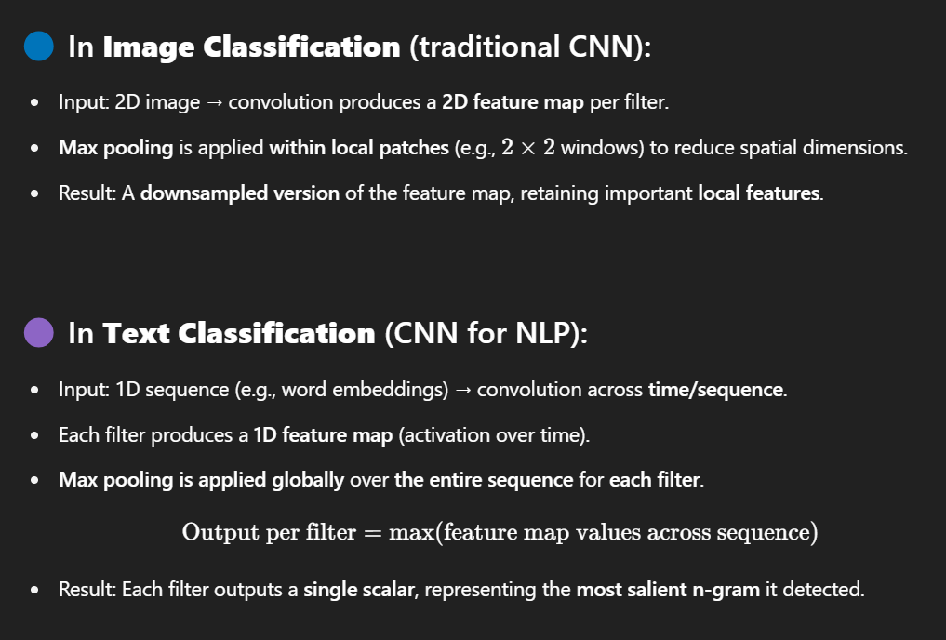

**An Illustrative Toy Example**

**1. Goal of the Example**

* Demonstrate **what CNN filters learn** when applied to sentiment analysis.
* Use a **simple toy model** trained on the **Stanford Sentiment Treebank (SST)**.
* Visualize how individual filters respond to **positive and negative phrases** in text.

**2. Dataset & Preprocessing**

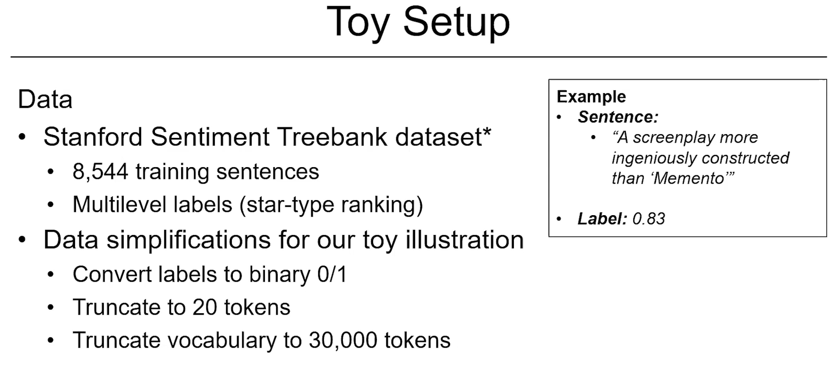

* **Dataset**: Stanford Sentiment Treebank (SST)
  + Contains over **8,000** sentiment-labeled examples.
  + Original labels are **star-style ratings** (e.g., 0.83).
* **Label Simplification**:
  + Ratings above 0.5 → **Positive (1)**
  + Ratings below 0.5 → **Negative (0)**
* **Further Simplifications for Demonstration**:
  + **Token limit per sentence**: 20
  + **Vocabulary limit**: 30,000 most frequent words
  + **Trained word embeddings from scratch** (no pre-trained GloVe, etc.)

**3. Model Architecture (Simplified CNN)**

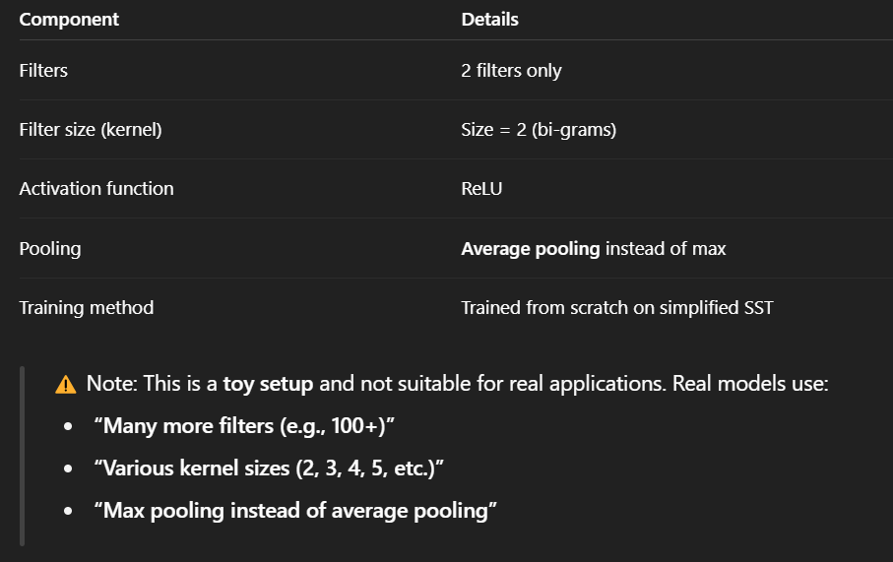

**4. Test Sentences (Not Seen During Training)**

Three similar sentences were created to test how filters behave:

**Sentence 1 (Positive):**

*“Very well done. Acting was very good and the brief discussion of the history was really fun today.”*

**Sentence 2 (Negative):**

*“Very poorly done. Acting was very bad and the long discussion of the history was really boring today.”*

**Sentence 3 (Mildly Negative):**

*“Bit poorly done. Acting was quite bad and the long discussion of the history was a bit boring today.”*

* Sentences are **manually constructed** for controlled comparison.
* Key changes involve **sentiment words** and **intensifiers** like "very" vs. "bit".

**5. How Filters Were Applied**

* **Filter size** = 2 → Each filter looks at **two consecutive words**.
* **Stride size** = 1 → Filter slides by one word each time.
* For each pair of words, the model:
  + Applies convolution
  + Applies ReLU activation
  + Stores result in a **feature map**
* Then applies **average pooling** across the feature map to summarize each filter’s signal.

**6. Visualization and Interpretation**

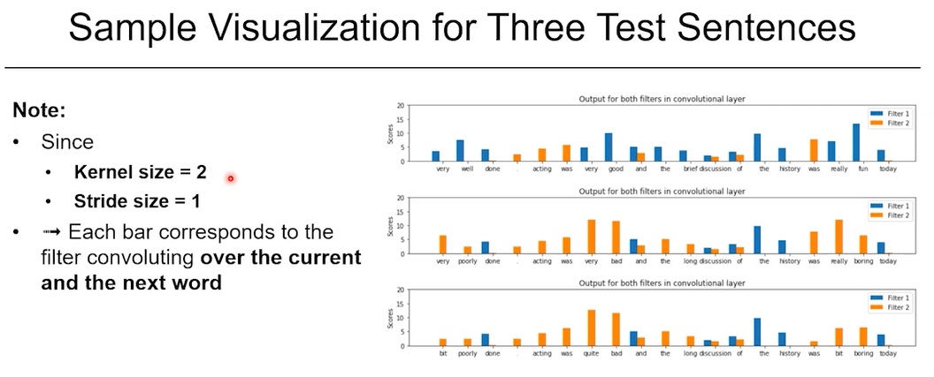

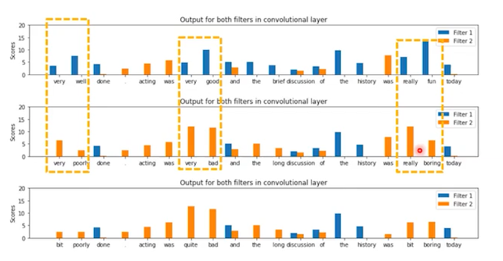

**Color Coding:**

* **Blue bars** = Output of **Filter 1**
* **Orange bars** = Output of **Filter 2**

**Key Findings:**

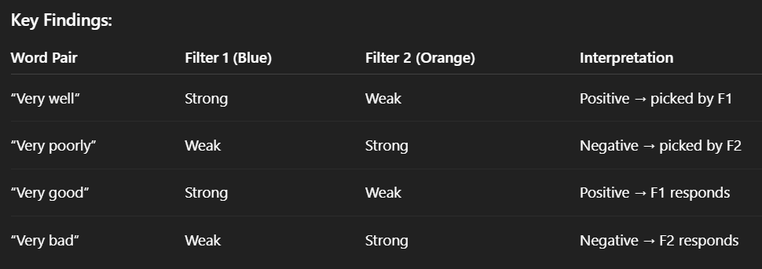

* Even though no explicit instructions were given to filters, they learned:
  + **Filter 1 (Blue)** → Positive sentiment features
  + **Filter 2 (Orange)** → Negative sentiment features

**7. Softening Sentiment Strength** 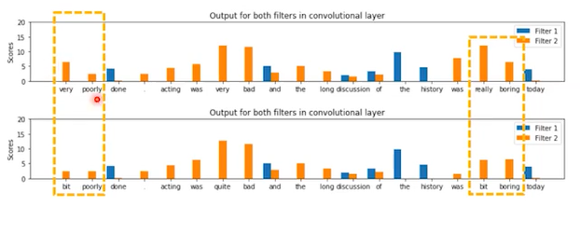

* Comparing Sentence 2 and 3:
  + “Very poorly” → Filter 2 response is **stronger**
  + “Bit poorly” → Filter 2 response is **weaker**
  + “Really boring” → Stronger signal
  + “Bit boring” → Weaker signal

✅ Suggests: **Filter 2 detects not just negativity, but the degree** of negativity  
→ Intensity modifiers like “bit” and “really” affect output strength.

**8. Other Observations**

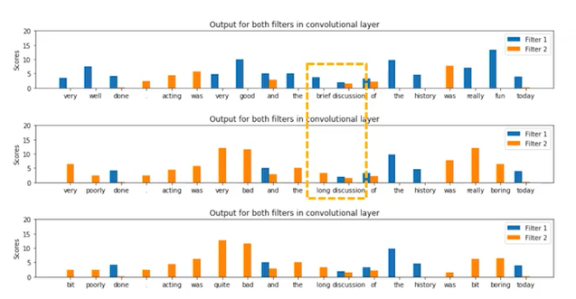

* “Brief discussion” (Sentence 1) → Less negative signal
* “Long discussion” (Sentence 2/3) → More negative signal
* CNN filters **learn associations** beyond just clear sentiment words — even subtle differences like **“brief” vs. “long”**.

**9. Summary of Key Points**

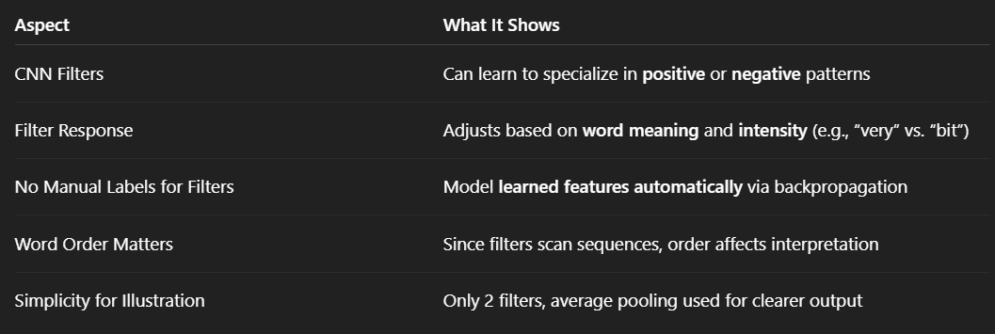

**Lecture Summary & Outlook – Text Classification with CNNs**

**1. Summary of What We Learned**

**a. Text Classification Is Important and Ubiquitous**

* Text classification is a **core task in NLP**:
  + Examples include **sentiment analysis**, **topic categorization**, **spam detection**, etc.
* It's widely used in real-world applications:
  + Reviews, emails, social media, legal documents, and more.

**b. Text Is Complex**

* Language includes:
  + **Phrases**, **idioms**, **colloquialisms**, **polysemy** (words with multiple meanings).
* A **naive approach** (e.g., bag-of-words) **cannot capture** these complex relationships.

**c. Neural Architectures Help Handle Complexity**

* **Word embeddings** are a key component:
  + Convert tokens into **dense vector representations**.
  + Help reduce **sparsity** and provide **semantic similarity**.
* Neural networks like **CNNs** can learn to detect important word patterns.

**2. Why CNNs Work Well for Text**

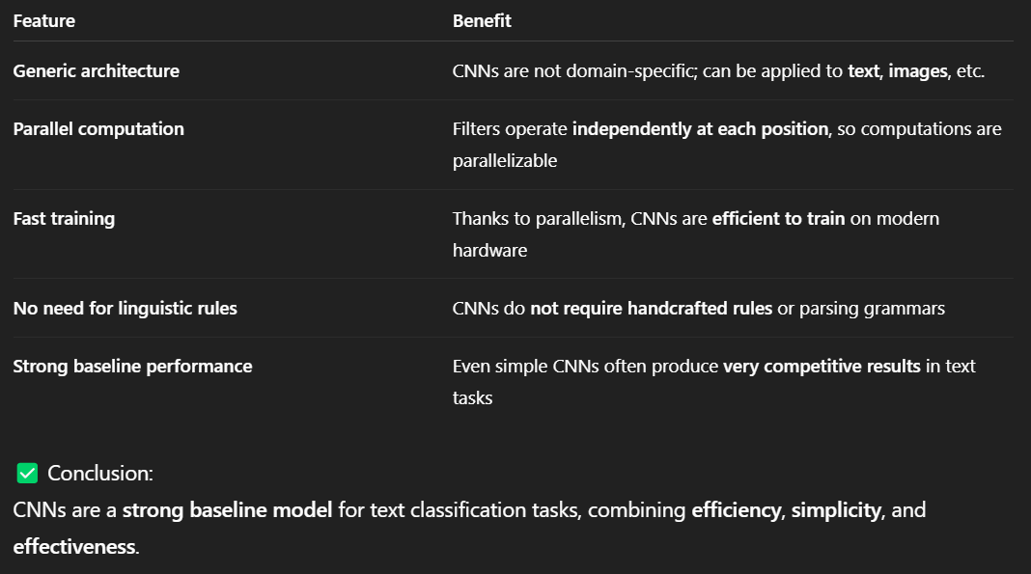

**3. Limitations and What’s Next**

**a. Limitations of CNN + Static Word Embeddings**

* Word embeddings (e.g., Word2Vec, GloVe) are **static**:
  + A word like *"sick"* always has the same vector, regardless of context.
  + Example:
    - *"That trick was sick!"* (positive slang)
    - *"I was feeling sick."* (literal illness)
  + A single word vector **cannot distinguish between these meanings**.
* As a result:
  + CNNs have to **learn the context** from scratch on top of limited embeddings.
  + This requires **lots of training data** and **deep architectures**.

**b. The Need for Context-Aware Representations**

* What we need:
  + **Word vectors that understand context**.
  + Embeddings that **adjust their meaning** based on surrounding words.

**An Exemplary Problem: Language Modeling**

**1. The Problem: Predicting or Correcting Words**

Imagine a user types the sentence:  
**“Have a nice say”**  
The intended sentence was likely:  
**“Have a nice day”**

Our task is to enable a computer to automatically detect and correct such mistakes by selecting the most likely intended word based on the context.

**2. Mathematical Formulation**

Let’s define the problem formally.  
Suppose the user typed:

**"Have a nice say"**

We want to infer what they **intended** to type.

**Formal Problem Statement**

We aim to find the sentence that maximizes the probability of being the intended sentence given the typed input:



This means:

Among all possible correct sentences, which one is **most likely** given the user typed “Have a nice say”?

**Challenges**

* There are **a huge number of possibilities** for what the user could have meant — how do we handle them efficiently?
* Do we need to **recalculate this probability distribution** from scratch for **every** typed input?

These challenges motivate the use of Bayes' Theorem, which we explore in the next section to simplify and optimize the computation.

**3. Solution: The Noisy Channel Model and Bayes’ Theorem**

We aim to solve the problem:

P(possibility ∣ typed)

Using **Bayes’ Theorem**, we can rewrite this as:

P(possibility ∣ typed) ∝ P(typed ∣ possibility) × P(possibility)

This is the core of the **Noisy Channel Model**, originally popularized in spell correction and machine translation.

**Why This Reformulation Helps**

**1. Efficient Precomputation**

* The term P(possibility) is **independent of what was typed**.
* That means we can compute P(possibility) **in advance**, using a large corpus (e.g., Wikipedia, news text), and reuse it for many different cases.

**2. Reduces the Search Space**

* We only need to consider candidates where P(possibility)>0.
* Most arbitrary combinations of words (like “roof banana elbow tree”) have zero probability of occurring in real English, so we can safely ignore them.

**3. Decomposes the Problem Logically**

* P(typed ∣ possibility): How likely is it that someone typed what they typed, **assuming** a specific intended phrase?
  + For example, how likely is it that someone would mistype “day” as “say”?
* P(possibility): How likely is the candidate phrase **in general**?

**5. Language Models: Defining and Decomposing the Probability of Text**

When we refer to a **language model**, we’re talking about the probability of a sequence of words (or tokens) occurring in a specific order in natural language.

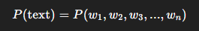

This is the **joint probability** of the entire sequence of tokens from start to finish.

**Decomposing the Joint Probability**

To compute this in practice, we use the **chain rule of probability**, which breaks the joint probability down into a product of conditional probabilities:

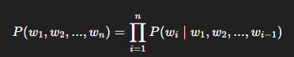

This means that the probability of the entire sentence is calculated by multiplying together the probability of each word **given all previous words** in the sentence.

**Central Object of Interest**

The most important piece in this equation is:

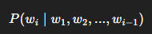

This expression tells us the **probability of a word wi** occurring given the **context** of all prior words in the sequence.

For example:

* In the sentence **“This is really great”**, the term

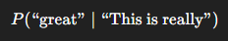

quantifies how likely it is for the word “great” to follow the phrase “This is really”.

**6. Example: Calculating the Probability of a Sentence**

To see how the language model works in action, let’s walk through a concrete example.

Suppose we want to compute the probability of the sentence:

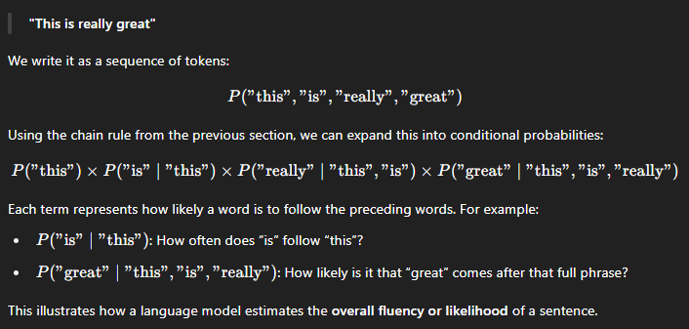

**7. Estimating Probabilities from Text**

We can estimate these probabilities from text by **counting how frequently sequences of words occur**.

However, calculating **P(wₙ | w₁,...,wₙ₋₁)** directly is impractical, so we simplify.

**8. Language Models: N-Gram Approximation and Counting-Based Estimation**

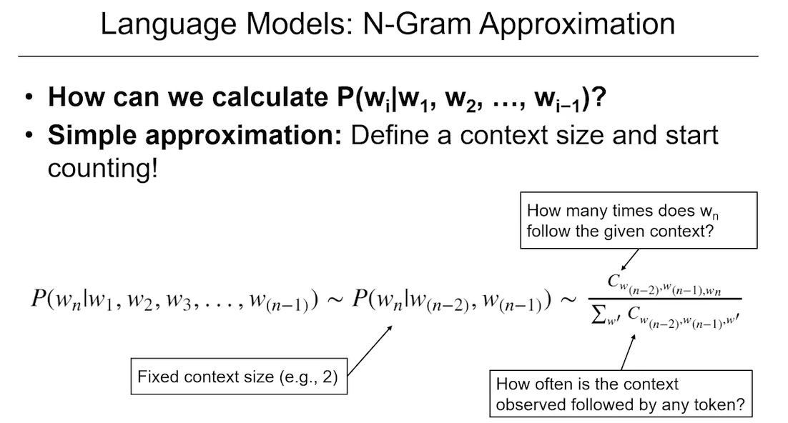

In theory, we would love to compute:

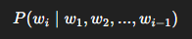

But in practice, this is hard. The number of possible contexts (w1,...,wi−1) grows **exponentially** with sentence length. We simply don’t have enough training data to reliably estimate all of these probabilities.

**The Simplifying Assumption: Fixed Context Size**

To solve this, we **approximate** the full context using only the most recent n−1 tokens. This leads to what’s called the **N-gram model**:

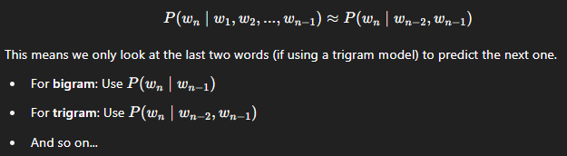

**Estimating Probabilities by Counting**

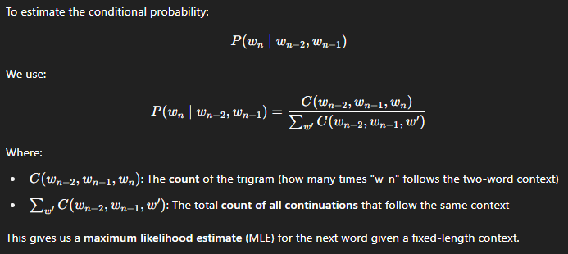

**Why Use N-Grams?**

* **Simple**: Just count co-occurrences in a large corpus like Wikipedia.
* **Fast**: No training or optimization required.
* **Effective (to a point)**: Works well for many short-context applications like autocomplete or spell-check.

**Limitations**

* **Context is limited**: You can't capture long-range dependencies (e.g., topic shifts or complex grammar).
* **Sparsity**: Many valid phrases never occur in your data — resulting in zero probabilities.
* **No semantics**: “dog bites man” vs. “man bites dog” are treated as totally different with no shared meaning.

**9. Smoothing Techniques**

To deal with sparsity and avoid assigning zero probability to unseen combinations, we use smoothing methods.

Two common techniques:

* **Add-k smoothing**: Adds a small count to every possible word sequence.
* **Kneser-Ney smoothing**: A more sophisticated and effective smoothing technique.

Although these were widely used in N-gram models, they are less relevant now due to the rise of neural network–based approaches.

**10. Why Move Beyond N-grams?**

* N-gram models fail to capture **contextual meaning**.
  + Example: The word **“sick”** means different things in:
    - “That snowboard trick was sick.” (positive)
    - “I was home all week because I was sick.” (negative)
* The model does not understand the **difference in usage** because it assigns a fixed vector to the word “sick,” regardless of context.
* Additionally, **long-term dependencies** in text cannot be modeled well with fixed window sizes.

**11. Looking Ahead: Neural Language Models**

The course will now shift focus to more powerful models that can address the limitations of N-gram methods.

These include:

* **Neural Language Models**
* **Recurrent Neural Networks (RNNs)**
* **Contextual Embeddings**
* **Transformers and BERT**

These approaches model language **with longer context**, **fewer sparsity issues**, and **greater accuracy**.

**Evaluation of Language Model**

Now that we understand what a language model does—computing the probability of a string of text as a product of conditional probabilities—the next question is: **how do we evaluate how good a language model is?**

**Goal of Evaluation**

We want to assess how well a model can predict the **next token** in a given context. That is, given a partial sentence like:

"Today is a very nice..."

The model should assign a **high probability** to the correct next word. The better the model is at doing this, the more accurate and useful it is. So, if model A predicts the correct word more frequently than model B, we consider model A superior.

**Cross-Entropy**

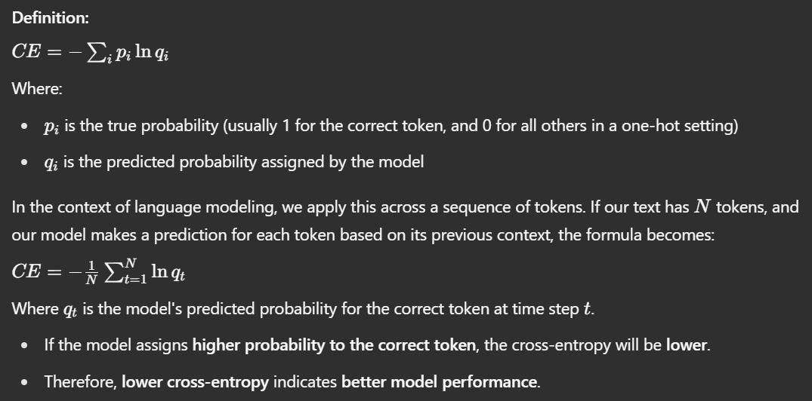

**Example:**

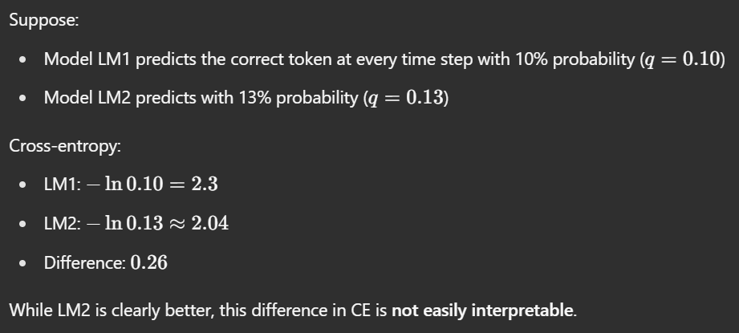

**Perplexity**

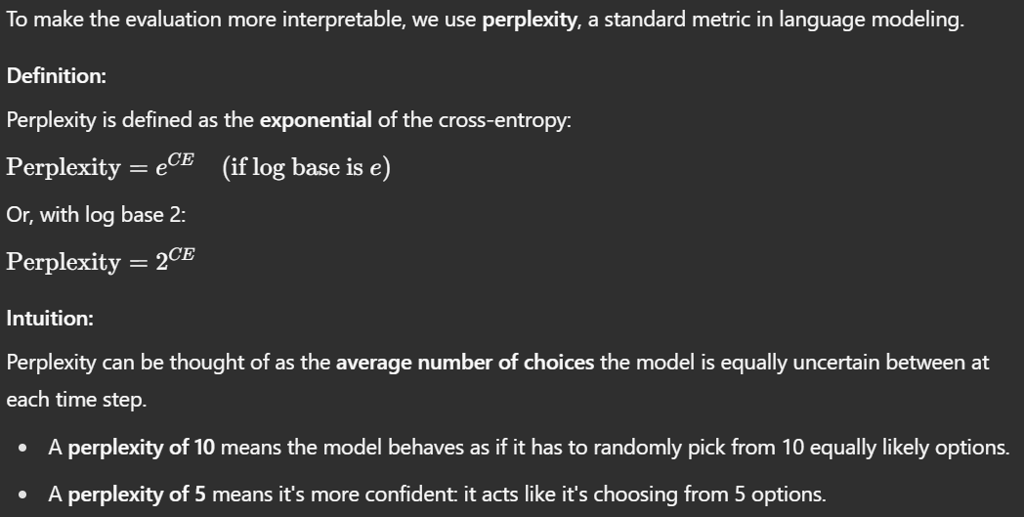

**Revisiting the Example:**

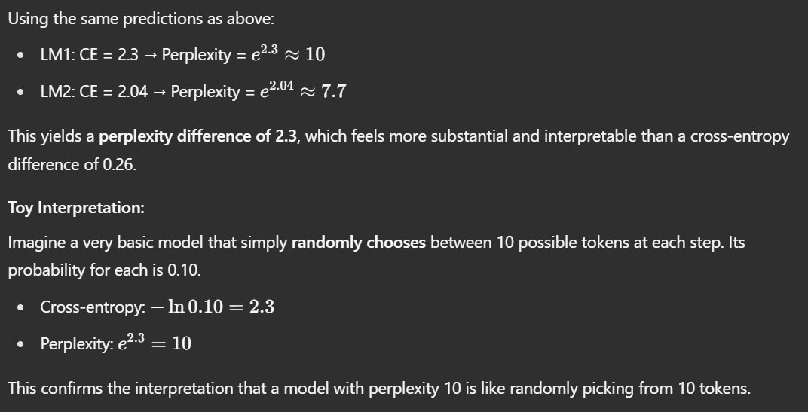

**Summary**

* **Cross-entropy** quantifies how well a model's predicted probabilities match reality.
* **Perplexity** converts that into an interpretable number: "How many choices is the model confused between?"
* **Lower cross-entropy and perplexity are better.**
* Perplexity is more interpretable and widely used in evaluating language models.

Thus, in modern NLP, **perplexity** is the preferred evaluation metric for comparing language models.

**Question 1.**

Assume the training corpus consists solely of:

“Jack is a man of many trades. Unfortunately, many of them are not very useful. And on many days he is using none of them. Maybe it would be better to be a man of many useful trades?”

What is the conditional probability P(‘days’ | ‘many’), assuming no smoothening?

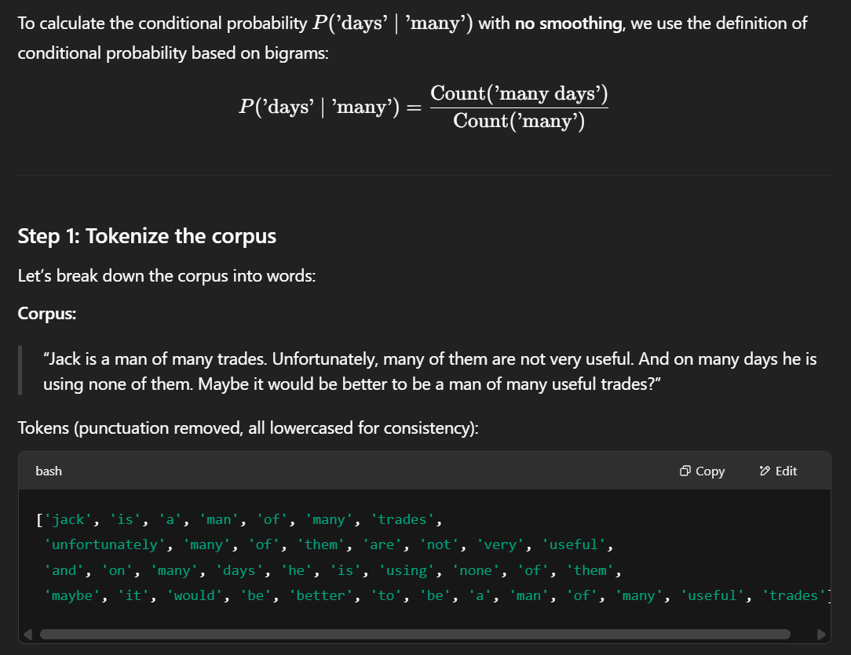

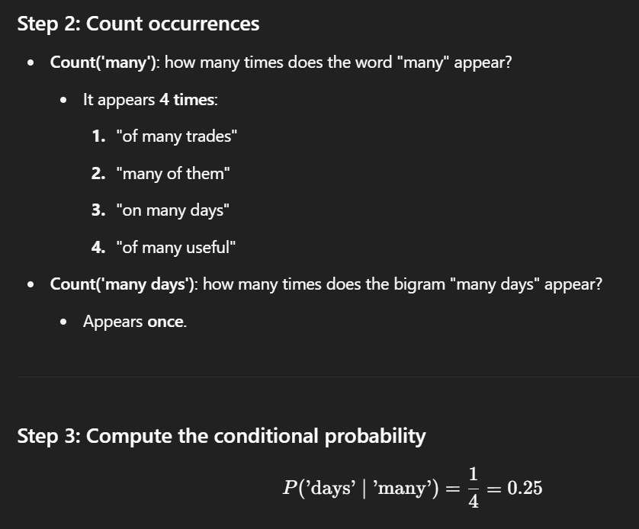

**Question 2.**

Assume the training corpus consists solely of:

“Jack is a man of many trades. Unfortunately, many of them are not very useful. And on many days he is using none of them. Maybe it would be better to be a man of many useful trades?”

What is the conditional probability P (‘trades’ | ‘of’, ‘many’), assuming no smoothening?

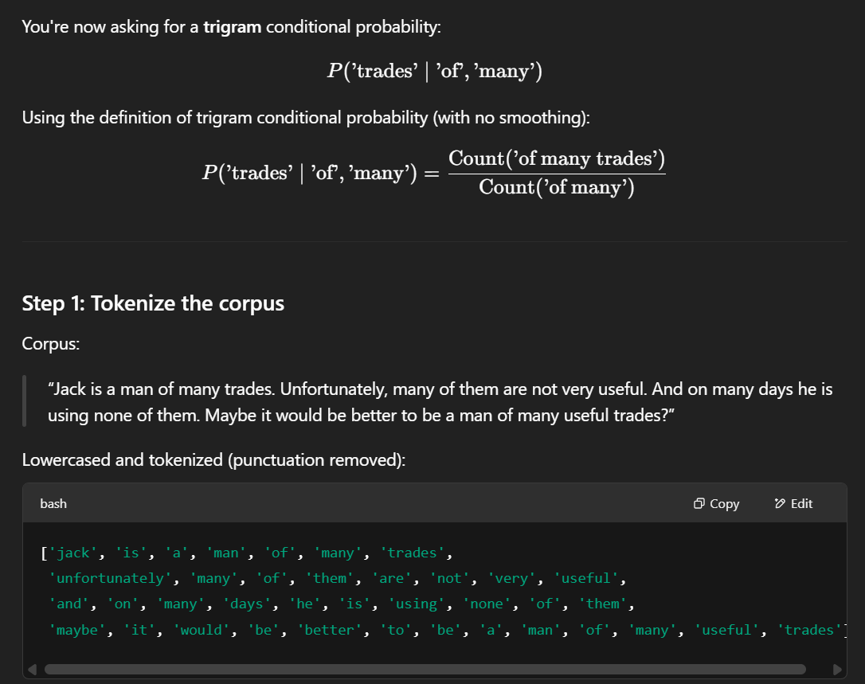

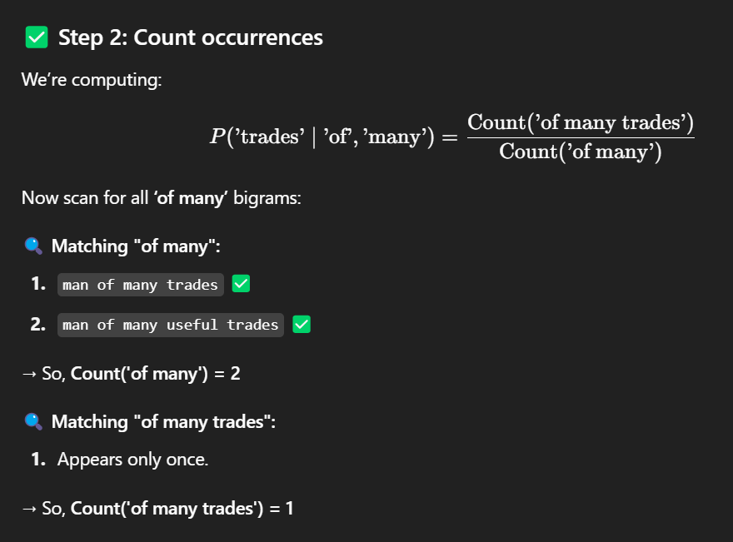

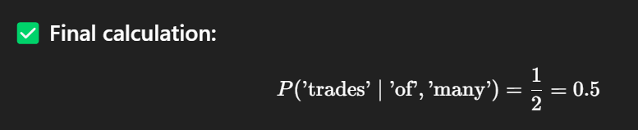

**Review of Recurrent Neural Nets (RNNs)**

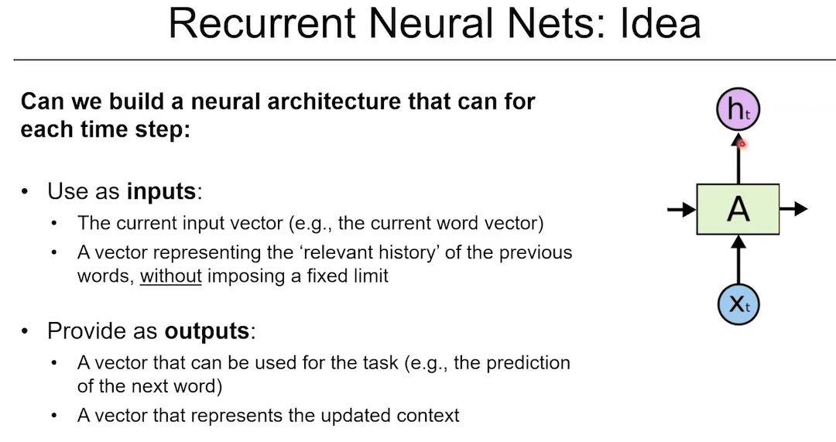

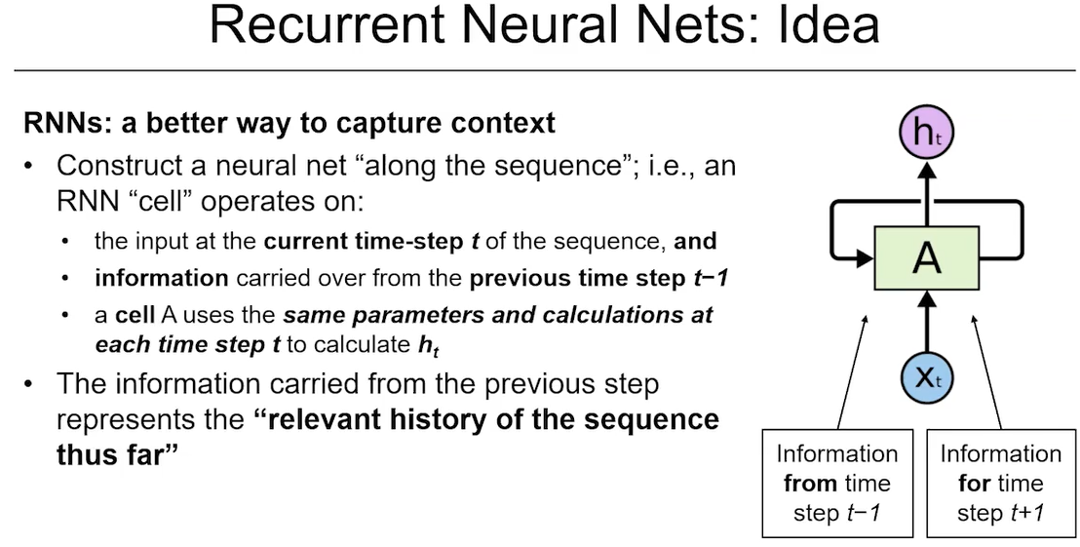

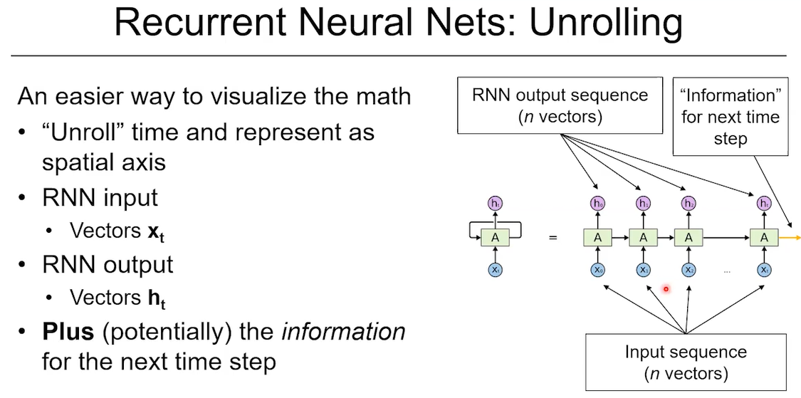

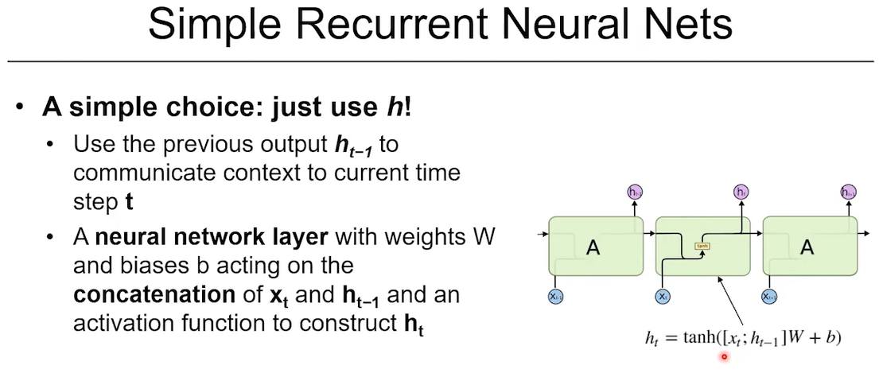

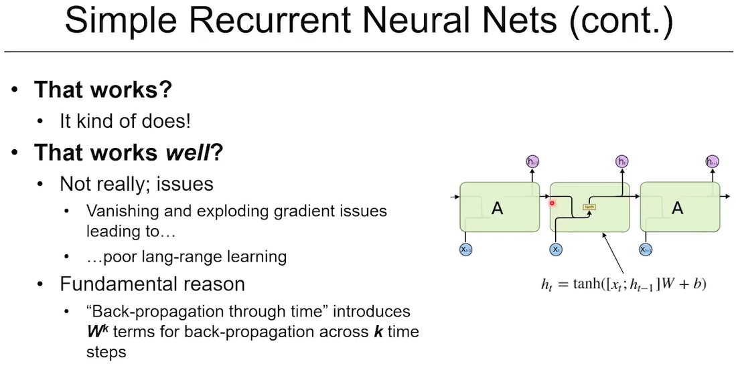

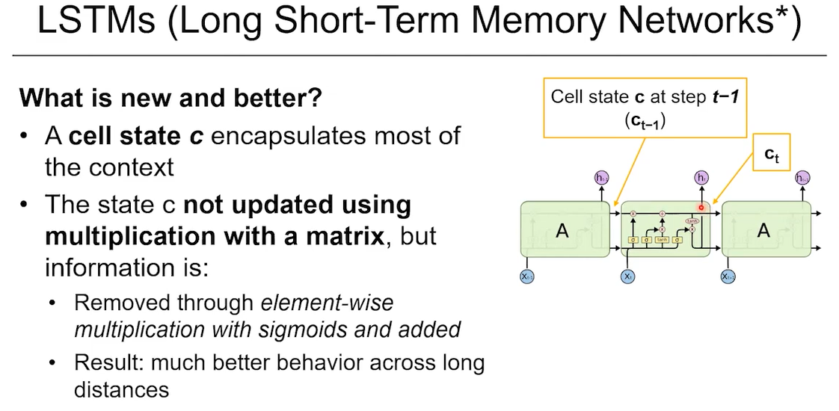

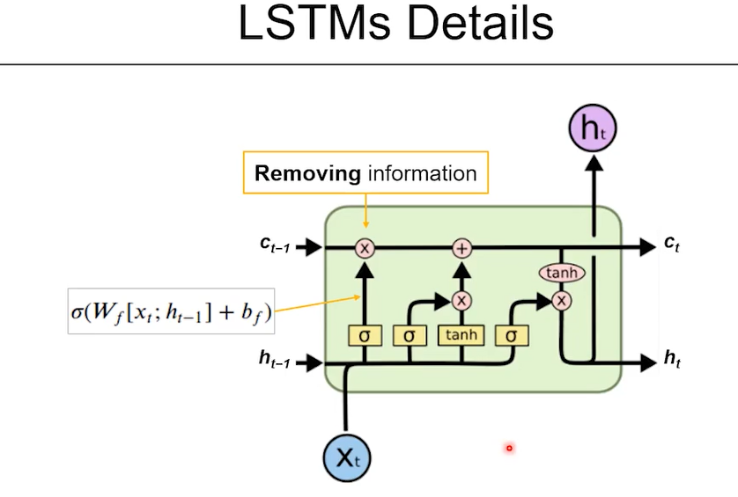

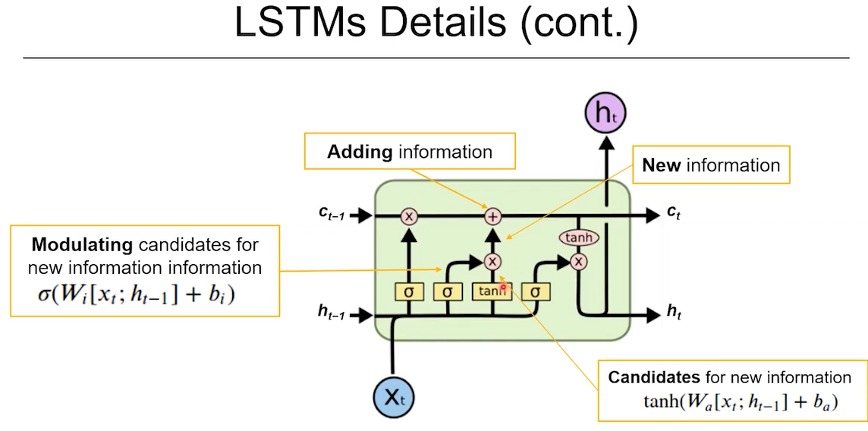

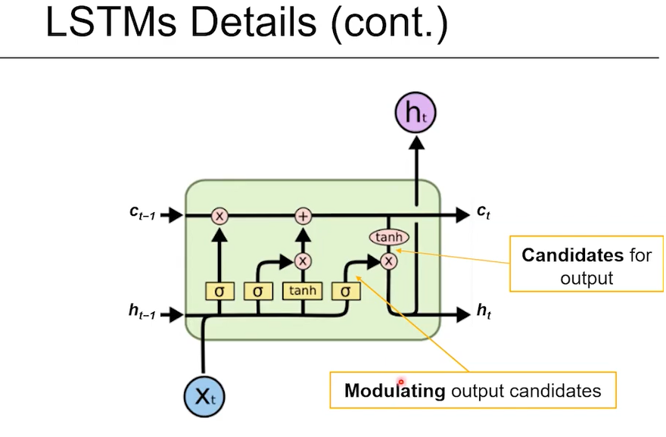

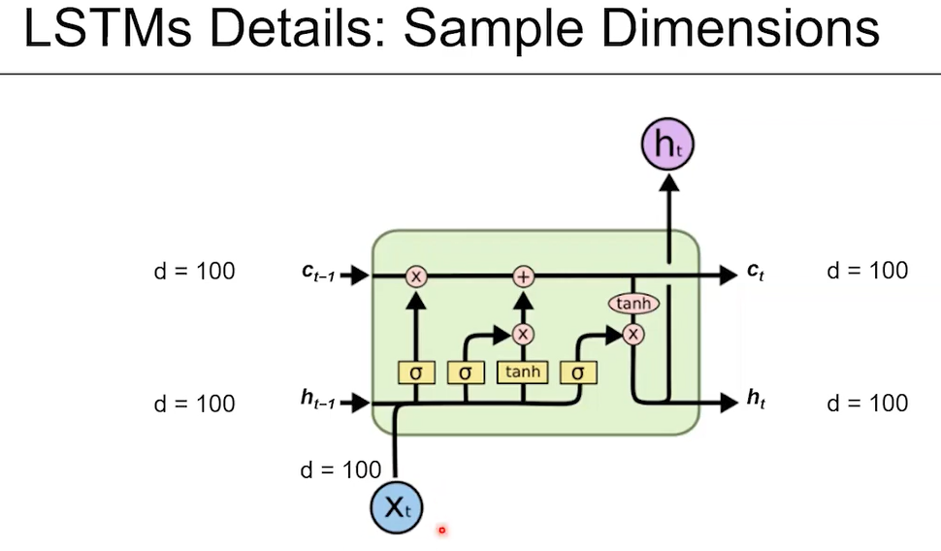

Now that we've seen how traditional language models use conditional probabilities, let’s bring **neural networks** into the picture and build more powerful language models.

**Motivation**

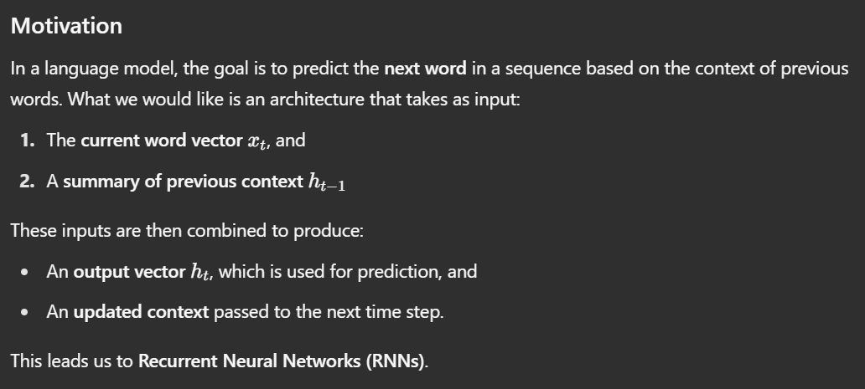

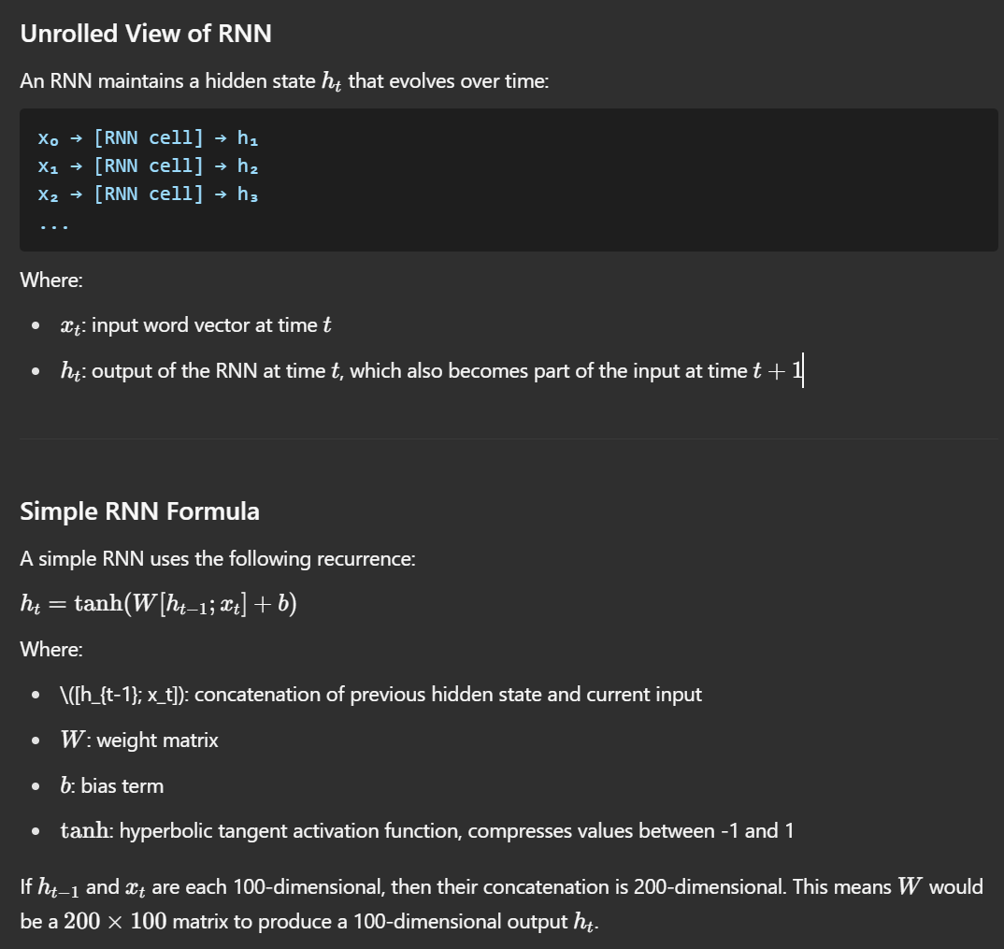

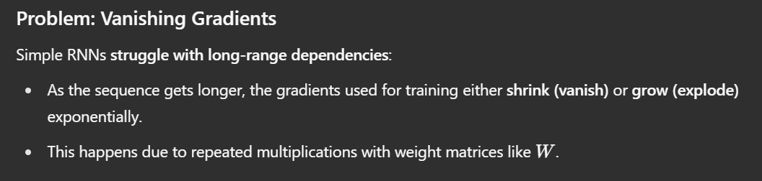

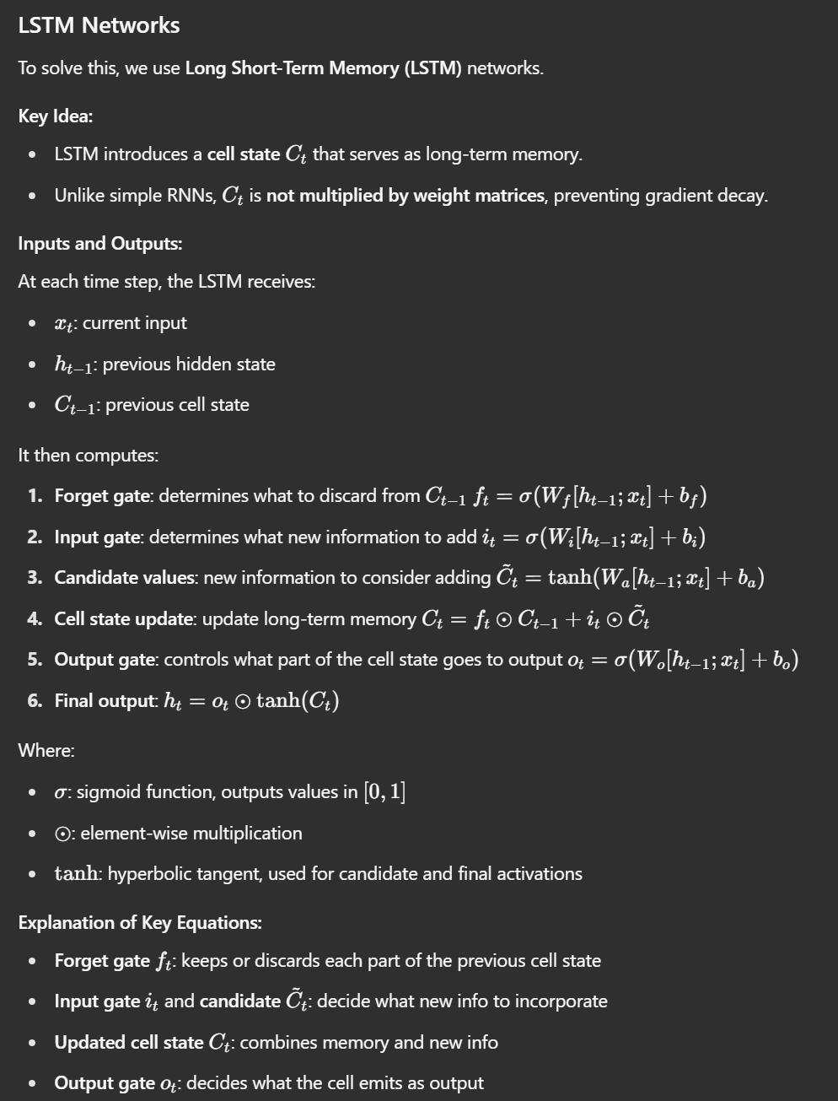 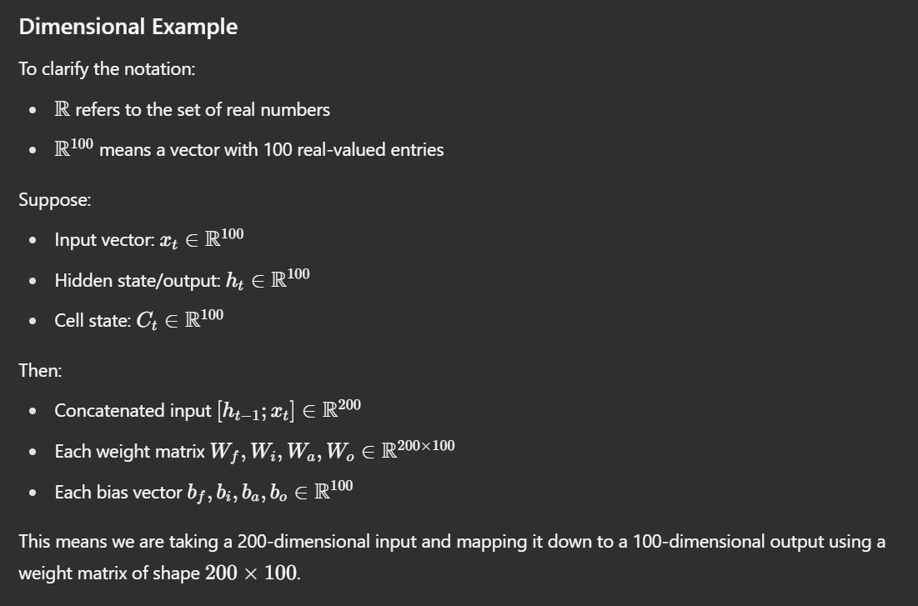

Question 1.

If the Simple Recurrent Neural Network, dim(xt) = dim(ht) = 100, what are the dimensions of:

1. W
2. b

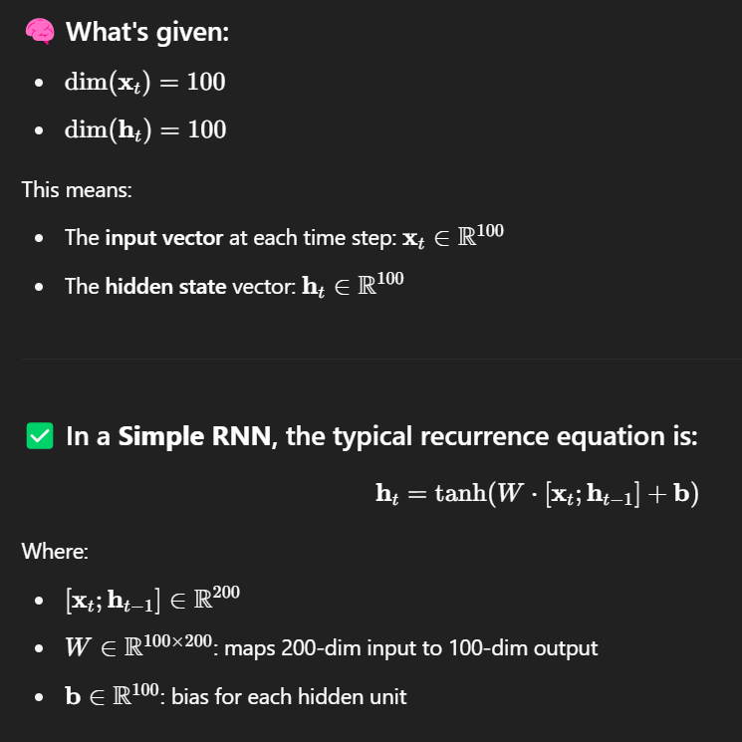

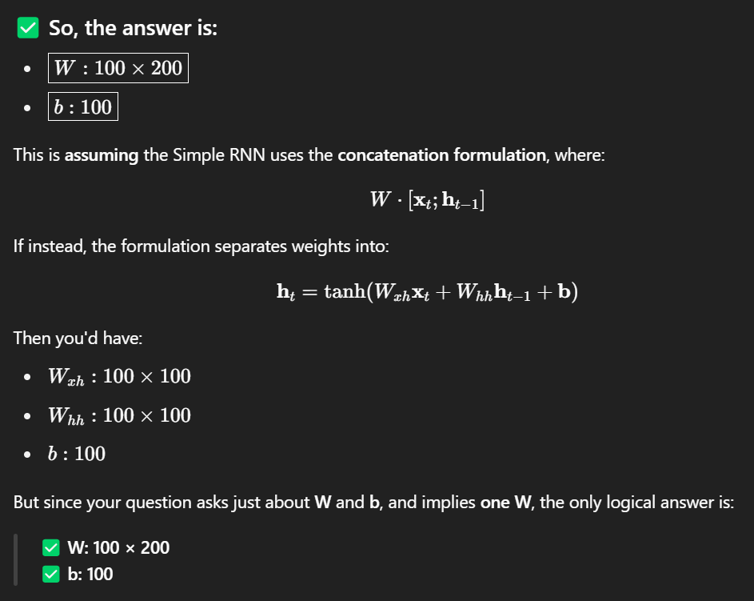

**RNNs and Language Models**

**Why RNNs for Language Models?**

Recurrent Neural Networks (RNNs) propagate information across time steps, making them ideal for language tasks where context from previous words matters. Unlike fixed-size window models (e.g., N-grams), RNNs can, in principle, retain information from arbitrarily far back in the sequence.

* **Goal**: Predict the next word based on context.
* **Input**: Current word vector and contextual information from previous steps.

**Example: Predicting Next Word**

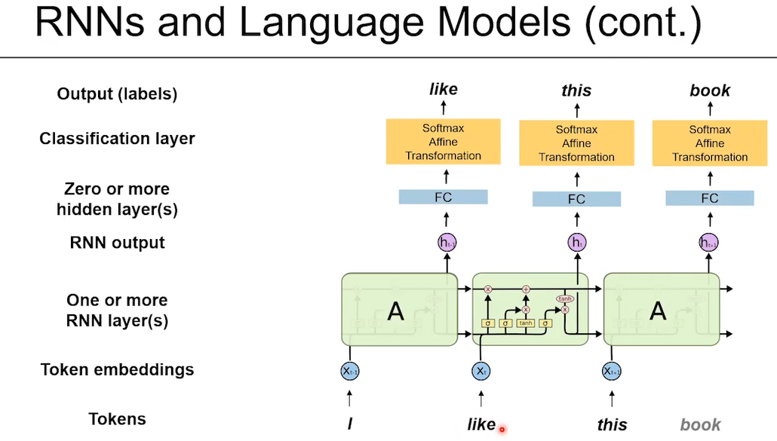

Given input sequence: "I like this"

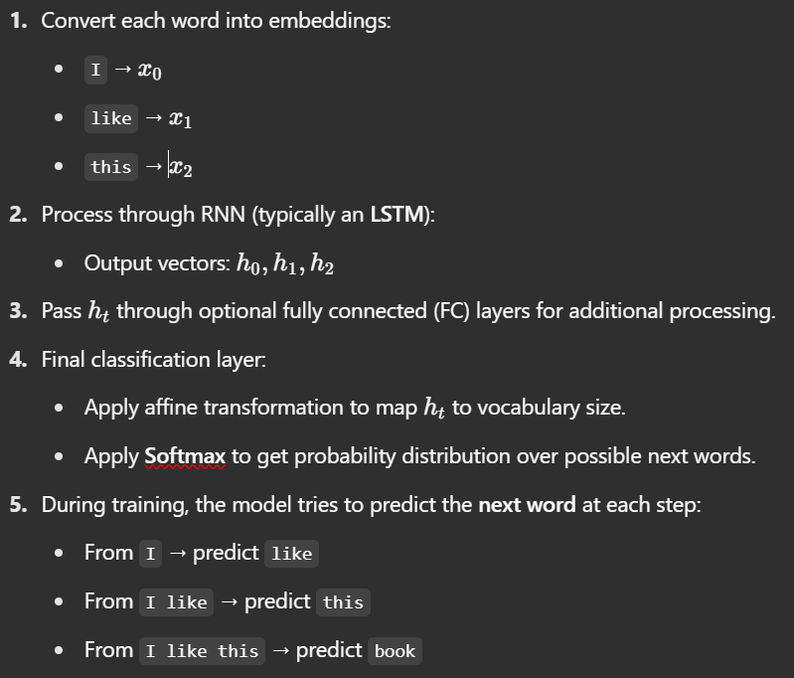

**Teacher Forcing (During Training)**

During training, the true next word is provided as input at each time step, even if the model’s previous prediction was incorrect. This method is called **teacher forcing**.

* At each time step, you **force the correct word** as the input for the next step.
* Even if the model's prediction is incorrect, you still feed the true next word.
* This stabilizes training and accelerates convergence.

**Inference (Generating Text)**

* During inference, you don’t know the next correct word.
* Use the **predicted word** as the input for the next step.

Example flow:

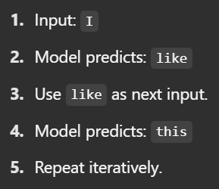

If the model predicts a different word (e.g., that), you continue with that prediction as new input.

**Output Distribution & Sampling**

* The final output is a **probability distribution** over vocabulary tokens.
* Selection methods:
  + **Argmax**: Pick the most probable word.
  + **Sampling**: Randomly select based on probability distribution for diversity.

**Summary**

* RNNs (especially LSTMs) are well-suited for language modeling.
* They can capture long-range dependencies without fixed window constraints.
* **Teacher forcing** is used during training.
* At **inference**, predictions are fed back to generate sequences.
* The output probabilities guide the selection of the next word.

**The Idea of Attention**

**Motivation: Why Attention?**

Recurrent Neural Networks (RNNs) and LSTMs summarize all past information into a single vector (the hidden state). This compression can cause important details to be lost, especially for long sequences. Moreover, RNNs process data sequentially, limiting parallelism.

**Challenges addressed by Attention:**

1. **Long-Range Dependencies**: Information from distant time steps is often forgotten.
2. **Sequential Bottleneck**: RNNs require previous steps to be computed before the next, slowing down training.

**Concept of Attention**

Attention allows the model to dynamically focus on specific parts of the input sequence when making predictions. Instead of relying solely on the final hidden state, attention computes a context vector as a weighted combination of all past hidden states.

**High-Level Illustration**

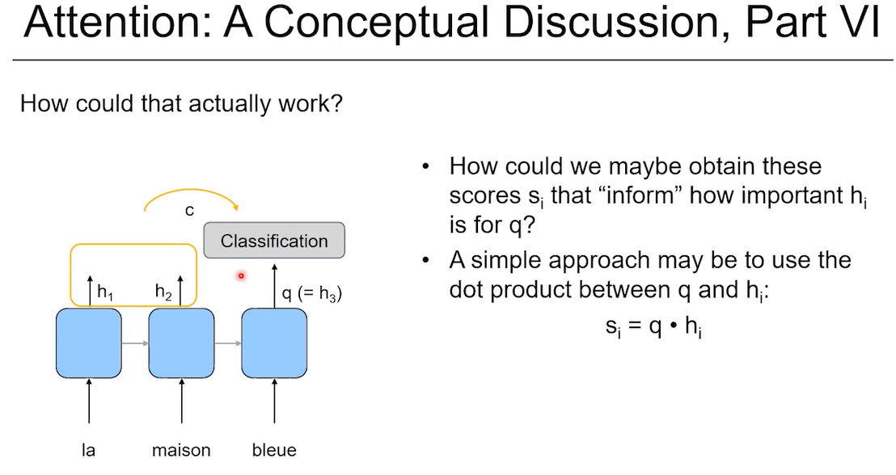

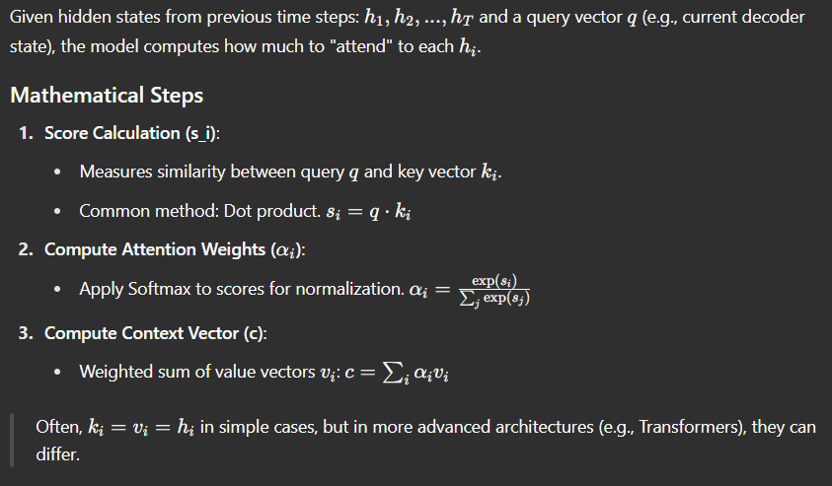

**The Core Attention Idea**

* Can we **communicate context differently**?
* Rather than relying solely on the recurrent structure:
  + Consider the **output vectors h1, h2, h3…**.
  + These outputs contain information about **previous steps**.
* Idea:
  + Ignore internal cell states for now (conceptual).
  + Build a **linear combination** of these output vectors to form a new **context vector c**.
  + c = linear combination of h1 and h2 (in simple example).
* Need **weights (alphas)** to combine h1, h2:
  + Indicate **importance** of h1 or h2 for current task.
  + Alphas should be between **0 and 1**.
  + They should **sum to 1** (convex combination).
* Calculate alphas via **softmax** of **scores s1, s2**:
  + Scores represent importance of h1, h2.
  + Softmax ensures normalization to proper weights.

**Computing the Scores (s values)**

* Scores s1, s2, … need to be **scalars**.
* Compute s values using **dot products**:
  + Take current vector (h3, renamed as **q** for query).
  + Compute s2 = q • h2 (dot product).
  + Compute s1 = q • h1.
  + Dot product satisfies scalar requirement.
  + Dot product represents something like **cosine similarity** scaled by vector norms.
  + Useful for measuring **relation between vectors**.
* This procedure is commonly used, possibly in **modified forms**.

**Visualizing the Attention Process**

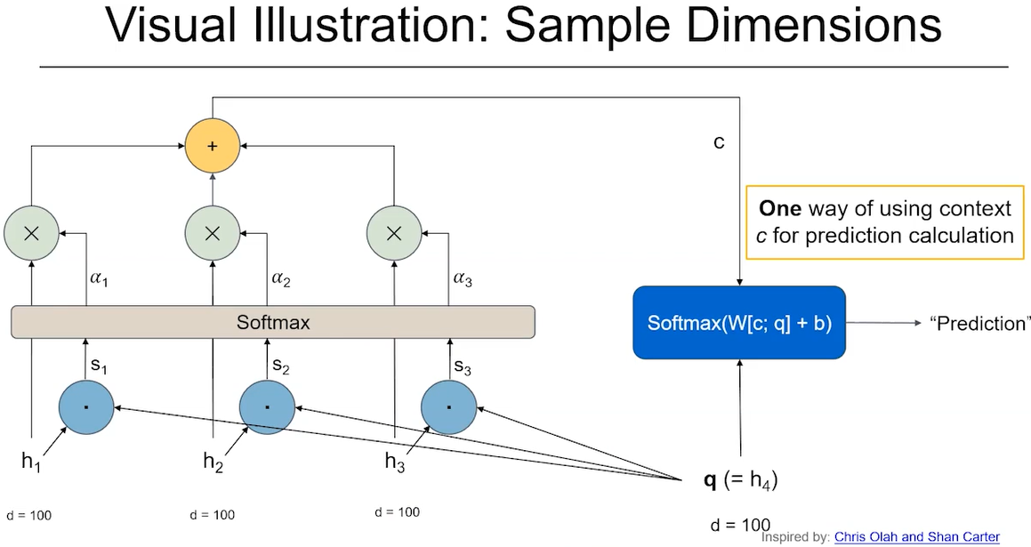

* q is used for some **calculation (classification/prediction)**.
* Past hidden states: h1, h2, h3 represent **contextual history**.
* q asks:
  + "How relevant are you, h3?"
  + "How relevant are you, h2?"
  + q **queries the history** of h vectors.
* Compute dot products: q • h3, q • h2, q • h1 → get scores s1, s2, s3.
* Apply **softmax** to scores → obtain alphas (α1, α2, α3).
  + αi tells how important time step i is for current calculation.
* Multiply h1, h2, h3 by their respective α1, α2, α3.
* Sum weighted vectors → form **context vector c**.
* Example usage:
  + Concatenate q and c.
  + Apply **matrix multiplication**.
  + Use **softmax** for classification.

**Why It’s Called "Attention"**

* The query q asks:
  + **"Where do I need to pay attention to?"**
  + Which previous position is useful?
  + Constructs c accordingly.
* The computed context vector c reflects:
  + Which past information is most **relevant now**.

**Important Note on Dimensions**

* All vectors: assume **100-dimensional** (q, h1, h2, h3, etc.).
* Dot product q • hi → scalar score si.
* Softmax → scalar αi.
* αi * hi → 100-dimensional vector.
* Sum of weighted vectors → context vector c (100-dimensional).
* Concatenating c and q → 200-dimensional vector (if needed).

**General Attention Framework**

* Query vector **q** (e.g., h3 or h4).
* Key vectors **ki** (previous output vectors h1, h2, etc.).
* Attention score computed between q and each ki.
* Attention weights (alphas) derived via softmax.
* Context vector c is computed as a **linear combination of value vectors vi**.
  + In example, vi are just h1, h2, h3.
* Final context vector c is used in further calculations.

**Different Methods to Compute Scores (s values)**

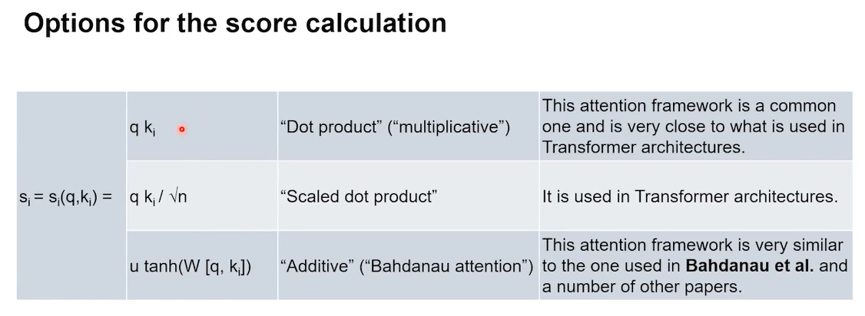

1. **Dot Product (q • ki)**:
   * Simple dot product to get si.
   * Common baseline method.
2. **Scaled Dot Product (q • ki / √n)**:
   * Divide by √n (n = vector dimension).
   * Helps to keep variance under control.
   * Prevents large dot product values from softmax exploding.
   * Used in **transformers**.
3. **Additive Attention (Bahdanau Attention)**:
   * Concatenate q and ki: [q; ki].
   * Multiply by learnable matrix W.
   * Apply tanh activation.
   * Project with learnable vector u to get scalar si.
   * This was the original attention mechanism in NLP papers.
   * More flexible, sometimes called **additive attention**.

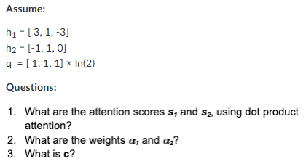

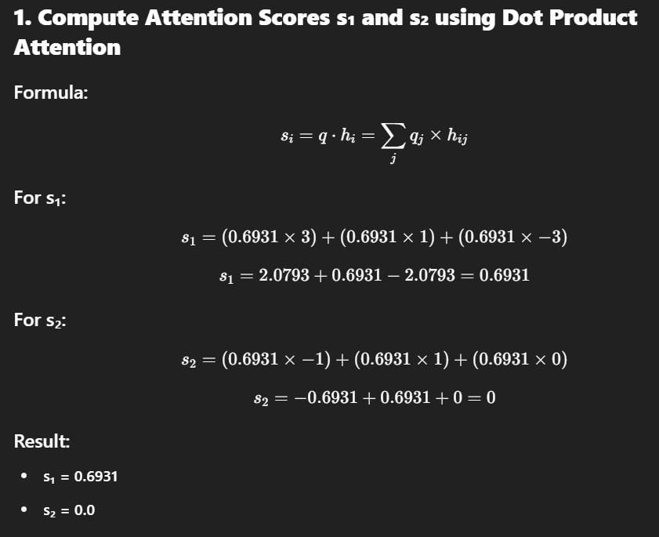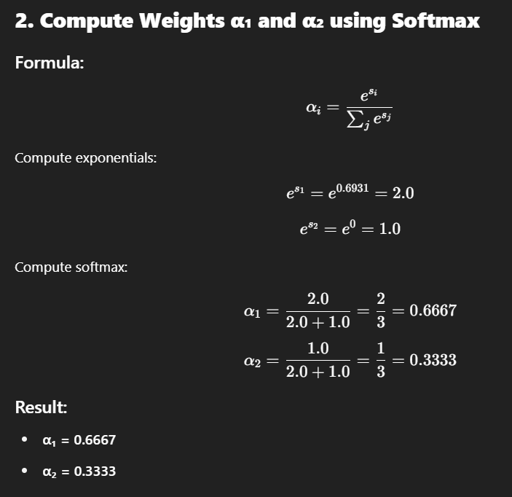

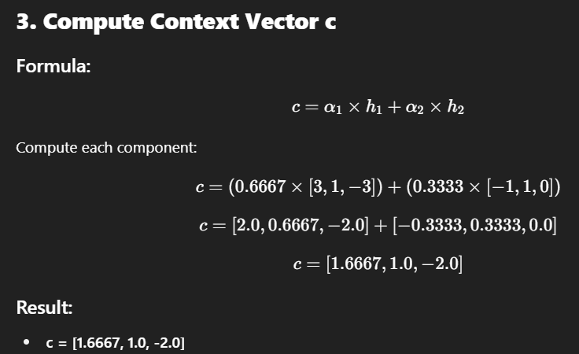

**Context Awareness and Embeddings: Toward Transformer Architectures**

**1. From Attention to Contextual Embeddings**

* After learning about **attention** and **context vectors**, we ask:
  + **Can this help improve word embeddings?**

**2. Recap: Why Embeddings Are Useful**

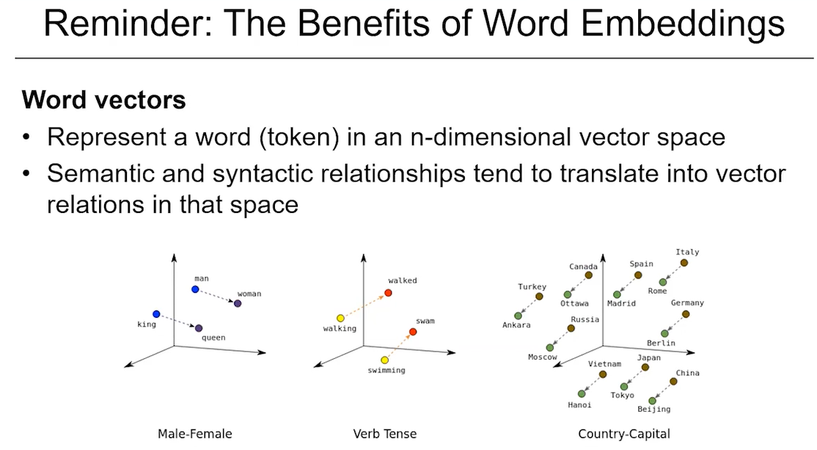

* **Word embeddings**: Represent words as vectors in n-dimensional space.
  + Similar words → similar embeddings.
  + Maintain **semantic & syntactic relationships**.
* Example of analogies:
  + The difference vector between "Turkey" and "Ankara" is similar to "Spain" and "Madrid".
  + Embeddings preserve these relationships to some degree.
* Embeddings enable:
  + **Numeric inputs** for neural nets.
  + **Less sparsity** in input space (words like "sky" and "skies" are similar, so related sentences help inform predictions).

**3. The Problem with Static Embeddings**

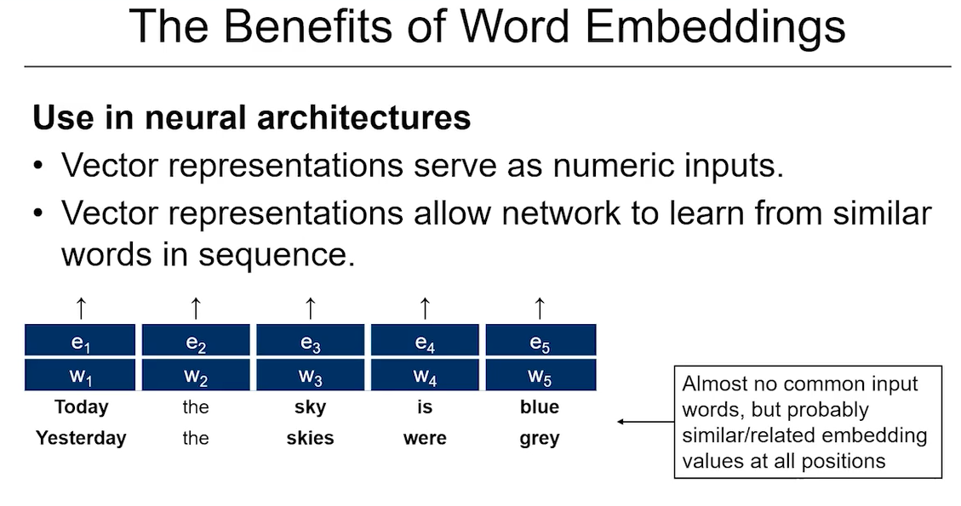

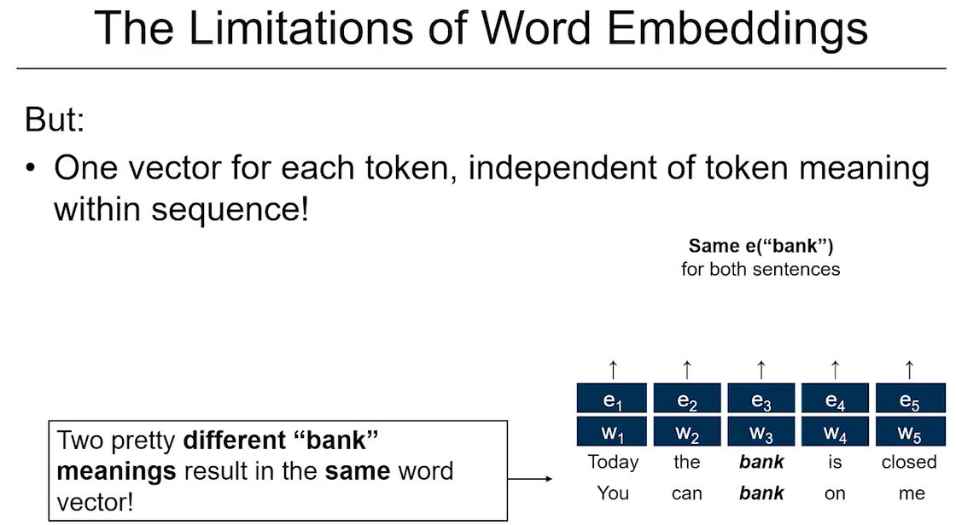

* Static embeddings have a **big limitation**:
  + Example sentences:
    1. "Today, the bank is closed."
    2. "You can bank on me."
  + Same word: **"bank"**.
    1. In sentence 1: refers to a **financial institution** (noun).
    2. In sentence 2: refers to **relying/dependence** (verb).
  + Problem: Only **one embedding vector** for "bank".
  + It’s the **same vector** in both contexts, which doesn’t make sense.
* Clearly, there's a need to differentiate meaning based on **context**.

**4. The Idea: Contextual Embeddings**

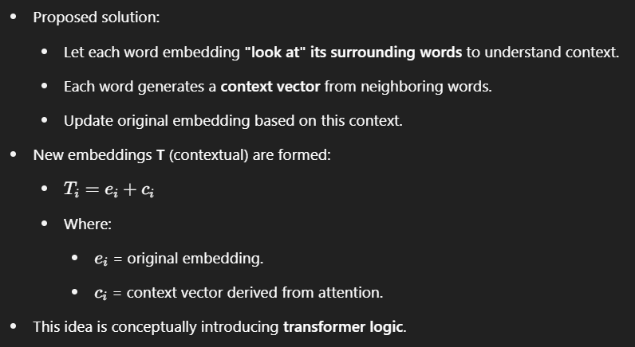

**5. Calculating Context Vector cₖ for Each Word**

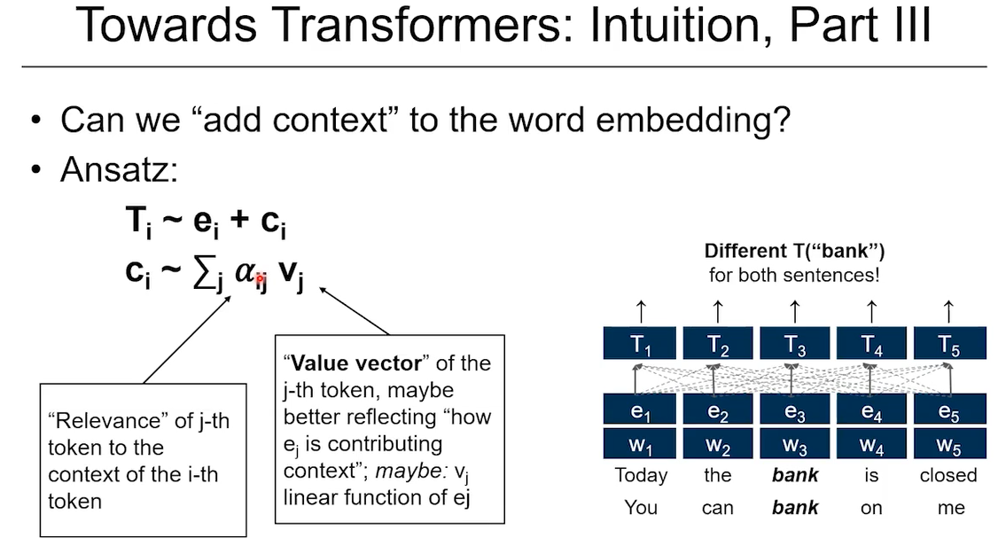

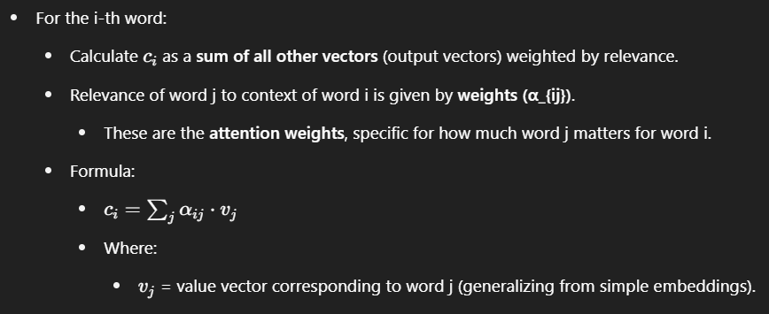

**6. How to Compute α (Attention Weights)**

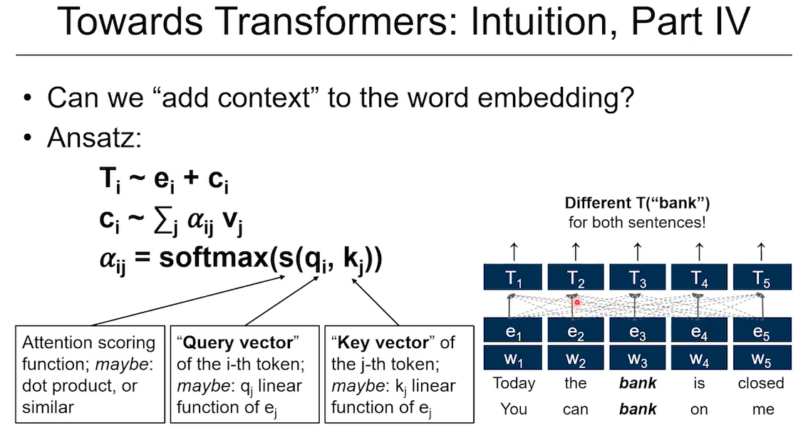

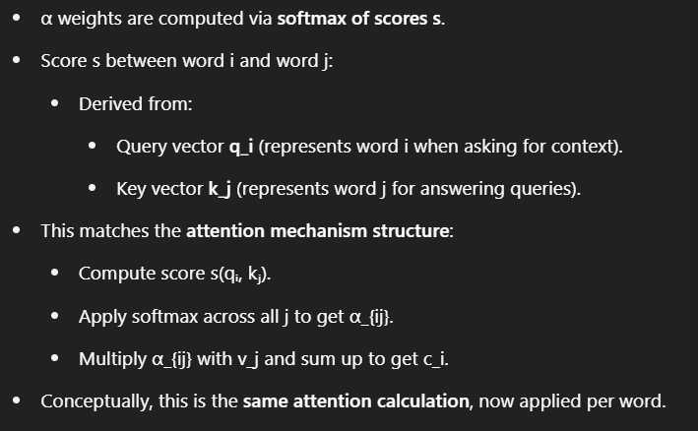

**7. From Static to Contextual Embeddings**

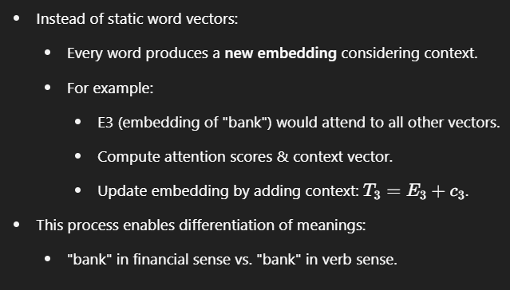

**8. Generalization and Connection to Transformers**

* General idea:
  + Move from **static vectors** to **context-based embeddings**.
  + Attention mechanisms enable dynamic updates based on context.
* Though conceptual here, this thinking leads to the design of **Transformers**.
  + Transformers apply this systematically across all tokens.

**Detailed Notes: Language Models, Attention & The Path to Transformers (Summary & Outlook)**

**1. Recap: Language Models**

* **Language models** provide:
  + The **joint probability** of a token sequence (W₁ to Wₙ) forming a **valid sentence**.
  + Typically trained to predict:
    - Given n-1 tokens (context), predict the **most likely next token**.
* Fits well with **Recurrent Neural Networks (RNNs)**:
  + At each time step t:
    - Input: current word vector.
    - Secondary input: context (from everything said so far, via cell state).
  + Output: vector used for classification/prediction.
* RNNs are **natural architectures** for language modeling.
  + Worked **reasonably well**.

**2. The Role of Attention**

* Attention is introduced as an **alternative way to create context**.
* Unlike RNNs:
  + **RNN context vectors** (cell states) require **sequential computation**.
  + Attention allows:
    - For a given position (current time step), you look at **multiple other positions**.
    - Perform an **attention calculation** to derive context.
  + Attention provides a **parallelizable** and **effective mechanism** to incorporate context.
* Attention is becoming **absolutely critical** in NLP architectures moving forward.

**3. Static Embeddings vs Contextual Embeddings**

* Discussion expanded towards:
  + Moving from **static embeddings** to **context-based embeddings**.
  + Using attention mechanisms to enhance embeddings with contextual information.
* Attention allows:
  + Adjusting word embeddings dynamically based on surrounding words.
  + Addressing issues where static embeddings fail (e.g., polysemy: “bank” example).

**4. Outlook: Transformers & Pre-trained Models**

* Introduction to **Transformer architectures**:
  + Visual reference to a **transformer model diagram** (not elaborated yet).
  + At the bottom of the transformer:
    - Static embeddings are taken as inputs.
    - Processed through multiple layers.
    - Resulting in **contextual embeddings** that carry deep language understanding.
* Core transformer computation involves:
  + **Attention mechanisms** (as previously discussed).
  + Adding context to embeddings → similar to concepts already covered.
  + The “adding” operation mentioned (embedding + context vector) is analogous.

**5. Key Takeaway**

* Much of what has been discussed (language models, attention, contextual embeddings):
  + Forms the **foundation of transformer architectures**.
  + Already conceptually covers **half of what a transformer does**.
  + While not complete yet, these ideas will be **formalized** in upcoming lessons.
* Encouragement to think ahead:
  + This summary bridges existing knowledge to the **transformer models** that will be studied in detail next.

**Summary Table**

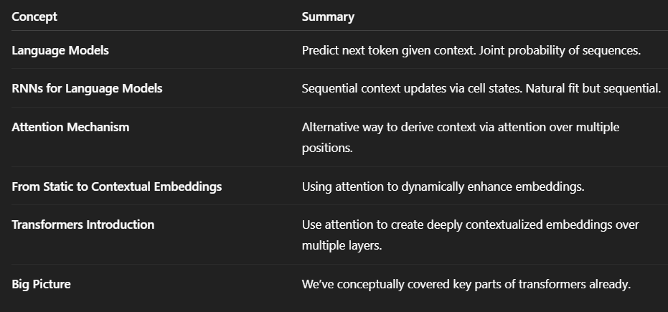

**Why is Attention so Critical in Modeling Context?**

**1. Limitations of RNN-based Context Modeling**

* **Sequential Bottleneck**:
  + RNNs (and LSTMs) build context step-by-step through hidden states.
  + To get context at time step *t*, you must process steps 1 to *t-1* sequentially.
  + **Cannot parallelize** → slow and inefficient, especially for long sequences.
* **Context Compression Problem**:
  + RNNs must compress **all previous information** into a **single vector (cell state)**.
  + As sequences grow longer, it becomes harder to retain information from distant tokens.
  + **Long-term dependencies are lost or diluted**.

**2. Attention: A New Way to Model Context**

* **Direct Access to All Tokens**:
  + For a given position (say, word at time *t*), attention allows **looking at every other token in the sequence directly**.
  + No need to rely on compressed cell states.
* **Flexible Contextualization**:
  + Attention computes **relevance scores** (via softmax) for how important each other token is to the current token.
  + Context is built as a **weighted sum of these relevant tokens**.
  + This is far more **adaptive and precise**.
* **No Sequential Dependency**:
  + Attention can compute context for all tokens **in parallel**.
  + This drastically improves **efficiency and scalability**.

**3. From Static to Contextual Embeddings**

* Traditional word embeddings are **static** (one vector per word).
* Attention allows dynamic, **context-sensitive representations**.
  + Example: "bank" in "river bank" vs "financial bank".
  + Attention-based models can **differentiate meanings** based on surrounding words.

**4. Foundation of Modern NLP Models**

* Attention mechanisms are the **core component of Transformers**.
  + Self-attention layers compute rich context across tokens.
  + Multiple attention layers refine contextual understanding.
* Pre-trained transformer models (like BERT, GPT) rely on attention for:
  + **Understanding sentence meaning**.
  + **Handling long-range dependencies**.
  + **Building contextualized word embeddings**.

**In Short:**

**Attention is critical because it enables models to build precise, flexible, and parallelizable context representations, overcoming the bottlenecks and limitations of RNNs, and making contextual word understanding possible.**

**Introduction to Pretrained Transformers**

**Recap from Last Week**

* The previous session focused on **language models** and **recurrent neural networks (RNNs)**.
* It explained how RNNs use **cell states** to maintain context across sequences.
* Introduced the concept of **attention**, specifically how **attention calculations** can be used to compute a **context vector** for each input.
* Discussed a high-level intuition about how **static word embeddings** might be improved using **attention mechanisms**, potentially transforming them into **context-sensitive embeddings**.

**Problem with Static Embeddings**

An example is provided to illustrate the limitations of static embeddings:

1. **Sentences:**
   * "Today, the bank is closed."
   * "You can bank on me."
   * "You can count on me."
2. **Issues Identified:**
   * The word **"bank"** appears in two contexts: as a **noun** (financial institution) and as a **verb** (to rely).
   * In static word embeddings, **"bank"** would have **the same vector representation** in both sentences, despite the different meanings.
   * Words like **"count"** and **"bank"** (in the sense of relying) share similar meanings in context but would be represented by **different vectors**.

**Key Questions and Goals**

* Can we **design architectures** that understand and handle these contextual differences effectively?
* How can we **train such architectures** using **large volumes of unlabeled text**?
* The goal is to build models that:
  + Understand **contextual meaning** of words.
  + Produce **context-based embeddings** rather than static ones.
  + Can be **pretrained** on massive datasets to learn rich representations of language.

**Purpose and Vision**

* These context-aware embeddings should be **practically useful**, not just semantically pleasing.
* If successful, such **pretrained models** could act as a **base architecture**.
* By adding a **simple neural network layer** on top, we could tackle a variety of **language processing tasks**, possibly achieving or surpassing **state-of-the-art results**.

**High-Level Transformer Structure**

**Recap of Previous Intuition**

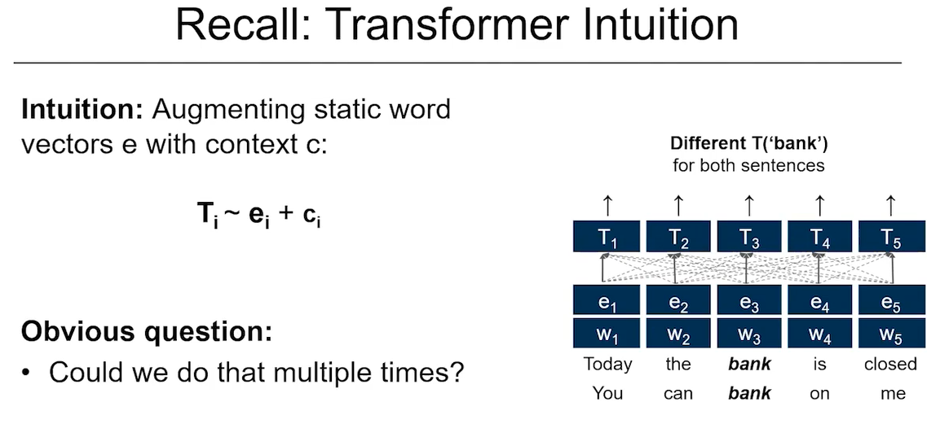

* Previously, we explored how to convert static embeddings (**e**) into context-sensitive ones (**T**) by incorporating information (**context c**) from the surrounding words.
* Example: The word **“bank”** would end up with **different final embeddings** depending on whether it appears in *"the bank is closed"* or *"you can bank on me"*.

**Key Question Raised**

* **Is this transformation done in one step?**
  + **No.** The process is handled **layer-by-layer** using the **transformer architecture**, which allows for progressive refinement of word representations.

**Transformer Architecture: Layered Structure**

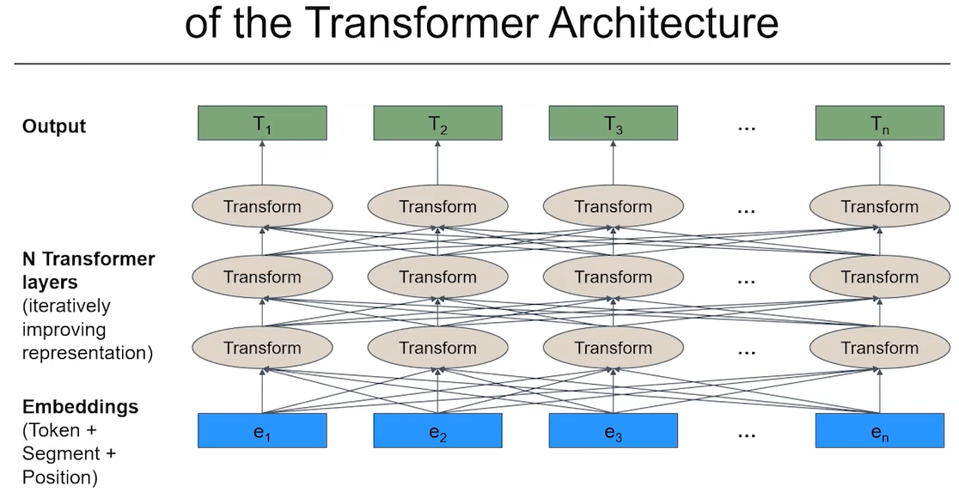

* Starts with **static token embeddings**.
* Then processes these through **multiple transformer layers**, each of which applies an **attention mechanism** to update word representations.

**In Each Transformer Layer:**

1. **Input** = all word vectors from the previous layer.
2. Each word is updated based on **attention-based calculations** that:
   * Look at **all other words** in the sentence (not just nearby ones).
   * Determine **how relevant** each of those other words is to the current word.
   * Use this relevance to **weigh and combine** information from other words into the current word’s new embedding.

**💡 What Are Attention-Based Calculations (in Simple Terms)?**

* **Attention** lets each word decide **how much to “pay attention” to every other word** in the sentence when updating its meaning.
* It calculates **relevance scores** between each pair of words (via dot products, scaled, then softmaxed).
* Each word’s new vector becomes a **weighted sum** of all the other word vectors, where weights reflect how important those words are to the current word’s meaning.
* This allows the model to:
  + Capture **long-range dependencies** (even if words are far apart),
  + Dynamically adjust meaning based on **context**.

**Final Representation**

* Each transformer layer outputs an updated embedding for each word.
* These are fed into the next layer, and the process continues—often through **many layers**.
* After the final layer, we get **T₁ through Tₙ**, a fully context-aware embedding for every word in the sequence.

**\*\* Multiheaded Self-Attention**

**Key Concepts Introduced**

**1. Self-Attention: Core Mechanism**

* **Self-attention** allows each word in an input sequence to **"attend to" every other word**, including itself.
* It computes a **contextual representation** of each word based on its **relationship to all other words**.

**2. From Embeddings to Attention Vectors**

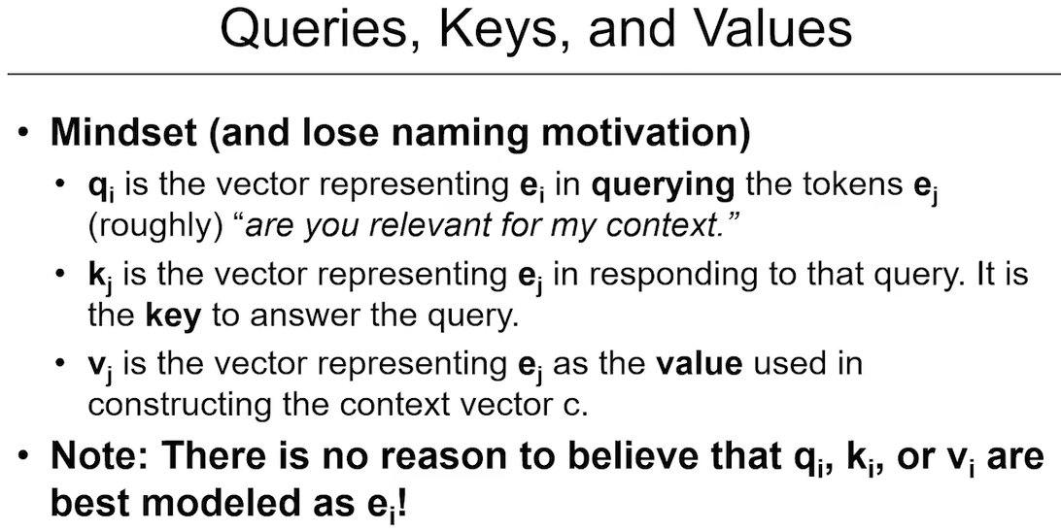

* We start with **embedding vectors** for each token (denoted as **e**).
* Instead of using embeddings directly in attention calculations, each input vector **eᵢ** is **transformed** into:
  + **Query vector (qᵢ):** Used to ask "How relevant are other tokens to me?"
  + **Key vector (kⱼ):** Used to answer the query—“Am I relevant to you?”
  + **Value vector (vⱼ):** The actual content passed if relevance is high.
* These vectors are **not arbitrary** but are learned as **linear projections** of the input embedding:

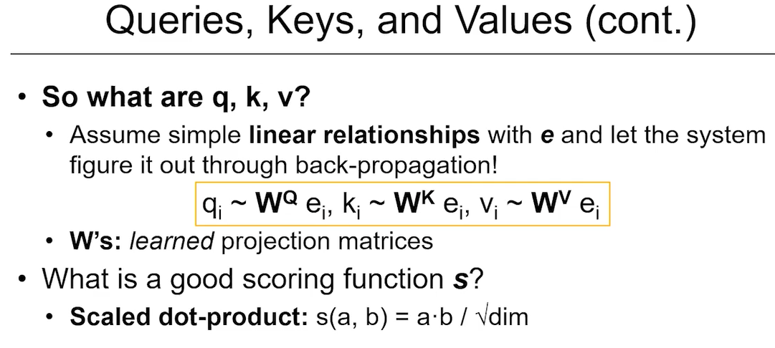

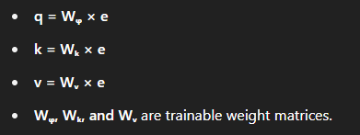

**3. Scoring & Attention Weights**

* To determine how much one word should attend to another:
  + Compute a **dot product** between **qᵢ** and each **kⱼ** → gives a **score**.
  + Normalize scores using **softmax** → gives **attention weights (α)**.
  + These weights tell us **how much importance** to place on each other word.
* Then, compute the **context vector** by:
  + Taking a **weighted sum** of the **vⱼ** vectors (using the softmax weights).
  + This result becomes the **new context-aware vector** for token i.

***Note:* The dot product is often scaled by √d (where d = dimension of q/k) to maintain numerical stability.**

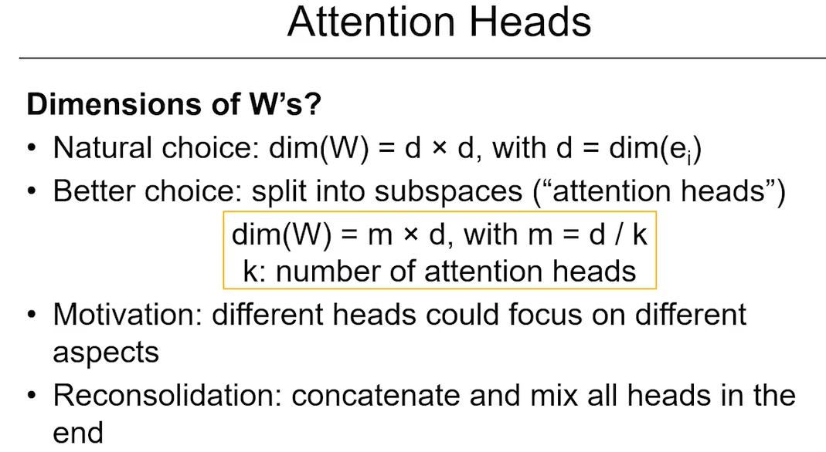

**Step-by-Step Example (Simplified)**

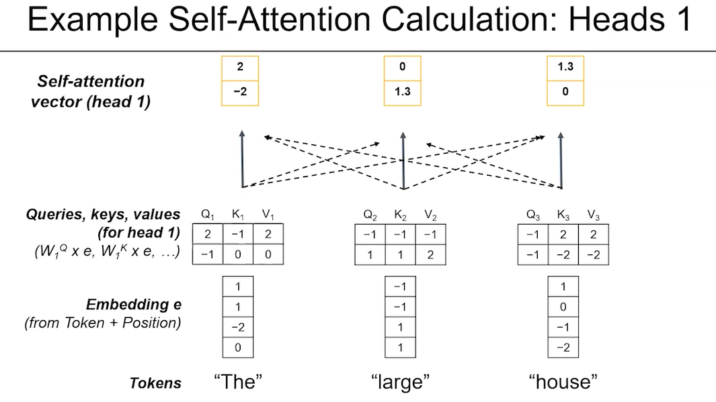

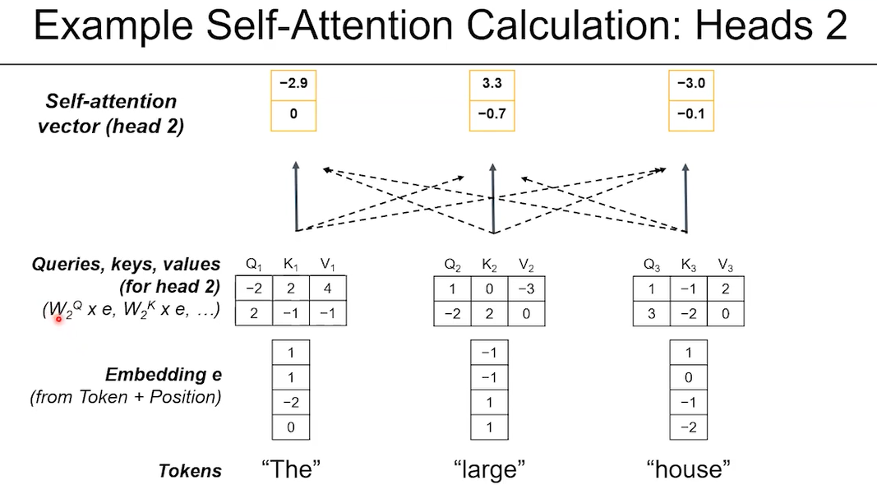

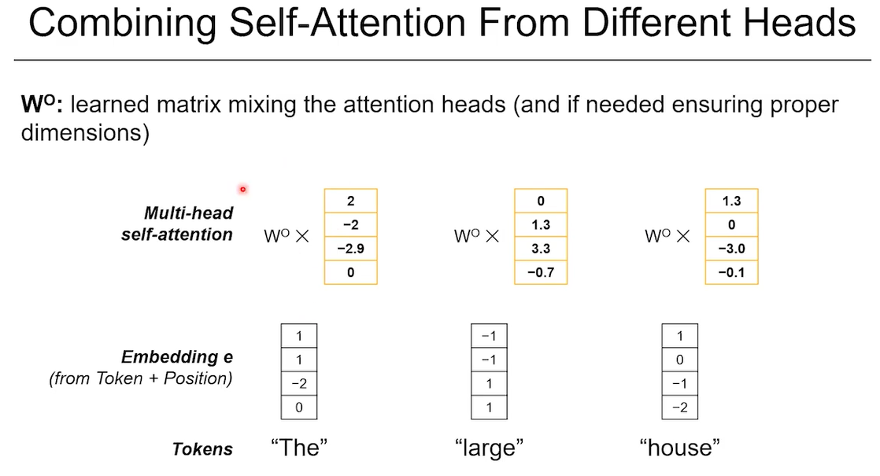

**Example: Input = "The large house"**

* Embedding dimension (**d**) = 4
* Number of attention heads = 2

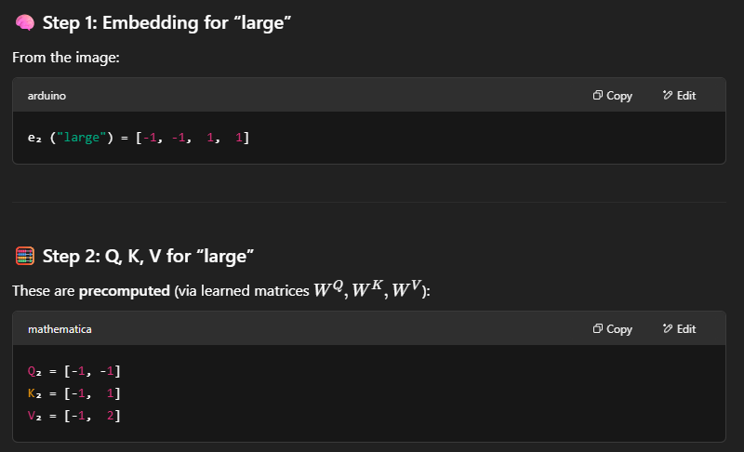

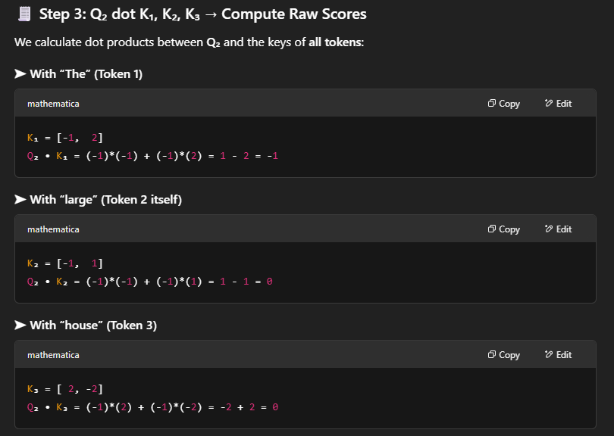

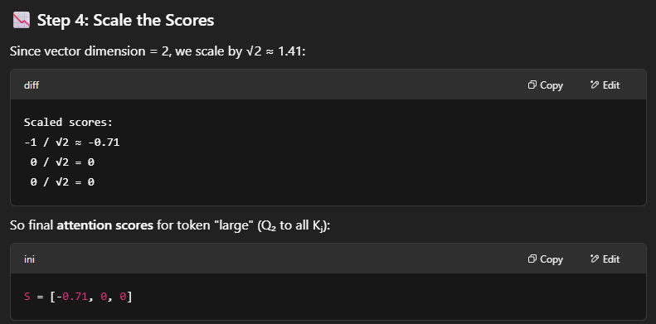

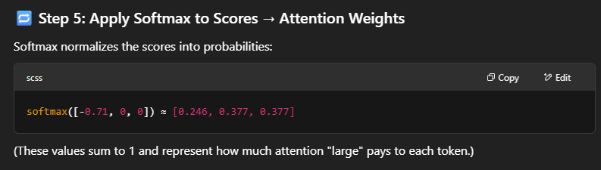

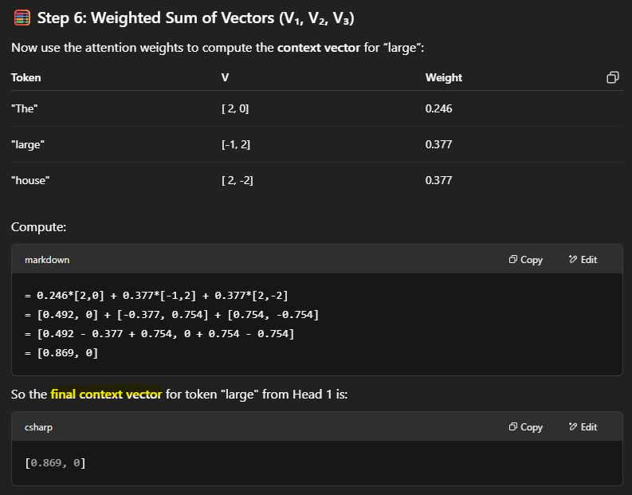

**Now for Head 2**

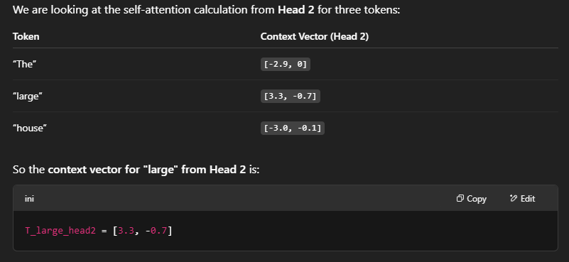

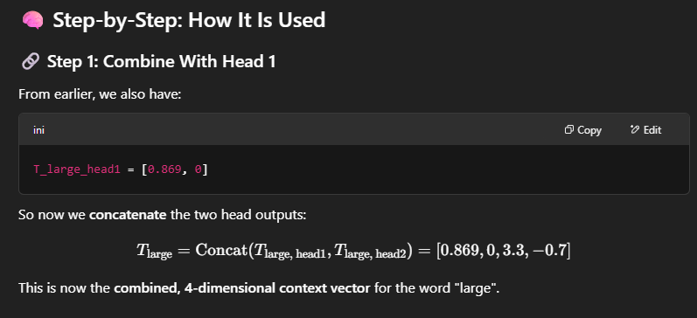

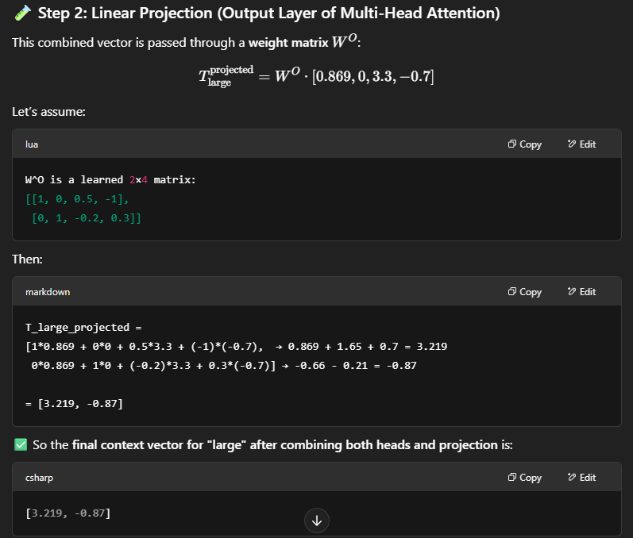

**Now combine both heads**

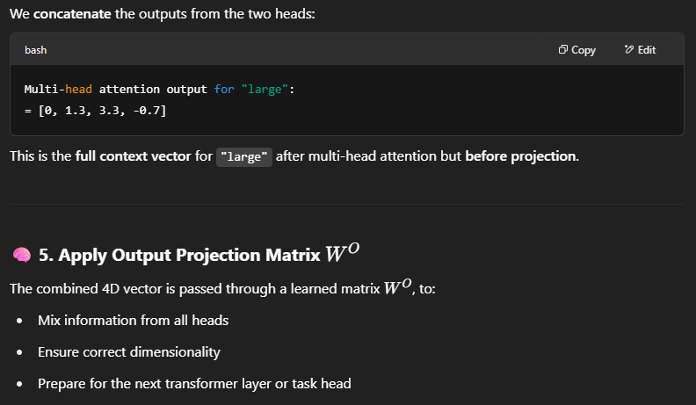

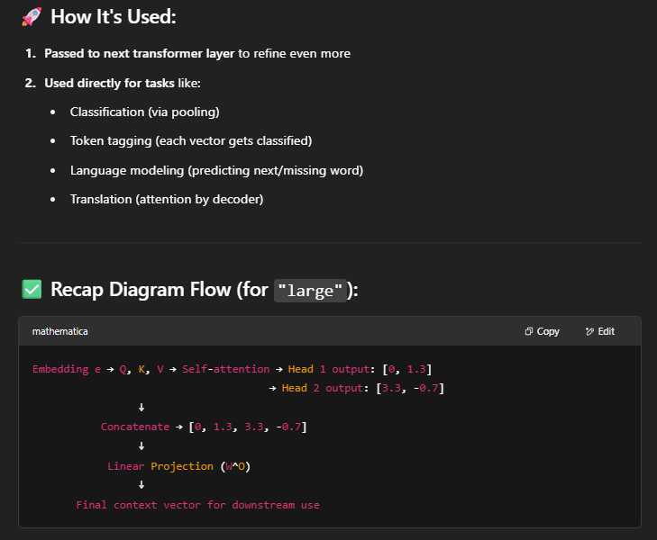

**Now imagine we want the model to classify whether each word is a noun, adjective, or verb.**

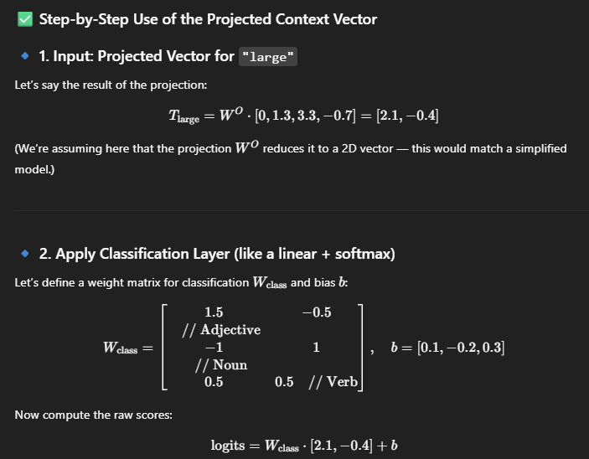

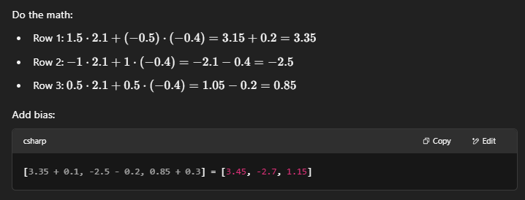

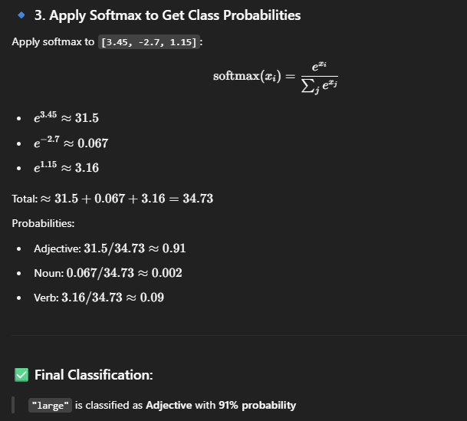

**Dimensionality & Heads**

* Embedding dimension (d) is often **split across heads**.
  + Example: if d = 512 and there are 8 heads → each head works on sub-dimensions of 64.
* Each head has its own **WQ, WK, WV**, enabling it to **specialize** in different aspects of context.

**Why Multi-Head Attention?**

* Similar to how **convolutional filters** in CNNs learn different features, each **attention head** can focus on a different **linguistic or syntactic relationship**.
* This allows the model to **capture richer information** about word relationships.

**Final Output of Self-Attention**

* For each token:
  + Multiple context vectors (one from each head) are **concatenated**.
  + Then passed through a **final linear layer (projection)**.
  + The result is a **single context-enriched vector per token**, ready to be passed to the next layer of the transformer.

Question

If dim(e) = d = 768 and you want to work with k = 12 heads, what are the (natural) dimensions of the Ws?

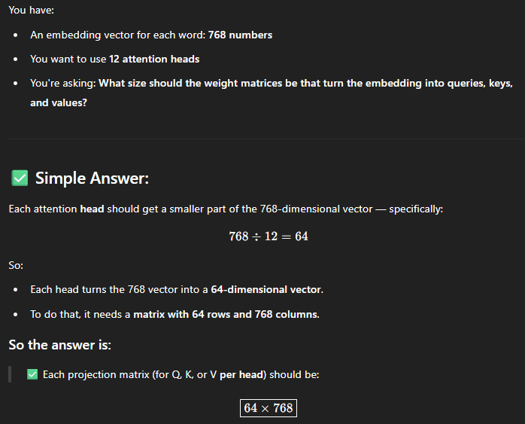

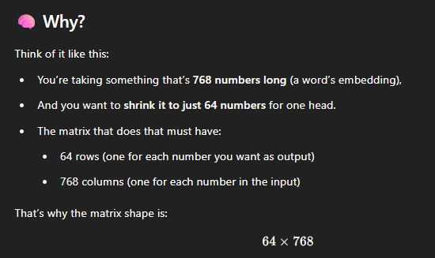

**Queston 2**

What is the run time of the self-attention calculation in O(n) notation, where n is the number of input tokens?

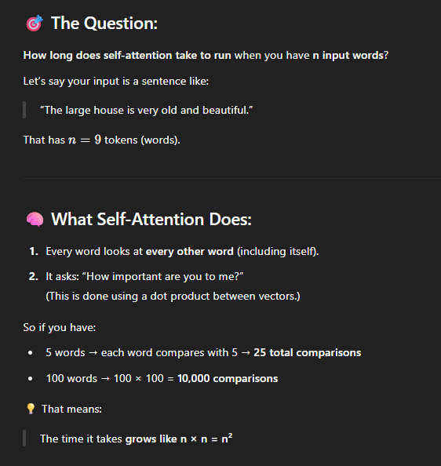

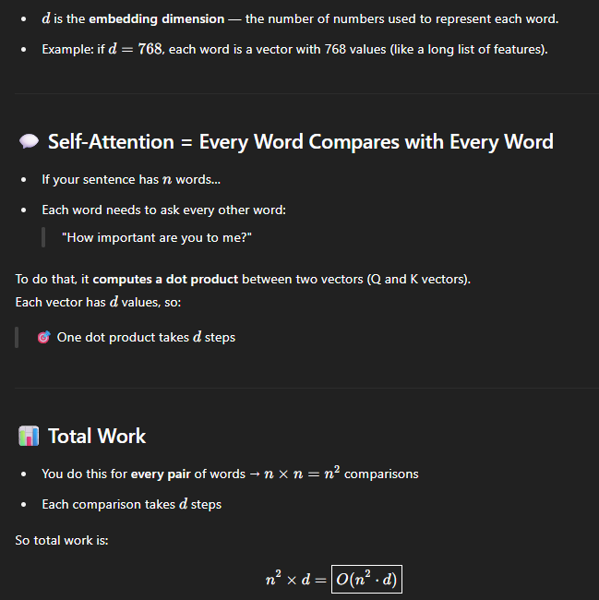

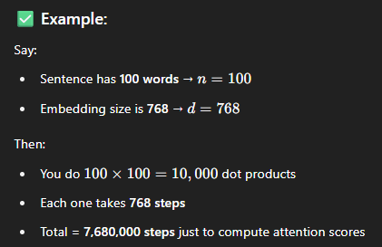

**The Transformer Architecture**

**Embeddings and Contextualization**

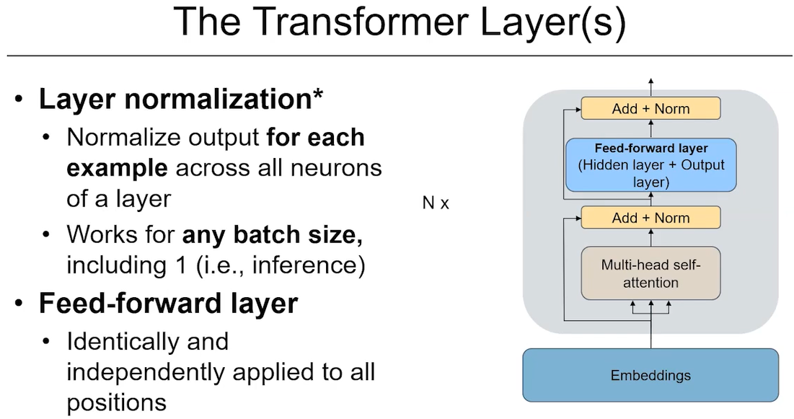

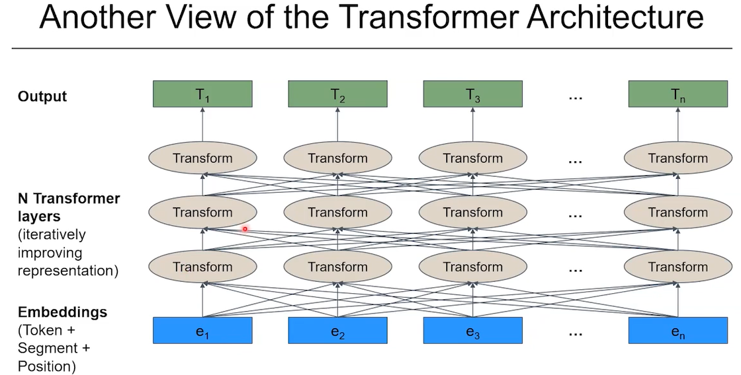

The Transformer architecture begins with input embeddings, which represent tokens as dense vectors. To enhance these embeddings with contextual meaning, the model applies **multi-head self-attention**, which lets each token attend to every other token in the input.

The output of this attention mechanism is called the **context vector**, which is then **added to the original embedding**. This operation mirrors the original intuition discussed earlier in the course:

E=e+c

where:

* e is the static embedding
* c is the learned context from self-attention
* E is the updated, context-enhanced embedding

This addition ensures that tokens now reflect not only their own meaning but also the influence of surrounding tokens.

**Add and Layer Normalization**

After the addition, the result undergoes **layer normalization**, which ensures that the values in the vector are scaled in a stable way. Layer normalization:

* Normalizes each example independently
* Applies across all features in the token vector
* Works for any batch size, including 1 (especially useful at inference time)

The purpose is to stabilize training and speed up convergence by avoiding internal covariate shift.

**Feedforward Layer**

The next component is a **feedforward network (FFN)**, consisting of:

* A hidden linear layer
* A nonlinearity (like ReLU or GELU)
* An output linear layer

This feedforward sublayer is applied **independently to each token** — the same network is used at every position. Its role is to enrich the token representations through nonlinear transformation.

The output of the feedforward layer is again passed through:

1. A **residual connection** (added to its input)
2. A second **layer normalization**

This completes one **Transformer sublayer**.

**Stacking Transformer Layers**

A typical Transformer model **stacks multiple identical layers** (often 12, 24, or more) to refine the token representations progressively. Each layer improves the context-awareness of each token. The stack allows for hierarchical and deep abstraction — much like layers in a CNN.

**Positional Encoding**

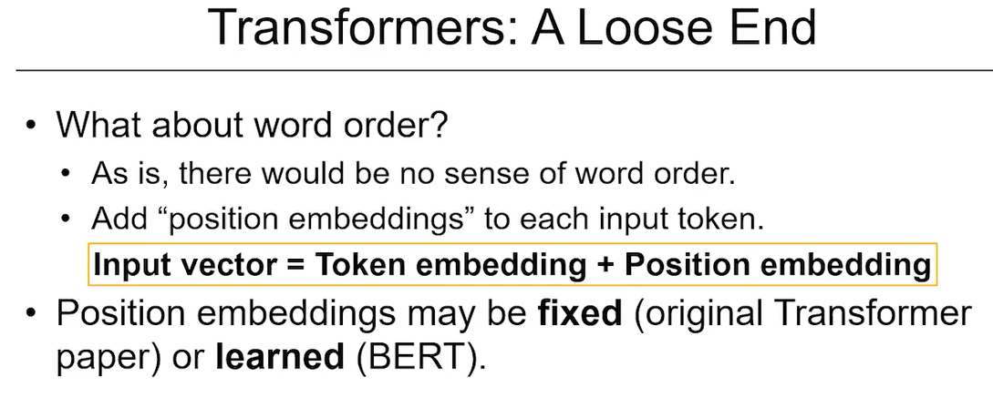

Self-attention treats input tokens as a bag of words — it has **no built-in sense of word order**. To fix this, **positional encodings** are added to the token embeddings before entering the Transformer.

Each position has a unique vector that gets added to the token’s vector. There are two common types:

* **Fixed sinusoidal encodings** (used in the original Transformer paper)
* **Learned positional encodings** (used in BERT and GPT)

The final input vector to the first Transformer layer is the sum of:

Token embedding+Position embedding+(Optional: Segment embedding)\text{Token embedding} + \text{Position embedding} + \text{(Optional: Segment embedding)}Token embedding+Position embedding+(Optional: Segment embedding)

**Benefits Over RNNs**

Transformers were a major advance over RNNs for two key reasons:

1. **Parallelization**:  
   RNNs process input sequentially (token 1 → 2 → 3), making training slow.  
   Transformers let every token attend to every other token **simultaneously**, enabling **full parallelism**. This makes training much faster on GPUs/TPUs.
2. **Long-range dependency modeling**:  
   RNNs struggle to remember information from distant tokens due to the vanishing gradient problem.  
   In contrast, **self-attention has direct access to all tokens**, even those 100+ positions away. Each token directly interacts with all others via attention.

These two factors enable Transformer models to scale and generalize better to complex language tasks.

**Empirical Impact**

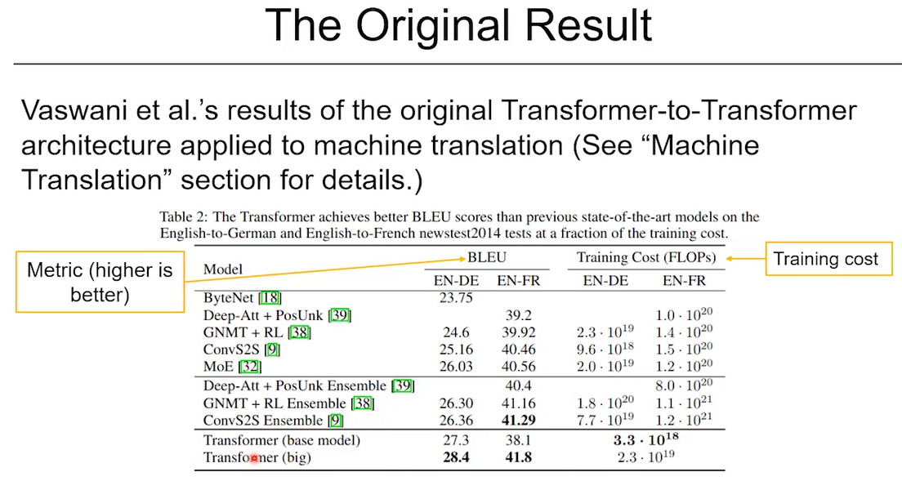

The original Transformer model (from the 2017 paper *Attention is All You Need*) was evaluated on **machine translation tasks** and showed:

* **Higher BLEU scores** than prior state-of-the-art RNN models
* **Drastically lower training cost** (e.g., 50× fewer FLOPs in some experiments)

This efficiency meant that models could be trained on far more data, leading to:

* Better generalization
* Faster experimentation cycles
* A new wave of large-scale language models

**Final Architecture Overview**

The full Transformer architecture can be summarized as:

1. **Input Embedding**  
   Sum of: token embedding + positional encoding (and possibly segment embedding)
2. **Transformer Block** (repeated NNN times):
   * Multi-head self-attention
   * Add + LayerNorm
   * Feedforward layer
   * Add + LayerNorm
3. **Output**:  
   Final context-enhanced token representations, used for:
   * Classification
   * Sequence prediction
   * Translation
   * Question answering, etc.

**The Transformer Architecture** **Language Models: GPT**

**1. Introduction: Using Transformers Beyond Translation**

Although transformers were originally introduced for **machine translation**, the script shifts the focus to **language modeling**—a more foundational task in NLP that’s easier to examine in detail.

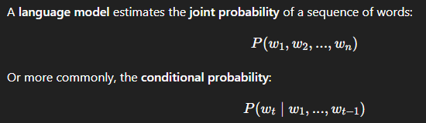

i.e., given a context, what's the probability of the next word?

Earlier models like **RNNs** handled this by passing hidden states forward through time, but they struggled with:

* **Long-range dependencies**
* **Sequential processing**, which slowed training

Transformers solve these issues, but standard transformers **attend to all tokens**, including future ones. That’s not allowed in language modeling, where you can only use the **past context**.

**2. Causal (Masked) Self-Attention: No Peeking Ahead**

To use transformers as language models, we need to modify the attention mechanism so it doesn’t "peek ahead."

This leads to the **decoder-only transformer architecture** (as used in GPT). In this setup:

* At each time step ttt, the model only attends to positions ≤ t
* This is enforced by a **causal mask** (usually a triangular mask applied during attention computation)

For example, if the input is "The large house", the self-attention for "large" must only look at "The" and not "house".

**3. Architecture of GPT**

The original GPT model (from 2018, by Radford et al.) consists of:

* **Input**: Token embeddings + position embeddings
* **Multiple Transformer layers** (12 in GPT-1)
  + Each with masked multi-head self-attention
  + Followed by Add & Norm
  + Followed by Feedforward layers + Add & Norm
* **Output**: For each position, a contextualized vector T_1, T_2, ..., T_n

These output vectors can be:

* Used to **predict the next token** (language modeling)
* Used for **classification** or other **downstream tasks**, by attaching simple heads on top

The training objective is standard language modeling (e.g., minimizing **cross-entropy** between predicted and true next words).

**GPT for Language Modeling: How It Works**

The GPT (Generative Pre-trained Transformer) architecture adapts the transformer model for the **language modeling task**, where the goal is to predict the next word given all previous words in a sentence. This is achieved using a **left-to-right (causal) transformer** — also known as a **decoder-only transformer**.

**Architecture Overview (as shown in the diagram)**

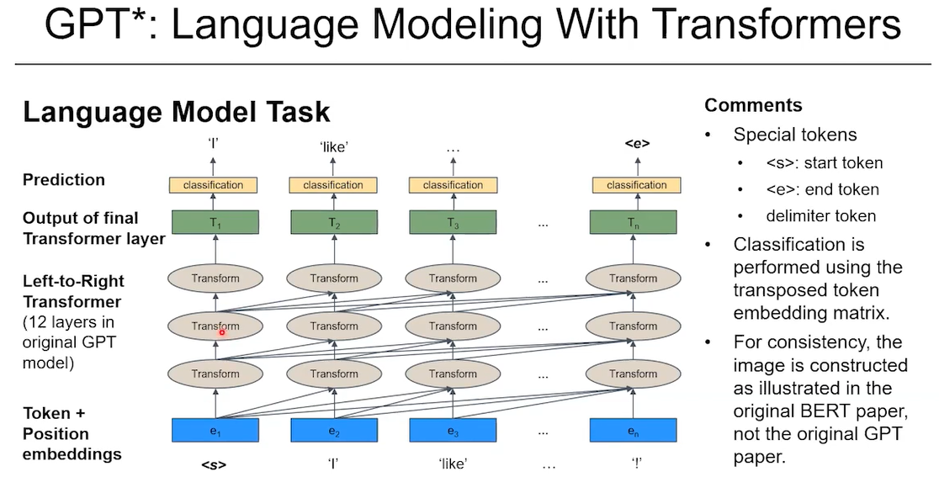

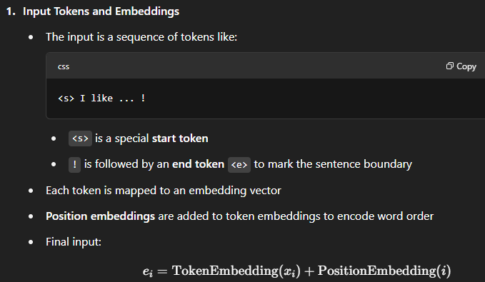

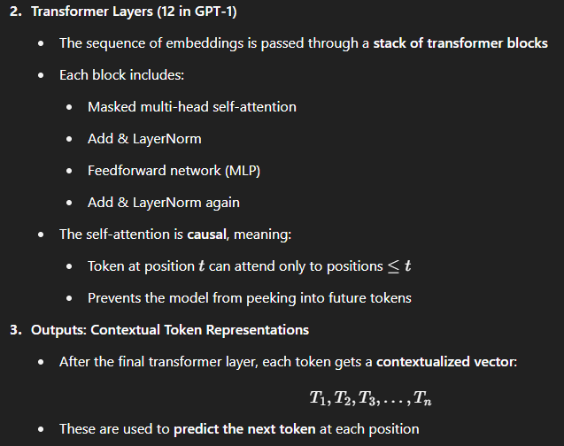

**Next-Token Prediction via Classification**

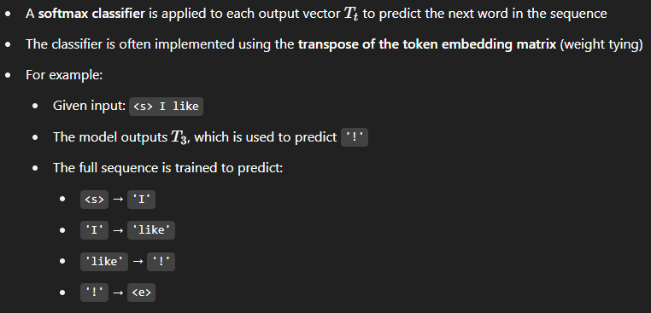

**Special Tokens and Practical Usage**

* **<s>**: Start token used to initiate generation
* **<e>**: End token that signals the model to stop generating
* These tokens are especially useful when GPT is used in **generation mode** (e.g., chatbots, completion)

**Training and Generalization**

* GPT is trained on massive corpora using this language modeling objective
* After pretraining, the model:
  + Understands syntax and grammar
  + Learns world knowledge implicitly
  + Can be fine-tuned for various **downstream tasks** (classification, QA, summarization, etc.)

**4. Pretraining and Transfer Learning**

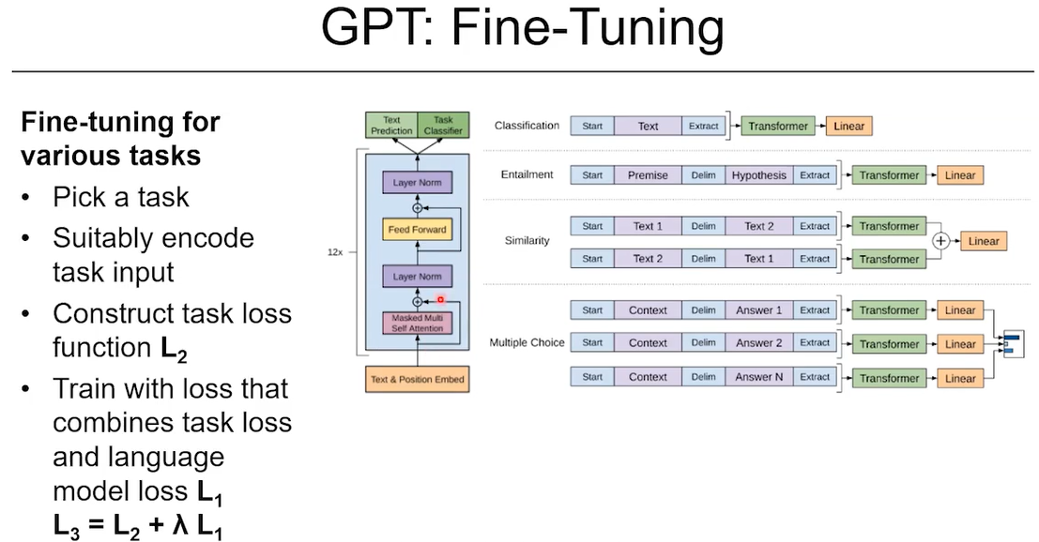

The power of GPT (and modern LLMs) comes from **pretraining + fine-tuning**:

* **Pretraining**: Train the model on vast amounts of raw text using language modeling
* **Fine-tuning**: Add a simple task-specific head (e.g., classification, QA) and fine-tune on a small dataset

For instance:

* Use the final vector T_n​ from the last layer as a representation of the entire input
* Attach a classification head (like a softmax layer) on top
* Fine-tune it on a labeled task like sentiment analysis, natural language inference, etc.

This results in **strong performance even on tasks with small labeled datasets**.

**5. Evaluation and Results**

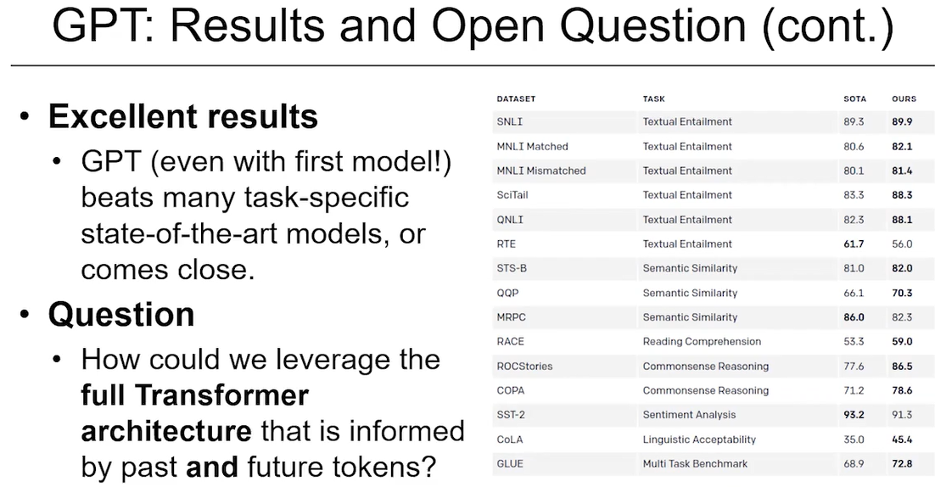

The GPT paper showed that:

* This approach significantly outperformed traditional methods on various NLP benchmarks
* Metrics like **perplexity** (for language modeling) and accuracy (for downstream tasks) improved
* The model was competitive or superior to task-specific architectures, despite using a **single pretrained model** with minimal task-specific layers

Tasks covered included:

* Text classification
* Sentence similarity
* Natural language inference
* Multiple-choice QA

Although the results are now outdated (GPT-2, GPT-3, GPT-4 have advanced far beyond), the original GPT set the stage for the **pretrain-on-unlabeled-text, fine-tune-for-task** paradigm.

**6. Why It Works So Well**

* **Transformer's self-attention** allows every word to interact with every previous word, enabling better long-term understanding
* **Masking prevents cheating**, ensuring that prediction of token ttt depends only on tokens ≤t\leq t≤t
* **Parallel training**: Unlike RNNs, Transformers can process multiple positions at once during training
* **Massive scale**: Training on large text corpora gives the model a wide understanding of grammar, facts, and world knowledge
* **Flexibility**: The same pretrained model can be adapted to many tasks with just a small amount of labeled data

**7. Decoder-Only Model vs Full Transformer**

The script notes that GPT uses only the **decoder half** of the original transformer. In contrast:

* The **original Transformer for translation** had both an **encoder** (which read the input sentence) and a **decoder** (which generated the translation)
* GPT discards the encoder and uses just the decoder, with masked self-attention

The script ends by posing a natural question:

“Could we do even better if we allowed tokens to also attend to **future** words, as well as past ones?”

That sets up the motivation for **bidirectional models like BERT**, which will be discussed next.

**Transformers and Masked Language Models: BERT**

**What is BERT?**

BERT stands for **Bidirectional Encoder Representations from Transformers**. It's a transformer-based language model developed by Google that **learns language representations by looking at the full context of a sentence**, i.e., both left and right of a word.

Unlike GPT (Generative Pretrained Transformer), which reads text **left-to-right** and predicts the next word (like autocomplete), BERT is **bidirectional** — it can consider words on **both sides** of a given word. This allows it to **better understand context**, which is crucial in natural language tasks like question answering, sentiment analysis, etc.

**BERT's Pretraining Tasks**

BERT is trained using two self-supervised learning tasks — this means it doesn’t need manually labeled data:

**1. Masked Language Modeling (MLM)**

* The model randomly masks out some words from a sentence and tries to **predict the masked word** based on the rest of the sentence.
* **Example**:  
  Input: "This food is the [MASK] food I ever had. Marvelous."  
  BERT predicts that [MASK] is likely "best".
* This is **different from GPT**, which can’t look ahead and only predicts the next word.

**2. Next Sentence Prediction (NSP)**

* BERT is trained to predict if one sentence logically follows another.
* **Example**:  
  Sentence A: "The sky is blue."  
  Sentence B: "This was a really busy day."  
  The model learns that these two **don’t follow** logically and should be labeled as “not next.”

**Transformer Architecture in BERT**

* BERT uses the **standard transformer encoder architecture** with **self-attention**.
* With MLM, BERT can look both **forward and backward**, unlike GPT which only looks backward (left-to-right).
* This allows for **richer contextual understanding**.

**Tokenization and Special Tokens in BERT**

Before feeding input into BERT, text is **tokenized**. BERT uses its own tokenizer called **WordPiece**, a subword tokenizer.

* **Example**:  
  "glaucoma" may become: "g", "##lau", "##com", "##a"  
  The "##" indicates a continuation of the word.

**Special tokens** used by BERT:

| **Token** | **Purpose** |
| --- | --- |
| [CLS] | Classification token, always at the start |
| [SEP] | Separates two sentences |
| [MASK] | Used for MLM task |
| [PAD] | Padding token for shorter sequences |

**Types of Embeddings in BERT**

Each input token is represented as the sum of **three embeddings**:

1. **Token Embedding** – for the actual word/subword.
2. **Position Embedding** – tells the model the position of the token in the sentence.
3. **Segment Embedding** – tells whether a token belongs to Sentence A or Sentence B (used in NSP).

These embeddings are added together to create a **768-dimensional input vector** (for BERT base).

**Model Size and Architecture**

| **Model** | **Layers** | **Heads** | **Embedding Dim** | **Parameters** |
| --- | --- | --- | --- | --- |
| BERT Base | 12 | 12 | 768 | ~110M |
| BERT Large | 24 | 16 | 1024 | ~340M |

* The **maximum input length** is 512 tokens due to computational constraints — processing longer inputs leads to **quadratic growth in time and memory**.

**Key Benefits of BERT's Pretraining Approach**

* **No manual labeling** is needed:  
  Text from sources like Wikipedia is processed automatically by:
  + Replacing words with [MASK] for MLM
  + Choosing sentence pairs for NSP
* **Contextual embeddings**:  
  Because of bidirectionality and deep training, BERT captures **meaning based on context** (e.g., "bank" in “river bank” vs. “money bank”).

**How BERT Is Used in Practice**

* After pretraining, BERT can be **fine-tuned** on specific tasks like:
  + Sentiment classification
  + Named entity recognition (NER)
  + Question answering (e.g., SQuAD)
  + Sentence similarity

Fine-tuning typically involves adding a **small neural network** on top of BERT and training on a labeled dataset for that specific task. Since BERT is already pretrained on general language understanding, this fine-tuning requires **less data and compute**.

**Output Dimensions**

When BERT processes a batch of inputs, its output tensor shape is:

[batch size, sequence length, embedding dimension]

Example:  
For a batch of 32 inputs, each 512 tokens long, BERT outputs a tensor of shape:

[32, 512, 768]

This means:

* 32 examples processed at once
* Each input has 512 tokens
* Each token is represented as a 768-dimensional vector

**BERT vs. GPT – Key Differences**

| **Feature** | **BERT** | **GPT** |
| --- | --- | --- |
| Directionality | Bidirectional | Unidirectional (left-to-right) |
| Pretraining Task | MLM + NSP | Next-word prediction |
| Tokenization | WordPiece | Byte-Pair Encoding (BPE) |
| Output | Contextual embeddings | Text generation |
| Use Case | Classification, QA, embedding extraction | Text generation, chatbots |

**Evolution After BERT**

* **ELMo** was an earlier attempt using LSTMs instead of transformers.
* BERT inspired many successors: **RoBERTa**, **DistilBERT**, **ALBERT**, etc.
* Newer models often adjust architecture, training data, or training methods.
* There’s also a growing trend of **multilingual** or **domain-specific** BERT variants (e.g., BioBERT for medical text).

**Final Notes**

* BERT **revolutionized NLP** by enabling **deep understanding of context** through self-supervised learning and bidirectional transformers.
* It's **not designed for long documents** due to quadratic complexity.
* Always use the **original tokenizer** associated with the model to ensure proper input formatting.
* BERT’s power comes from **pretraining on massive corpora** and then **fine-tuning** on specific tasks with much less effort.

**Context-Based Embeddings With BERT**

**What are we trying to do?**

We want to **test if BERT understands the meaning of words based on context**. Specifically:

* In sentence 1: **"Today the bank is closed"** → "bank" = place
* In sentence 2: **"You can bank on me"** → "bank" = rely on
* In sentence 3: **"You can count on me"** → "count" = rely on

We want to see:

* Does BERT give different embeddings (vectors) for the word “bank” depending on the sentence?
* Is the word “bank” in sentence 2 more similar to “count” in sentence 3 than to “bank” in sentence 1?

**What tools do we need?**

* transformers → to load BERT
* tensorflow → for using the BERT model (or PyTorch)
* numpy → for vector math
* scipy.spatial.distance → to compute cosine similarity

**Step 1: Install Libraries (one-time setup)**

pip install transformers tensorflow

**Why?**  
We use:

* **transformers**: to load pretrained BERT and tokenizer from Hugging Face.
* **tensorflow**: because we’re using the TensorFlow version of BERT.  
  (You can also use PyTorch, but this example uses TensorFlow.)

**Step 2: Import Necessary Packages**

import numpy as np

from transformers import BertTokenizer, TFBertModel

from scipy.spatial.distance import cosine

**Why?**

* BertTokenizer: Turns text into numbers BERT understands (tokens).
* TFBertModel: Pretrained BERT model that gives us embeddings.
* cosine: To measure **how similar two vectors are**. Values range from:
  + 1.0 → exactly the same
  + 0.0 → completely different

**Step 3: Load Pretrained BERT Model and Tokenizer**

tokenizer = BertTokenizer.from_pretrained('bert-base-uncased')

model = TFBertModel.from_pretrained('bert-base-uncased')

**Why?**  
We’re using the **base** version of BERT:

* “Uncased” means it treats “Bank” and “bank” the same.
* This model gives a **768-dimensional vector** for each token in a sentence.
* These vectors will help us see **how meanings differ** by context.

**Step 4: Define the Sentences**

sentences = [

"Today the bank is closed", # bank = financial institution

"You can bank on me", # bank = rely/trust

"You can count on me" # count = rely/trust

]

**Why?**  
We’re testing:

* **Same word, different meaning** → “bank” in #1 vs #2
* **Different word, same meaning** → “bank” in #2 vs “count” in #3

BERT should **understand context** and give **different vectors** when the meaning changes.

**Step 5: Tokenize the Sentences**

inputs = tokenizer(sentences, return_tensors="tf", padding=True, truncation=True)

**Why?**

* BERT doesn’t read raw text; it reads **token IDs**.
* The tokenizer:
  + Adds [CLS] at the beginning
  + Adds [SEP] at the end
  + Converts words into **token IDs**
  + Makes sure all sentences are the same length with **padding**
* Returns a dictionary of inputs:
  + input_ids, attention_mask, token_type_ids

**Step 6: Feed Sentences into BERT**

outputs = model(inputs)

last_hidden_states = outputs.last_hidden_state # shape: (3, 7, 768)

**Why?**  
We pass our tokenized sentences into BERT. The output:

* Has **3 sentences**
* Each sentence has **7 tokens** (5 original words + [CLS] and [SEP])
* Each token gets a **768-dimensional vector**

This means we now have a **unique vector** for every word in every sentence — and those vectors depend on the **context**!

**Step 7: Extract Word Vectors for “bank” and “count”**

vec_bank1 = last_hidden_states[0][3].numpy() # "bank" in sentence 1

vec_bank2 = last_hidden_states[1][3].numpy() # "bank" in sentence 2

vec_count = last_hidden_states[2][3].numpy() # "count" in sentence 3

**Why?**  
We want to compare:

* "bank" in **sentence 1** (noun)
* "bank" in **sentence 2** (verb)
* "count" in **sentence 3** (similar verb meaning)

We choose **index 3** because:

* [CLS] is at index 0
* Then tokens: "today", "the", "bank" → "bank" is at index 3

**Step 8: Calculate Cosine Similarity**

similarity_bank1_bank2 = 1 - cosine(vec_bank1, vec_bank2)

similarity_bank2_count = 1 - cosine(vec_bank2, vec_count)

**Why?**  
Cosine similarity tells us **how close the vectors are**:

* If the **similarity is high** → the words are used similarly in context.
* If it’s **low** → they mean different things.

**Step 9: Print the Results**

print("Similarity between 'bank' (finance) and 'bank' (trust):", similarity_bank1_bank2)

print("Similarity between 'bank' (trust) and 'count' (trust):", similarity_bank2_count)

**Expected Output (approx):**

Similarity between 'bank' (finance) and 'bank' (trust): 0.45

Similarity between 'bank' (trust) and 'count' (trust): 0.65

**Why this is awesome:**

* BERT sees that **“bank” has different meanings** in different sentences.
* It also sees that **“bank” and “count” have similar meanings** in context.

Static models like Word2Vec would fail this — they always give **one vector per word**. BERT fixes that.

**Final Script with Comments**

import numpy as np

from transformers import BertTokenizer, TFBertModel

from scipy.spatial.distance import cosine

# Step 1: Load tokenizer and model

tokenizer = BertTokenizer.from_pretrained('bert-base-uncased')

model = TFBertModel.from_pretrained('bert-base-uncased')

# Step 2: Sentences to test contextual meaning

sentences = [

"Today the bank is closed", # "bank" = place

"You can bank on me", # "bank" = trust

"You can count on me" # "count" = trust

]

# Step 3: Tokenize input for BERT

inputs = tokenizer(sentences, return_tensors="tf", padding=True, truncation=True)

# Step 4: Get BERT output (embeddings for each token)

outputs = model(inputs)

last_hidden_states = outputs.last_hidden_state # shape: (3, 7, 768)

# Step 5: Extract the vectors of interest

vec_bank1 = last_hidden_states[0][3].numpy() # "bank" in sentence 1

vec_bank2 = last_hidden_states[1][3].numpy() # "bank" in sentence 2

vec_count = last_hidden_states[2][3].numpy() # "count" in sentence 3

# Step 6: Calculate cosine similarity

similarity_bank1_bank2 = 1 - cosine(vec_bank1, vec_bank2)

similarity_bank2_count = 1 - cosine(vec_bank2, vec_count)

# Step 7: Show the result

print("Similarity between 'bank' (finance) and 'bank' (trust):", similarity_bank1_bank2)

print("Similarity between 'bank' (trust) and 'count' (trust):", similarity_bank2_count)

Now we’ll fine-tune BERT on a **text classification task** where each input sentence is assigned a label (e.g., positive or negative sentiment).

**Overview: How BERT is used for classification**

**🔹 What happens under the hood:**

1. BERT processes the input sentence and gives a **768-dimensional vector** for each token.
2. The vector for the **[CLS] token** (at the start) is used to represent the whole sentence.
3. A simple **classification layer** (like a dense layer with softmax) is added on top.
4. The model is trained (fine-tuned) using labeled data.

**Let’s Build a Sentiment Classifier with BERT**

We’ll use:

* transformers from Hugging Face
* TensorFlow (or PyTorch — we’ll show TF for now)
* Pretrained **BERT** model: bert-base-uncased
* A sample dataset (we’ll use a small one for demo)

**Step-by-Step Implementation**

**Step 1: Install dependencies**

pip install transformers datasets tensorflow scikit-learn

**Step 2: Load a sample dataset (sentiment classification)**

We’ll use the **IMDb movie reviews** dataset from Hugging Face Datasets.

from datasets import load_dataset

# Load a small subset for demo

dataset = load_dataset("imdb", split="train[:2000]") # 2000 examples

dataset = dataset.train_test_split(test_size=0.2)

train_dataset = dataset["train"]

test_dataset = dataset["test"]

Why?  
This gives us labeled movie reviews:

* "text": the review
* "label": 0 = negative, 1 = positive

**Step 3: Load BERT tokenizer and preprocess**

from transformers import BertTokenizer

tokenizer = BertTokenizer.from_pretrained("bert-base-uncased")

def preprocess_function(example):

return tokenizer(example["text"], truncation=True, padding="max_length", max_length=128)

train_encodings = train_dataset.map(preprocess_function, batched=True)

test_encodings = test_dataset.map(preprocess_function, batched=True)

Why?

* Tokenization turns raw text into token IDs
* Padding ensures all inputs are same length (128 tokens here)
* Output is ready to feed into BERT

**Step 4: Prepare TensorFlow Datasets**

import tensorflow as tf

def format_dataset(dataset):

return tf.data.Dataset.from_tensor_slices((

{

"input_ids": tf.constant(dataset["input_ids"]),

"attention_mask": tf.constant(dataset["attention_mask"]),

},

tf.constant(dataset["label"])

))

train_tf = format_dataset(train_encodings).shuffle(1000).batch(16)

test_tf = format_dataset(test_encodings).batch(16)

Why?

* We convert Hugging Face format to TensorFlow Dataset
* Shuffle + batch = ready for training

**Step 5: Build the classification model**

from transformers import TFBertForSequenceClassification

# Binary classification: num_labels=2

model = TFBertForSequenceClassification.from_pretrained("bert-base-uncased", num_labels=2)

Why?  
This model has:

* Pretrained BERT
* A classifier on top (a Dense layer)
* It uses the [CLS] token embedding to make predictions

**Step 6: Compile and train**

from tensorflow.keras.optimizers import Adam

model.compile(

optimizer=Adam(learning_rate=5e-5),

loss=tf.keras.losses.SparseCategoricalCrossentropy(from_logits=True),

metrics=["accuracy"]

)

model.fit(train_tf, validation_data=test_tf, epochs=3)

Why?

* We use **cross-entropy loss** for classification
* from_logits=True because model outputs raw scores (logits)
* Fine-tune for a few epochs (usually 2-4 is enough for BERT)

**Step 7: Evaluate and predict**

model.evaluate(test_tf)

# Predict a sample sentence

test_sentence = "This movie was absolutely wonderful!"

inputs = tokenizer(test_sentence, return_tensors="tf", padding=True, truncation=True, max_length=128)

outputs = model(inputs)

logits = outputs.logits

predicted_class = tf.argmax(logits, axis=1).numpy()[0]

print("Predicted label:", predicted_class) # 1 = positive

**Question**

What is the position index corresponding to the word "car" when BERT is processing the sentence "I got a brand new car"?

(Assume that no words get split upon tokenization. And remember that python indices start with 0.)

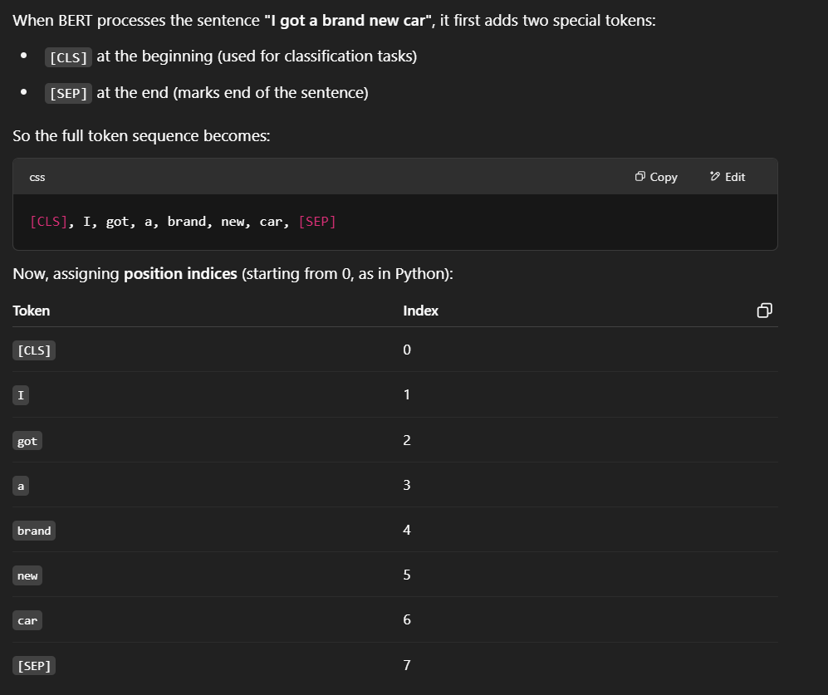

**Question 2**

What is the position index corresponding to the word "car" when BERT is processing the two sentences as two segments for the same example:

‘today was a great day’,  ‘I got a brand new car.’

(Assume that no words get split upon tokenization. And remember that python indices start with 0.)

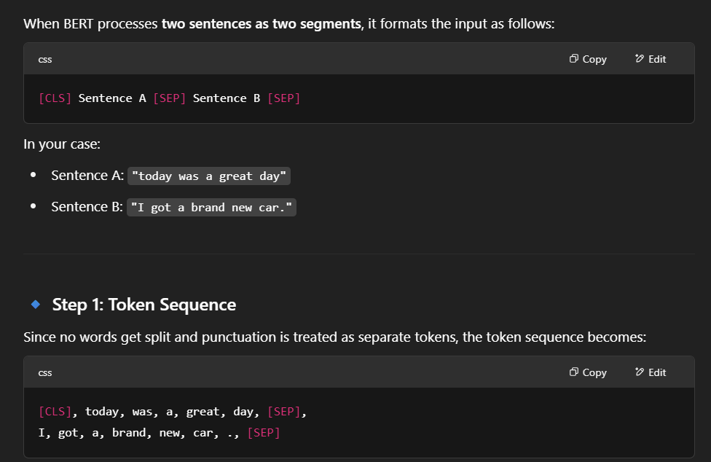

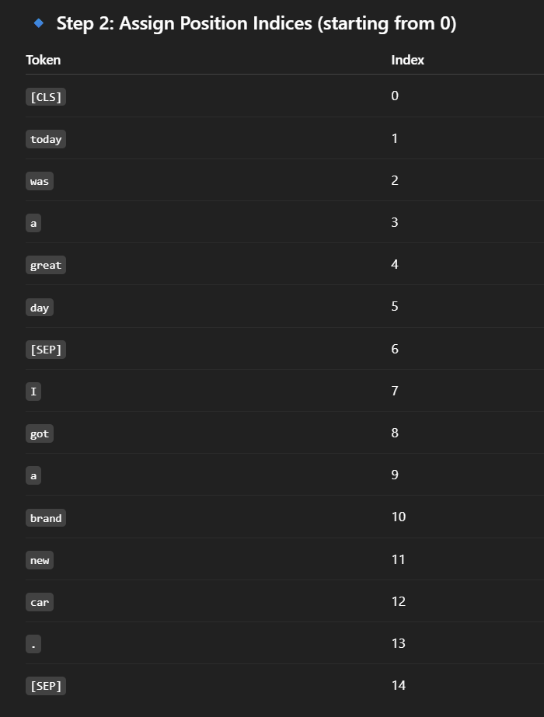

**Question 3**

For the last example, if the maximum length is defined as 20, how many padding tokens would be added?

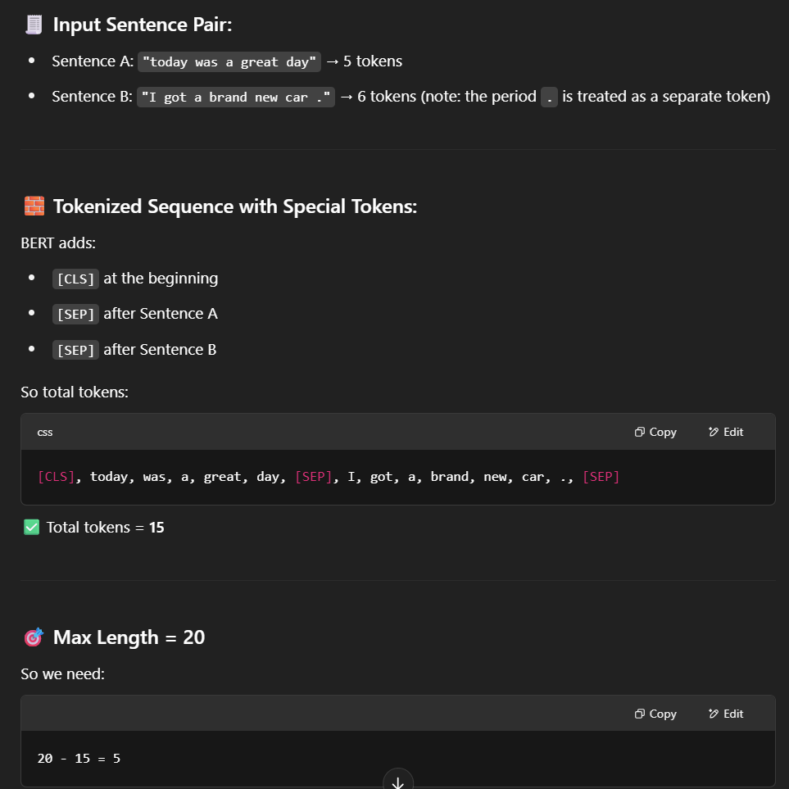

**BERT and Downstream Tasks**

**What’s the Goal?**

Now that we've seen that **BERT creates context-aware word embeddings**, we're moving to the **main practical goal**:

**Using BERT for real-world NLP tasks** like classification, question answering, and named entity recognition.

**1. Text Classification with BERT**

**Goal:**

Classify an entire sentence or paragraph into categories  
(e.g., *positive/negative*, *spam/ham*, *intent*, *topic*).

**Input Preparation:**

For **single sentence** input:

[CLS] I love this product! [SEP]

If you have **sentence pairs** (e.g., for entailment tasks):

[CLS] Sentence A [SEP] Sentence B [SEP]

**What Happens Inside BERT?**

* Each token gets transformed into a **768-dimensional vector** (in BERT base).
* The [CLS] token's vector (position index 0) is **used to represent the full input**.

**Model Head:**

* A **fully connected (dense) layer** is placed on top of the [CLS] output.
* Optionally, you can add a hidden layer in between.

**Classifier Head Structure:**

[CLS] (768-dim)

↓

Dense (hidden layer, e.g., 256-dim, with ReLU)

↓

Dense (output layer, e.g., 3 neurons → softmax)

**Example: Sentiment Classification (Positive/Negative)**

from transformers import TFBertForSequenceClassification

model = TFBertForSequenceClassification.from_pretrained('bert-base-uncased', num_labels=2)

This loads:

* BERT + a dense output layer for 2-class classification.

**Fine-tuning**: You train the entire model on labeled data (sentences + labels), including updating BERT’s own weights.

**Key Points:**

* You **reuse** BERT’s language knowledge.
* The classifier learns **how to use [CLS]’s representation** to make decisions.
* **Fine-tuning BERT end-to-end** helps adapt it to your task.

**2. Question Answering (QA) with BERT**

**Goal:**

Given a **question** and a **paragraph**, find the **span** (start and end tokens) in the paragraph that answers the question.

**Input Example:**

**Question:**  
*"Where does Harry live?"*  
**Paragraph:**  
*"Harry lives in London with his uncle."*

**Tokenized Input:**

[CLS] Where does Harry live? [SEP] Harry lives in London with his uncle. [SEP]

**What Happens Inside BERT?**

* BERT processes **both the question and the paragraph** together.
* Every token gets a contextual vector.

**Model Head:**

Instead of just using [CLS], we now classify **each token**:

* Is this token the **start** of the answer span?
* Is this token the **end** of the answer span?

We use **two linear (dense) layers** on top of BERT:

start_logits = Dense(1)(token_output) # shape: [batch, seq_len, 1]

end_logits = Dense(1)(token_output) # shape: [batch, seq_len, 1]

You then apply **softmax over the sequence length** to get probabilities.

**Prediction:**

* You pick the token index with the **highest start probability**
* And the one with the **highest end probability**
* That gives you the span: e.g., London

**Implementation with Hugging Face:**

from transformers import TFBertForQuestionAnswering

model = TFBertForQuestionAnswering.from_pretrained('bert-base-uncased')

This adds:

* A pair of dense layers on top of the token-level outputs (one for start, one for end).

**Key Notes:**

* You fine-tune this on datasets like **SQuAD**, where answers are spans.
* You use cross-entropy loss for both start and end positions.

**3. Named Entity Recognition (NER) with BERT**

**Goal:**

Label each word/token in a sentence with a class like:

* PER (person)
* LOC (location)
* ORG (organization)
* O (non-entity)

**Input Example:**

**Sentence:**  
*"Barack Obama visited Germany."*

**Tokenized Input:**

[CLS] Barack Obama visited Germany . [SEP]

**What Happens Inside BERT?**

* Each token gets a **768-dim vector** (contextual).
* You want to **predict a class for each token**.

**Model Head:**

Use a **classification layer** on **every token's output**, not just [CLS].

token_logits = Dense(num_labels)(token_output)

Apply **softmax per token** to get class probabilities.

**Example with Hugging Face:**

from transformers import TFBertForTokenClassification

model = TFBertForTokenClassification.from_pretrained("bert-base-uncased", num_labels=9)

This gives:

* A dense layer over each token.
* You fine-tune it using labeled token data (e.g., CoNLL-2003).

**Key Notes:**

* You may need to handle **token splits** from WordPiece (e.g., “german” → “ger”, “##man”).
* Usually, you only label the **first subword**.

**Summary Table: BERT Downstream Task Setup**

| **Task** | **Input Format** | **Output Used** | **Head Type** | **Output Shape** |
| --- | --- | --- | --- | --- |
| **Text Classification** | [CLS] text [SEP] | [CLS] output | Dense classifier | [batch, num_classes] |
| **Question Answering** | [CLS] question [SEP] paragraph [SEP] | All token outputs | Two dense layers (start/end) | [batch, seq_len] each |
| **NER** | [CLS] sentence [SEP] | All token outputs | Dense classifier on each token | [batch, seq_len, num_labels] |

**Example Datasets for Fine-Tuning BERT**

| **Task** | **Dataset** | **Description** |
| --- | --- | --- |
| Sentiment Classification | IMDb, SST-2 | Movie review polarity |
| Question Answering | SQuAD | Questions and answer spans |
| NER | CoNLL-2003 | Entity tagging in news articles |
| Paraphrase | MRPC | Sentence similarity |
| Textual Entailment | MNLI | Is sentence B entailed by sentence A? |

**How Fine-Tuning Works (Under the Hood)**

1. Load pretrained bert-base-uncased
2. Attach your task-specific "head" (dense layers)
3. Tokenize your data and format as BERT expects
4. Train the full model (including BERT weights)
5. Evaluate on your downstream task

**Why BERT Works So Well**

* Deep **contextual understanding**
* Trained on **huge text corpora** (Wikipedia + Books)
* Self-supervised learning = no need for manual labels in pretraining
* General-purpose → adapt to *many tasks* with minor architecture changes

**Text Generation Intro**

**1. Text Generation as a General Task**

* Text generation is a **broad umbrella** that includes tasks like:
  + Question answering
  + Translation
  + Summarization
  + Story continuation
* All these involve **taking a source text** and **generating a target text**.

**Example Tasks:**

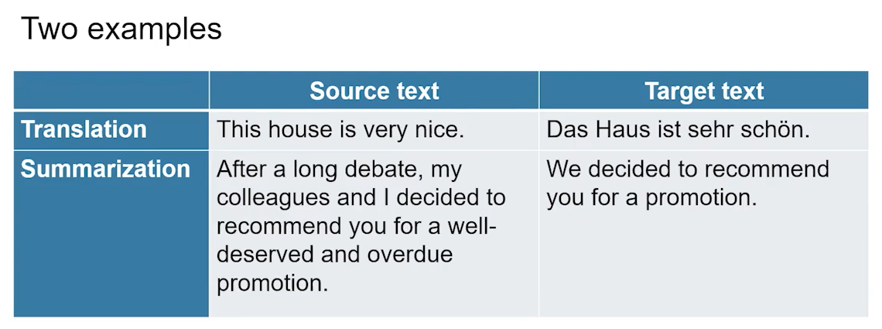

* **Translation:**  
  **Input** (source): “This house is very nice.”  
  **Output** (target): “Das Haus ist sehr schön.”
* **Summarization:**  
  **Input**: A long sentence about recommending someone for promotion.  
  **Output**: A concise version like “We decided to recommend you for a promotion.”

**Key idea:**

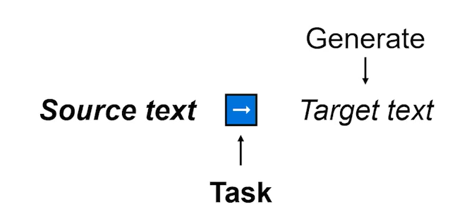  
**Source Text + Task → Target Text**  
You can even use the **same source text** with **different tasks**, like translating it vs summarizing it.

**2. Text Generation and Language Models**

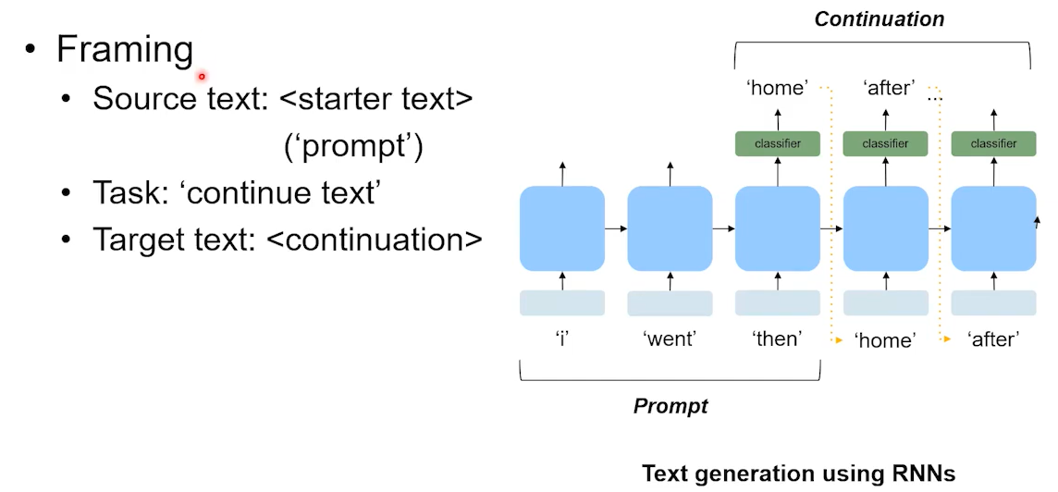

* Language models (LMs), especially those trained with large datasets, are inherently **text generators**.
* Example task: **Next-word prediction**
  + Input: "I went then"
  + Model output (step-by-step): “home”, then “after”, etc.

This is how **autoregressive language models** like GPT work—predicting one word at a time based on the previous context.

**3. Transformers and the Rise of Powerful Text Generators**

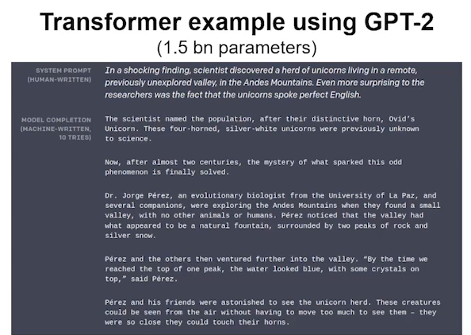

* Transformer-based models, like **GPT-2**, changed the game for text generation.
* GPT-2 (2019) had **1.5 billion parameters** and showed:
  + Strong grammatical coherence
  + Topic consistency
  + Contextual memory (remembers earlier parts of a story)
* **Example Prompt:**  
  "In a shocking finding, scientists discovered a herd of unicorns..."  
  Model’s output: Continues the narrative logically and fluently, despite minor factual oddities like “four-horned unicorns.”

**Main point:** These outputs are impressive in form (grammar, coherence) even if the **content may include fictional or incorrect details**.

**4. Why Is This Important?**

* Simple continuation is fun but **not enough** for real-world usefulness.
* The **goal of the lecture** is to move beyond just generating pretty text to **using these models for productive tasks**, such as:
  + Generating code
  + Automating summaries of meetings
  + Real-time language translation
  + Assisting with medical notes or legal documents

**Added Context for Deeper Understanding**

**A. Architecture Behind the Scenes**

* These models use **encoder-decoder** or **decoder-only** transformer architectures.
* GPT-2 is a **decoder-only model**: It only looks at past context (left-to-right generation).
* Translation and summarization (like in T5 or BART) often use **encoder-decoder architectures**:
  + Encoder reads the source.
  + Decoder generates the target based on encoded info.

**B. Token-by-Token Generation**

* Language models generate text **token-by-token**, using **probability distributions** over vocabulary at each step.
* This is why they can “hallucinate” or generate convincing but incorrect information—they’re not fact-checking, just estimating likely sequences.

**C. Applications Today**

* Tools like **ChatGPT, Google Translate, and AI writing assistants** all use versions of these models.
* They’re also used in **voice assistants**, **email auto-completion**, and even **coding tools** like GitHub Copilot.

**Takeaway**

The lecture introduces the **foundational idea** that **text generation is not just one task but a framework** for a wide range of language-based applications. These models have grown from simple next-word predictors into powerful tools for solving real-world problems across translation, summarization, dialogue, and more—thanks to **transformers** like GPT-2 and beyond.

**The Idea of Sequence-to-Sequence Learning**

**1. Motivation for Seq2Seq: Why Language Models Alone Aren’t Enough**

* Initially, it seems like we could use a **language model** (like GPT) to do translation:
  + Input: “That is good”
  + Desired Output: “Das ist gut” (German translation)
* But there’s a problem:
  + A standard language model trained in English might continue the phrase with “cake” (i.e., “That is good cake”) rather than starting a German sentence with “Das”.
  + This is because the model hasn’t been trained to generate output in **a different language** from the input.
* So, a **plain language model is not ideal for translation** tasks when input and output are in different languages or domains.

**2. Introducing the Seq2Seq Framework**

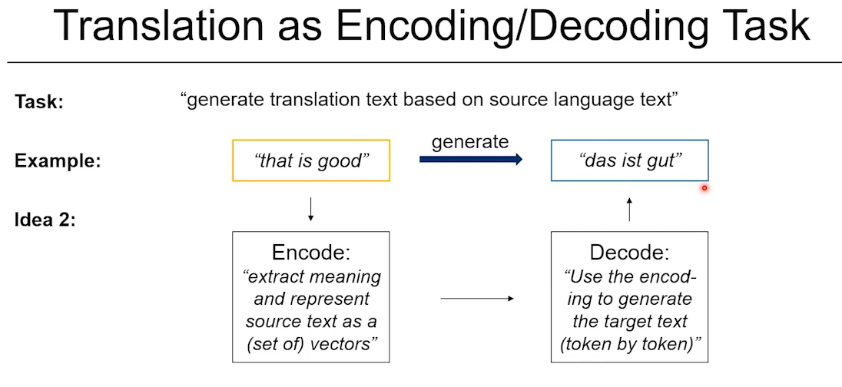

* The better solution is to separate the model into **two parts**:
  + **Encoder**: Reads and understands the input sequence (e.g., “That is good”), converting it into a mathematical representation (usually a vector or sequence of vectors).
  + **Decoder**: Takes that representation and **generates the output sequence** (e.g., “Das ist gut”), one word or token at a time.

**Key Concept:**  
Input (source text) → **Encoder** → Internal Representation → **Decoder** → Output (target text)

**3. Why This Approach Works Better**

* By **encoding the meaning** of the source sentence and **decoding** it separately, the model avoids the issue of just predicting what’s most probable in the same language.
* This makes it well-suited for tasks like:
  + Machine translation
  + Text summarization
  + Question answering
  + And other structured generation tasks

**4. Historical Context: A Breakthrough in 2014**

* The Seq2Seq approach was **formalized in a key 2014 paper**:  
  **“Sequence to Sequence Learning with Neural Networks”** by Sutskever, Vinyals, and Le.
* It was groundbreaking because:
  + Their model, using encoder-decoder LSTMs (a type of recurrent neural network), **matched or outperformed traditional translation systems**.
  + Those older systems relied on hand-crafted rules and grammar structures.
  + Seq2Seq models learned **directly from data**.

**Added Context for Deeper Understanding**

**A. Architecture Choices**

* **Seq2Seq is a conceptual framework**, not limited to a specific type of neural network. It can be built using:
  + **Recurrent Neural Networks (RNNs)** – used in early Seq2Seq models like the 2014 paper
  + **LSTMs and GRUs** – RNN variants that better handle long sequences
  + **Transformers** – modern models like BERT, T5, and GPT use attention-based transformers, which are more efficient and powerful

**B. Advantages of the Encoder-Decoder Setup**

* **Language independence**: Can handle tasks where input and output differ in form or language
* **Transferability**: Works across many NLP problems
* **Modularity**: Allows flexible adaptation of encoder and decoder components

**C. Foundation for Today’s Models**

* Modern models like **T5 (Text-to-Text Transfer Transformer)** and **BART** use encoder-decoder transformers to perform a wide variety of text generation tasks.
* Even **ChatGPT (GPT-3, GPT-4)**, while not a classic Seq2Seq model, builds on these foundational ideas to generate coherent text from input prompts.

**Takeaway**

The **sequence-to-sequence architecture** solves key limitations of basic language models when it comes to tasks like translation. By introducing an **encoder to understand the input** and a **decoder to generate the output**, the model can better handle tasks that involve **different formats or languages**. Originally proven powerful in neural machine translation, Seq2Seq has since become a **core concept** across many natural language processing applications.

**A Basic Encoder–Decoder RNN Architecture**

**1. Key Concepts of the Encoder-Decoder Model**

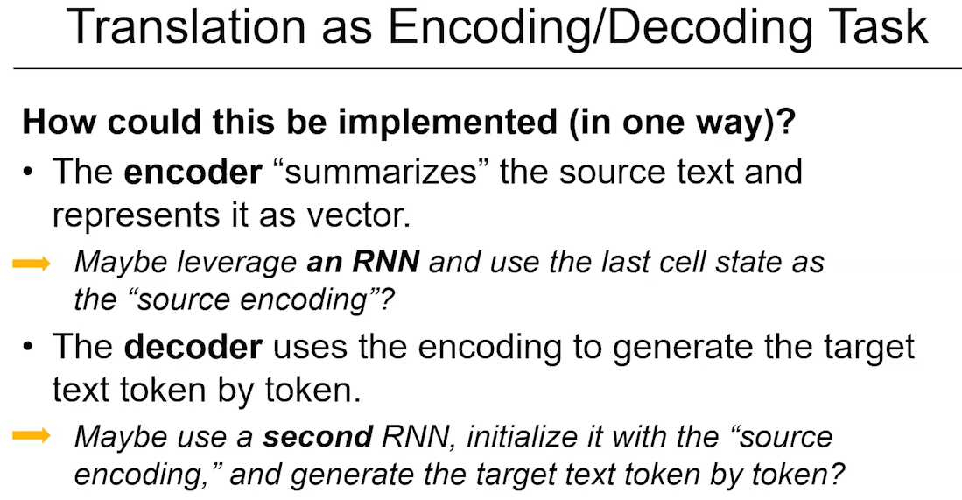

* The **encoder** processes the input sentence (e.g., “This is good”) and converts it into a **fixed-size vector representation**.
  + This vector is often called the **thought vector**, though that's a conceptual term.
  + It is typically the **final hidden state** (or cell state) of the encoder RNN, which contains context about the entire input sequence.
* The **decoder** is another RNN that:
  + Is **initialized** with the final state of the encoder.
  + Receives a **start token** to begin generation.
  + Produces one token at a time (e.g., the German translation: “Das”, then “ist”, then “gut”), using its own previous output as input for the next step.
  + Stops when an **end token** is predicted.

**2. Architecture Details**

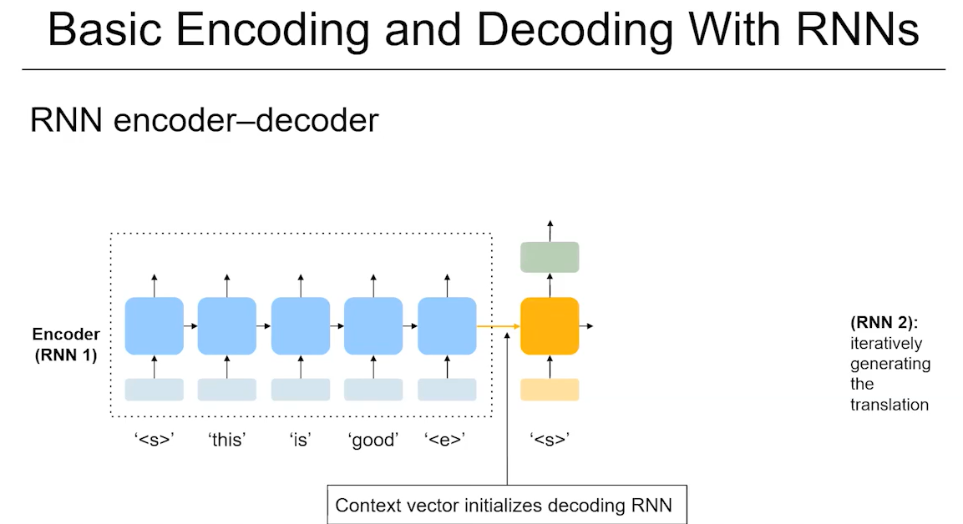

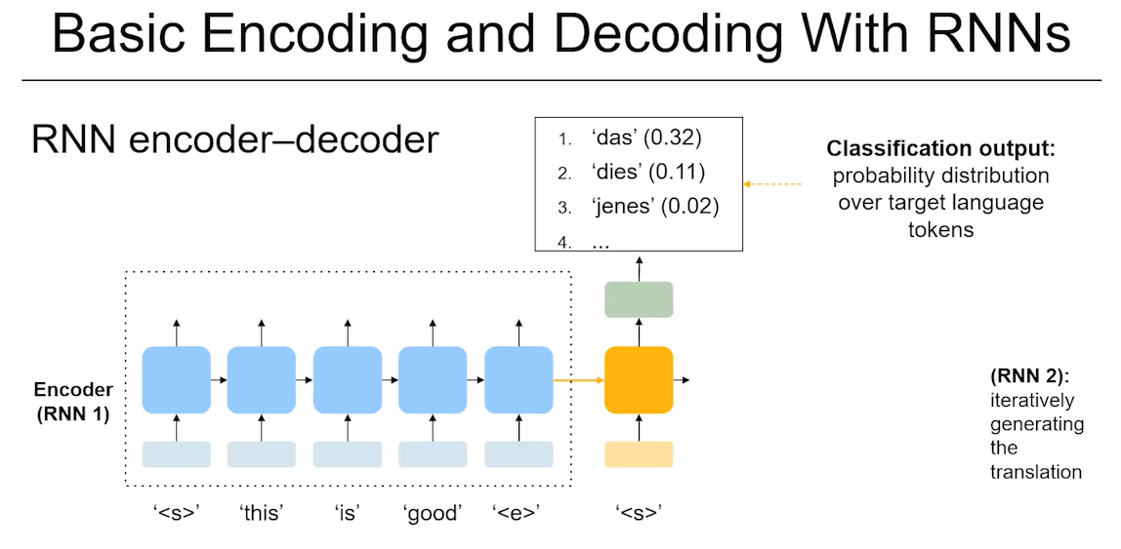

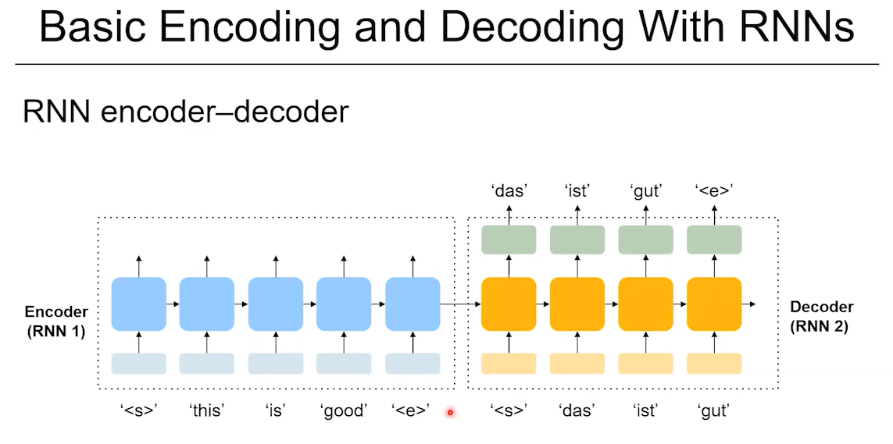

* **Encoder (RNN1)**:
  + Processes the input word-by-word.
  + Passes a hidden state from one time step to the next.
  + The **final hidden state** summarizes the entire sentence.
* **Decoder (RNN2)**:
  + Initialized using the encoder’s final hidden state.
  + Begins with a **start-of-sequence token**.
  + At each step:
    - Takes in the previous word (initially the start token).
    - Uses its internal state to **predict the next word**.
    - Updates its hidden state and repeats.
  + Generation continues until an **end-of-sequence token** is produced.

**Important Note:**  
The decoder is trained to **maximize the probability** of the correct next word at each step, given the previous words and the encoded input context.

**3. Interpretation of Components**

* The **encoder RNN** can be thought of as a **language model for the source language** (e.g., English).
* The **decoder RNN** acts like a **language model for the target language** (e.g., German), but it also has **context from the source** through the initialization.

**Additional Context to Deepen Understanding**

**A. Why RNNs Were Used**

* RNNs were suitable for sequential data like language because:
  + They handle **variable-length input** and **output** sequences.
  + They maintain **hidden state memory** across time steps.
  + But, they also had **limitations** (e.g., vanishing gradients, trouble with long dependencies), which later led to the use of **LSTMs/GRUs**, and eventually **Transformers**.

**B. Limitations of One-Vector Encoding**

* In this model, the **entire input sentence is compressed into a single vector**.
  + This can work well for short sentences.
  + But for longer, more complex sentences, this **bottleneck** can lead to degraded performance, as critical details may be lost.
  + This limitation was later addressed with **attention mechanisms** (e.g., in Transformer models).

**C. Training Method**

* During training, models often use a method called **teacher forcing**:
  + The decoder is fed the **ground-truth previous word** (not its own predicted word) to reduce error accumulation and speed up learning.

**Takeaway**

The **RNN-based encoder-decoder architecture** was a major step forward in machine translation and other sequence-to-sequence tasks. By encoding an input sentence into a fixed vector and decoding from it, the model could translate, summarize, or generate coherent sequences in another language or style. While powerful at the time, it was eventually outperformed by attention-based models like Transformers, which could better handle long-range dependencies and context.

**

**Encoding RNN (Encoder)**: To process the input sequence and summarize it into a fixed-size context vector

* Reads the entire input sequence (e.g., an English sentence) one token at a time.
* Updates its internal hidden state with each token.
* The final hidden state represents a compressed representation of the entire input sequence — capturing its meaning, structure, and context.

**Decoding RNN (Decoder)**: To generate the output sequence, using the context vector produced by the encoder as a guide.

* Initialized with the context vector from the encoder.
* Produces the output sequence (e.g., a translation into French) one token at a time.
* Each output token is based on the decoder's previous hidden state and the previously generated token.

**RNN Encoder–Decoder Architectures With Attention**

**1. Background: The RNN Encoder-Decoder Architecture**

* The RNN-based encoder-decoder model works fairly well and was state-of-the-art at the time it was introduced.
* It has a **simple structure**:
  + The **encoder** converts the input sentence into a **fixed-size vector** (typically the final hidden state).
  + The **decoder** uses this vector to generate the target sentence **token-by-token**.
* Despite being simple and requiring no explicit grammar rules, the model struggles with:
  + **Long input sequences**
  + **Remembering earlier words** in a long sentence (since the encoder compresses all info into one vector)

**2. The Problem with Long Sentences**

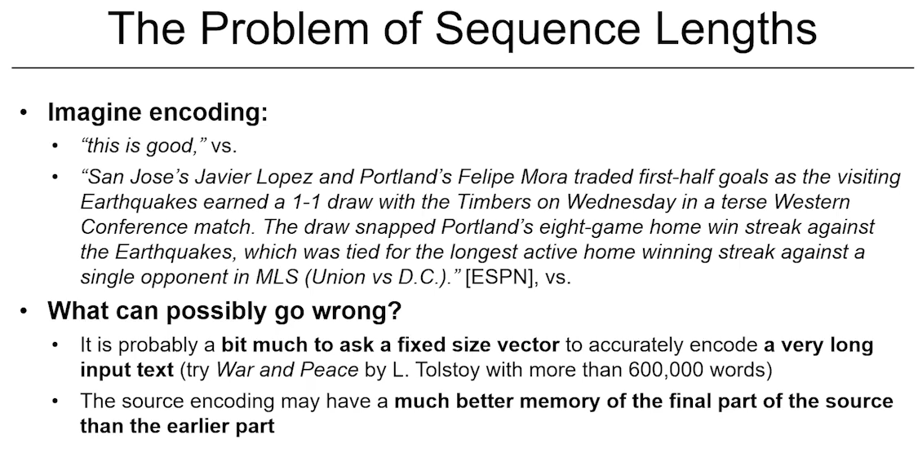

* For short sentences like "This is good", the fixed vector works well.
* For longer sentences (e.g., sports news or complex statements), it’s **too much to expect a single vector** to capture all the necessary context.
* Another issue: RNNs tend to remember **recent tokens better** than earlier ones, due to their sequential structure.

**3. The Solution: Attention Mechanism**

* The idea of attention was introduced in **2014 by Bahdanau, Cho, and Bengio** in the paper *“Neural Machine Translation by Jointly Learning to Align and Translate”*.
* Instead of relying solely on the final hidden state, attention allows the model to:
  + **Look back at all encoder outputs**
  + **Weight them** based on relevance to the current decoding step
  + **Construct a context vector dynamically** for each generated word

**Key Idea:**  
At each decoding step, the model **"asks" where to look in the input sentence**—i.e., which parts are most relevant to generating the current word.

**4. How Attention Works**

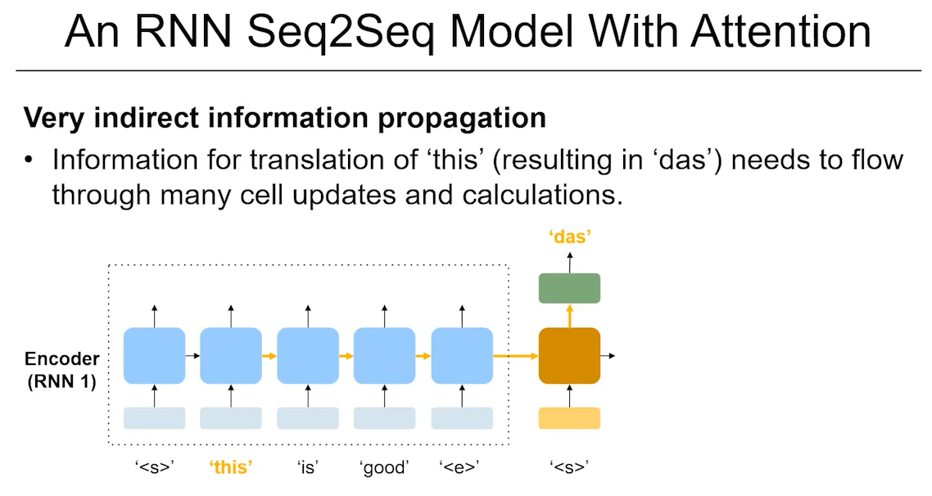

* When the decoder starts (e.g., to predict "das" for "this is good"):
  1. The decoder’s current state becomes the **query**.
  2. The encoder’s output vectors serve as **keys and values**.
  3. **Dot products (or other scoring functions)** compute alignment scores between the query and each key.
  4. These scores become **attention weights** after softmax normalization.
  5. A **context vector** is formed as the weighted sum of all encoder outputs.
  6. The decoder combines this context vector with its own state to generate the next word.

This allows the decoder to **focus on specific parts** of the input sentence at each step, rather than relying on a single summary.

**Step-by-Step Breakdown**

**1. Encoder processes the input sentence**

* Input: "This is good" → tokenized as: [this, is, good]
* Each token is processed sequentially by the **encoder RNN**, which produces:
  + A **hidden state** for each word:

h1 = Encoder("this")

h2 = Encoder("is", h1)

h3 = Encoder("good", h2)

* Now we have a list of hidden states:
  + H = [h1, h2, h3]

**2. Decoder starts generating output**

* Decoder begins with a **start token** <s> (indicating start of translation).
* It has an **initial hidden state**, often initialized from the encoder's final state (optional if attention is used).
  + Let’s call the decoder’s hidden state at time step 1: s1 = Decoder(<s>)

**3. Attention mechanism activates**

* The decoder’s current state s1 is used as the **query**.
* The encoder’s hidden states [h1, h2, h3] are used as both the **keys and values**.

Now we compute **attention scores**:

1. **Score Calculation**: For each encoder hidden state hi, we compute a similarity score with the decoder state s1.  
   Example using dot product:

score_i = s1 · hi

This gives scores for each input word:

[score1, score2, score3]

1. **Softmax Normalization**: Convert scores to **attention weights**:

attention_weights = softmax([score1, score2, score3])

Let’s say:

attention_weights = [0.9, 0.05, 0.05]

→ The model is **mostly attending to “this”**, which makes sense because we’re trying to generate “Das” (the German equivalent of “This”).

1. **Context Vector Creation**: Compute a **context vector** as a weighted sum of the encoder states:

context = 0.9*h1 + 0.05*h2 + 0.05*h3

**4. Word prediction**

* The decoder now combines:
  + Its current hidden state s1
  + The context vector
* These are fed into a classifier to predict the next word:

output_probs = softmax(W * concat(s1, context))

* Output: A probability distribution over all German words.
  + Highest probability → “Das”

**5. Next Step**

* The decoder takes “Das” as the next input and proceeds to generate “ist” using the **same attention process**:
  + Compute new decoder state s2
  + Use s2 to compute new attention scores on [h1, h2, h3]
  + Focus likely shifts to “is”
  + Generate “ist”

And so on, until the end token is predicted.

**5. Empirical Results: BLEU Scores and Long-Range Accuracy**

* BLEU score: A standard metric for evaluating translation quality (higher is better).
* Results from the original attention paper show:
  + Without attention: BLEU scores **drop for longer sentences**.
  + With attention: BLEU scores **stay higher**, even as sentence length increases.
* Attention **enables the decoder to maintain translation quality** over long sequences by accessing all relevant encoder information.

**6. Bonus Benefit: Interpretability**

* The attention weights themselves offer **interpretability**.
* Example: In an English-to-French translation:
  + Visualizing attention scores reveals **word alignment patterns** (e.g., reordered phrases like "European Economic Area" → "zone économique européenne").
  + Bright spots in attention heatmaps correspond to strong alignment between source and target tokens.
  + This makes attention both **effective and insightful** for understanding model behavior.

**7. Further Insights: Rethinking the Initial Context Vector**

* Originally, the decoder was **initialized** with the encoder’s final hidden state.
* But with attention, this is **no longer strictly necessary**.
  + The decoder can start with a generic token (e.g., a start token) and immediately **use attention** to access the entire encoder output.
* A 2017 paper (*“Massive Exploration of Neural Machine Translation Architectures”*) found that:
  + **Omitting the initial encoder vector** still leads to good performance.
  + **Attention replaces the need for a fixed, compressed context vector**.
* This insight set the stage for **fully attention-based models**, like **Transformers**, which do not use RNNs at all.

**Takeaway**

The introduction of **attention** fundamentally improved encoder-decoder models by enabling them to:

* Handle **long sequences more effectively**
* Generate **higher-quality translations**
* Offer **interpretability** through alignment visualization

Attention helped resolve the key bottleneck of encoding all input into a single vector and has since become a **foundational mechanism in modern NLP**, especially in Transformer architectures like BERT, GPT, and T5.

**The Core Encoder–Decoder Transformer Architecture**

**1. Motivation: Moving Beyond RNNs**

* The **encoder-decoder framework** works well for sequence-to-sequence tasks like machine translation.
* Originally, this was implemented using **Recurrent Neural Networks (RNNs)**.
* But RNNs are **sequential** in nature and **not efficient** for long sequences or parallel processing.
* So the question arises: can we implement the same conceptual structure with something better?

**Answer:** Yes — with **Transformers**, introduced in the 2017 paper **“Attention is All You Need”** by Vaswani et al.

**2. Overview of Transformer Architecture**

* Transformers replace recurrence with **self-attention** mechanisms, allowing for:
  + **Parallel computation**
  + **Better handling of long-range dependencies**
  + **Improved scalability**
* The **core structure** of the transformer includes:
  + **Multi-head self-attention layers**
  + **Feed-forward neural networks**
  + **Residual connections and layer normalization**

**3. Transformer as Encoder-Decoder**

* The transformer model still follows the **encoder-decoder paradigm**, but with different components.

**Encoder:**

* Takes in the input sentence (e.g., English).
* Embeds the tokens and passes them through **multi-head self-attention layers**.
* Produces a set of encoded vectors, one for each token.
* Each layer processes **in parallel** across all tokens.

**Decoder:**

* Takes in the target sentence so far (e.g., in German) using **output embeddings**.
* Uses:
  1. **Masked self-attention**: looks only at previously generated tokens to prevent "peeking" ahead.
  2. **Cross-attention**: queries the encoder’s outputs to retrieve relevant source information.
  3. **Feed-forward layers** to further process the results.
* At each step, it predicts the next word based on:
  1. The decoder’s current state
  2. The attention over previously generated words
  3. The attention over the **source input from the encoder**

**4. Masked Self-Attention and Decoder-Only Models**

* The decoder’s **masked self-attention** ensures the model **only sees previous tokens**—critical for autoregressive generation.
* This masked attention is also the **core of GPT-style models**, which are:
  + **Decoder-only models**
  + Designed to predict the next word given past words (like language modeling)
  + Do **not** use encoder inputs (unlike full translation tasks)

So, **GPT looks like the decoder** portion of the transformer but without the cross-attention step that brings in encoder outputs.

**5. Advantages of Transformers**

* **Parallelism**: Unlike RNNs, transformers can process all tokens in a sequence **simultaneously** during training.
* **Scalability**: Enables training on **massive datasets**, which boosts performance.
* **Lower computational cost**: Even large models like the one in the Vaswani paper outperformed previous methods while using **less compute**.

**6. Empirical Results**

* **BLEU score** (a metric for translation quality) was used to evaluate performance.
* The original Transformer model **outperformed RNN-based models**:
  + Higher BLEU scores
  + Better handling of long sequences
  + Faster training and inference times

This combination of performance and efficiency made the Transformer model the **new standard** for machine translation and many other NLP tasks.

**7. Foundation for Pretrained Transformers**

* This architecture laid the groundwork for later models like:
  + **BERT** (Bidirectional Encoder Representations from Transformers) – encoder-only
  + **GPT** – decoder-only
  + **T5, BART** – full encoder-decoder transformers

The script ends by noting that this discussion leads into **pretrained transformer-to-transformer models**, which combine encoder-decoder architecture with **large-scale pretraining**, enabling high performance on a wide range of NLP tasks with little task-specific tuning.

**Takeaway**

The transformer model introduced by Vaswani et al. **revolutionized NLP** by replacing recurrence with self-attention. Its encoder-decoder structure supports efficient, high-quality sequence generation (e.g., translation). This architecture enabled the development of today’s powerful pretrained models like GPT, BERT, and T5 — and transformed not only translation, but the entire field of natural language understanding and generation.

**T5: A Pretrained Encoder–Decoder Transformer Model Approach**

**1. Motivation: From Task-Specific Models to Universal NLP Models**

* Traditionally, NLP models were **task-specific**:
  + One model trained for translation English → German
  + Another trained for summarization
  + Another for sentiment classification, etc.
* This approach is inefficient:
  + Each model needs its own architecture and training
  + Large labeled datasets are required per task
* **Our brain doesn’t work this way**—we perform many tasks using the same underlying language ability.

**Goal:** Can we create **one model** that can do **multiple NLP tasks** using the **same architecture and same weights**?

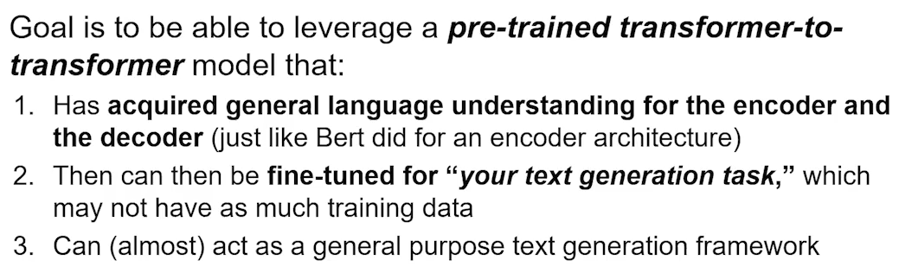

**2. Inspiration from BERT**

* **BERT** (2018) showed how **pretraining** a model on a general language task (masked language modeling) allows for effective **fine-tuning** on various tasks.
* BERT is an **encoder-only transformer**, which limits it to **understanding tasks** (e.g., classification, NER), but not **generative tasks** (e.g., translation, summarization).

**T5 extends this idea**:

* Uses the **encoder-decoder transformer architecture** (like in Vaswani's original Transformer model for translation)
* Trains **both encoder and decoder** on a **text-to-text framework** (input: text → output: text)

**3. T5 Core Design Principle: “Everything is Text-to-Text”**

The major design choice of T5 is that **every NLP task should be framed as a text-to-text problem.** That means:

* Inputs and outputs are both **strings**
* Tasks are defined by **prefix prompts** embedded in the input

**Examples:**

| **Task** | **Input to Encoder** | **Output from Decoder** |
| --- | --- | --- |
| Translation | "translate English to German: That is good" | "Das ist gut" |
| Summarization | "summarize: The stock market crashed yesterday due to inflation fears." | "Stock market crashed due to inflation" |
| Sentiment | "sst2 sentence: This movie was surprisingly entertaining." | "positive" |
| Grammatical Acceptability (CoLA) | "cola sentence: The course is jumping well." | "not acceptable" |
| Question Answering | "question: What is the capital of France? context: France's capital is Paris." | "Paris" |

🔎 *Notice how the task is specified by a prefix — the model doesn’t “know” the task unless you tell it via the prompt.*

**4. Architecture of T5**

* Based on the **standard Transformer encoder-decoder structure**:
  + **Encoder** processes the input string (including the task prefix)
  + **Decoder** generates the output string token by token
* Uses **masked self-attention** in the decoder, ensuring autoregressive generation
* Trained and fine-tuned using **teacher forcing**: at each time step during training, the correct token is fed into the decoder (instead of the model's own previous prediction)

**5. Pretraining the T5 Model**

Unlike BERT or GPT, T5 needs **both encoder and decoder** to be trained simultaneously. So:

* **Dataset used:**
  + **C4 (Colossal Clean Crawled Corpus)**
    - 750GB of English text scraped and cleaned from Common Crawl
    - Diverse: includes news articles, forums, blogs, etc.
* **Pretraining objective:**
  + **Span-corruption objective** (aka “denoising”):
    - Input: Sentence with random spans of words replaced by placeholder tokens (e.g., <extra_id_0>)
    - Output: The model predicts the missing spans
  + Example:
    - Input: "The quick brown <extra_id_0> over the lazy dog."
    - Output: "<extra_id_0> fox jumps"

This trains T5 to:

* Understand sentence structure
* Predict missing text
* Learn general language representation — both encoding and decoding

**6. Fine-Tuning T5 for Specific Tasks**

Once T5 is pretrained, it is fine-tuned on **multiple supervised datasets**, including:

* **GLUE** (e.g., sentiment analysis, entailment, paraphrasing)
* **SuperGLUE** (harder versions of GLUE tasks)
* **CNN/DailyMail** (for summarization)
* **WMT** (for translation)
* **SQuAD, TriviaQA** (for question answering)

This fine-tuning makes T5 adaptable to a **wide range of tasks with minimal structural changes.**

**7. Encoding Tasks with Instruction Prompts**

Instead of building task-specific heads (like in BERT), T5 uses **prefix prompts**:

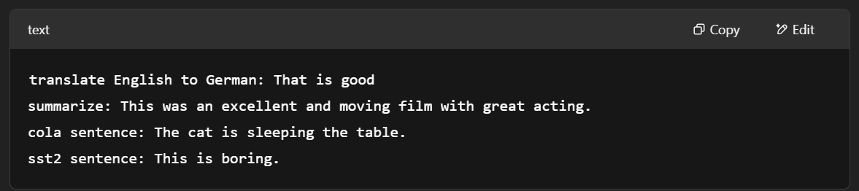

This idea of **“prompting”** later evolved into **instruction-tuned models** like **FLAN-T5**, which are trained to follow human instructions even more broadly.

**8. Performance and Evaluation**

* **T5 achieved state-of-the-art results** across many benchmarks.
* Used **BLEU scores** for translation, **ROUGE** for summarization, and accuracy/F1 for classification tasks.
* **Scalability**: T5 was released in various sizes — from **T5-Small (~60M parameters)** to **T5-11B** (11 billion parameters).
  + Larger models generally performed better.

**9. Legacy and Influence**

T5 influenced a wide range of future models:

* **FLAN-T5**: Instruction-finetuned T5 for improved multi-task generalization
* **UL2**: Unified language model combining denoising, autoregressive, and other objectives
* **Prompt-based learning**: Inspired research on **prompt engineering**, **task prompting**, and **instruction tuning**
* Forms the backbone of **many Google NLP applications**

**Key Takeaways**

* **T5 unified all NLP tasks into a single text-to-text format.**
* It showed that a **single model architecture**, when pretrained on a large dataset and fine-tuned properly, can **excel across translation, summarization, classification, and more**.
* It introduced:
  + Pretrained encoder-decoder learning (not just encoder-only like BERT)
  + Prefix-based **prompting** for task conditioning
  + Span corruption as a **pretraining objective**
* T5 demonstrated that **general language understanding and generation can be learned jointly**, laying the foundation for today’s most powerful multi-task and instruction-following language models.

**T5: Pretrained Encoder–Decoder Transformer Model Results**

**1. Why Pretraining Matters**

* Pretraining is **critical** for large models like T5.
* It must be done on **unlabeled data**, because:
  + Human-annotated data is scarce and expensive.
  + You need massive corpora to train large transformer models.
* The goal is to **teach both the encoder and decoder** a general understanding of language **without task-specific supervision**.

**2. What Kind of Pretraining Objectives Can We Use?**

To train a **transformer-to-transformer (encoder-decoder)** model like T5 using **self-supervision**, we need **pretraining tasks** where the input and output are derived from the same raw text. The T5 team **compared multiple strategies**, which we’ll now explore:

**A. Next-Span Prediction (Autoregressive-Like Pretraining)**

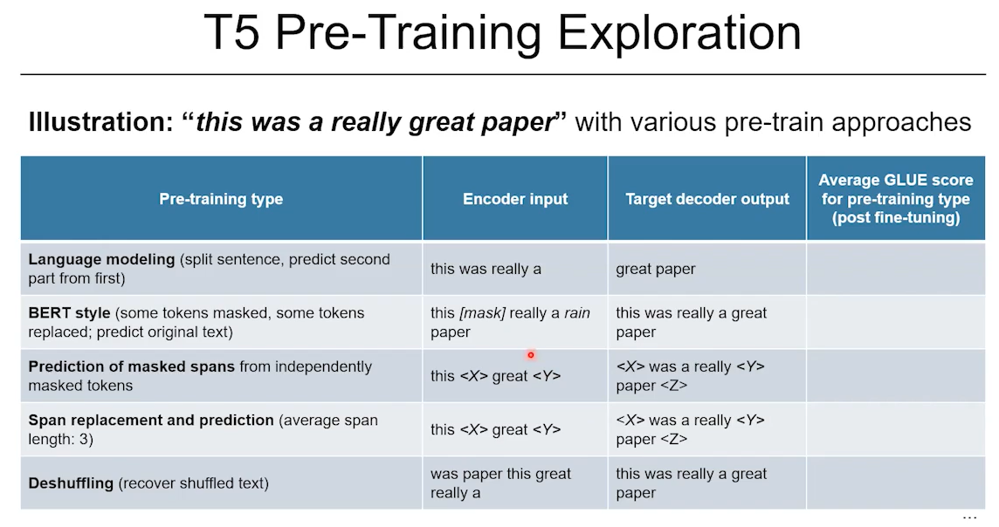

* **Idea**: Split the sentence into two halves:
  + Input to **encoder**: "This was a really"
  + Target output for **decoder**: "great paper"
* Simulates classic language modeling by asking the model to **predict what comes next**.
* **Limitation**: Only leverages part of the sentence and focuses on predicting the tail.

**B. BERT-Style Masked Language Modeling**

* Inspired by BERT's approach:
  + Encoder input: "This <mask> a really great paper"
  + Decoder output: "was"
* Or reconstruct the **entire sentence** from masked input:
  + Input: "This <mask> a <mask> paper"
  + Output: "was really great"
* Still, the decoder’s role is limited in this approach.

**C. Span-Corruption (Used in T5)**

* The **preferred method** used in the final T5 model.
* Mask out **spans of tokens** (not just individual words), and have the model **generate the full, missing spans**.

**Example:**

* Input to encoder: "This was <extra_id_0> paper."
* Target output for decoder: "<extra_id_0> a really great"
* This trains:
  + The **encoder** to understand the surrounding context
  + The **decoder** to reconstruct the missing content
* **Span corruption with average span length of 3** worked best in experiments

**D. Deshuffling**

* Encoder gets a **permuted version** of the sentence.
  + Input: "Really paper a great was this"
  + Decoder must reconstruct: "This was a really great paper"
* This approach performed **significantly worse** in experiments.

**3. Empirical Results of Pretraining Strategies**

* Evaluated using the **GLUE benchmark** (a suite of language understanding tasks).
* **Span corruption (average span length = 3)** led to the **highest GLUE scores**.
* **Deshuffling** resulted in the lowest performance—showing that **not all self-supervised tasks are equally effective**.

**Key Insight:**  
The **choice of pretraining task heavily influences downstream performance**. Some tasks help the model generalize better than others.

**

A **higher GLUE score** indicates that a model performs better on **average across all tasks**.  
It reflects the model's **general language understanding** and **transferability**.

* The GLUE benchmark is a widely respected measure of general language understanding.
* T5’s creators used it to rigorously compare pretraining objectives.
* Span corruption with average span length of 3 provided the best GLUE score, meaning it best prepared the model to generalize across a wide range of tasks.

**4. Fine-Tuning T5 for Multiple Tasks**

Once pretrained, the model must be **fine-tuned** for various downstream tasks.

**A. How to Fine-Tune**

* T5 was fine-tuned on many tasks **jointly** (not one model per task).
* Tasks varied by:
  + **Data size** (e.g., SQuAD has many examples; CoLA has few)
  + **Language** (e.g., English-only tasks vs multilingual)
* They used a **sentence-piece tokenizer** capable of handling **multiple languages**, which made it easier to train a single multilingual model.

**5. Framing Tasks for T5: The Text-to-Text Principle**

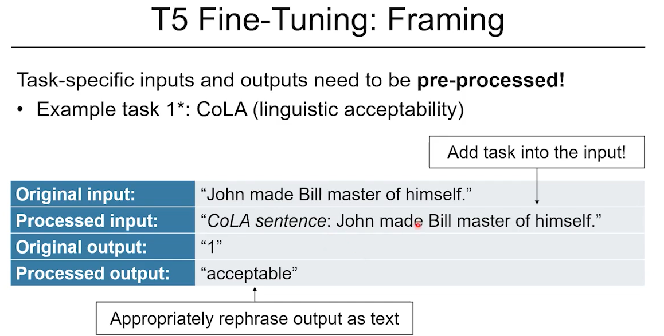

Each task is converted into a **string-based prompt**, so the encoder gets:

* A **task-specific prefix**
* The **task input** (e.g., a sentence or question)

The decoder produces a **textual output**, even for classification or Boolean decisions.

**Example 1: CoLA (Acceptability Classification)**

Original:

* Input: "John made Bill master of himself."
* Output label: 1 (acceptable)

Reformatted for T5:

* Encoder input: "cola sentence: John made Bill master of himself"
* Decoder output: "acceptable" (instead of just 1)

**Why this matters**:  
Using natural language outputs helps the model leverage its strength in **text generation**, rather than expecting it to learn mappings like 0 → not acceptable.

**Example 2: Word-in-Context (WiC)**

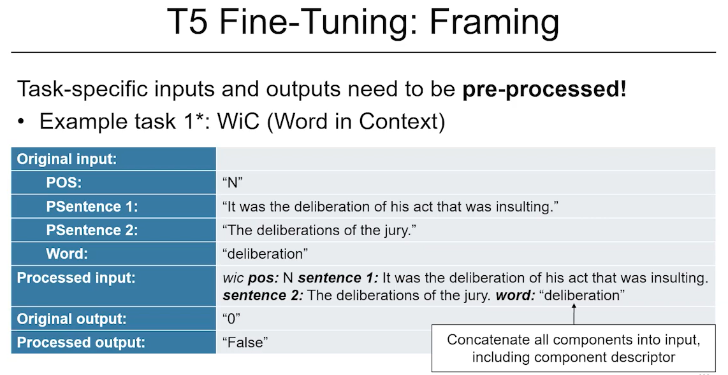

* Task: Decide if the same word in two sentences has the same meaning.

Original:

* Sentence 1: "It was the deliberation of his act that was insulting."
* Sentence 2: "The deliberations of the jury lasted three hours."
* Target word: "deliberation"
* Label: 0 (not the same meaning)

Reformatted for T5:

* Encoder input:  
  "wic POS: noun sentence1: It was the deliberation of his act that was insulting. sentence2: The deliberations of the jury lasted three hours. word: deliberation"
* Decoder output: "false"

Again, the model learns to **interpret natural text prompts and generate a natural response**, not just output binary codes.

**6. Model Sizes and Performance**

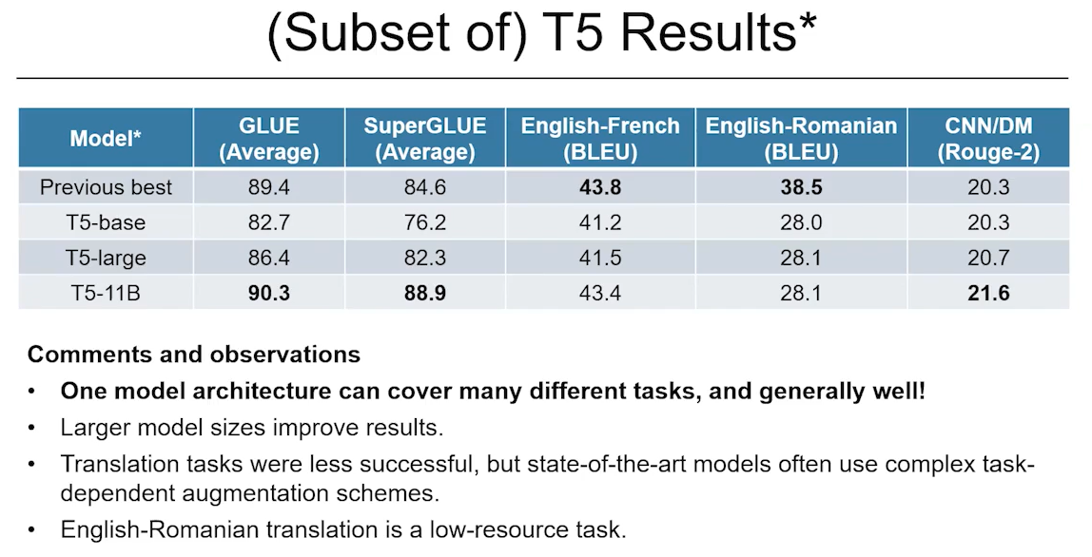

T5 was trained in **multiple sizes**, from **T5-Small (~60M parameters)** to **T5-11B** (11 billion parameters).

* Larger models achieved **better accuracy** across most tasks.
* T5 performed well on GLUE and SuperGLUE, even compared to specialized models.
* **Translation** tasks, especially low-resource languages, remained challenging due to lack of task-specific data in pretraining.

**7. Why Use a Single Unified Model?**

The **benefits of one large, multi-task model** like T5 include:

* **Shared learning**: What is learned from one task can benefit others.
* **Efficiency**: No need to build and maintain separate models.
* **Consistency**: One architecture, one format, one API for many tasks.
* **Adaptability**: The model can be easily fine-tuned for new tasks with limited data.

**Analogy**: Just like a human leverages prior knowledge across tasks, a large pretrained model can **transfer understanding** to new domains.

**Final Takeaways**

* **Pretraining** is foundational: The way you train the model at scale shapes what it can later do.
* **Span corruption** is the most effective pretraining strategy for T5.
* T5 handles all NLP tasks as **text-to-text problems**, allowing one model to:
  + Translate
  + Summarize
  + Classify
  + Detect entailment
  + Judge grammatical acceptability
  + And more
* **Task design and formatting matter**: You must carefully craft the prompt and output format to match the model’s strengths in language understanding and generation.
* T5’s success laid the foundation for more recent **instruction-tuned** and **multi-task LLMs**, such as **FLAN-T5**, **UL2**, and **PaLM**.

**A Huge "Decoder-Only" Model With Competitive NLP Task Performance Without Fine-Tuning: GPT-3**

**1. What Came Before: The Fine-Tuning Paradigm**

Previous models like **T5** or **BERT** used a two-step process:

* **Pretraining**: Learn general patterns from massive text data.
* **Fine-tuning**: Adjust the model on a specific task using labeled data.

**Limitations**:

* Required retraining for every new task.
* Needed lots of labeled examples.
* Models often performed poorly on real-world data if test conditions didn’t match training data.

**2. What GPT-3 Introduced**

OpenAI introduced **GPT-3** in the 2020 paper *"Language Models are Few-Shot Learners"*. It proposed:

* A single, very large pretrained model.
* No task-specific fine-tuning.
* Use of **prompts** to teach the model what to do at runtime.

This idea is simple but powerful: train a model on enough general language data that it can solve many tasks just by being told what to do — without further training.

**3. Architecture and Model Size**

GPT-3 uses a **decoder-only transformer** (like GPT-2) trained as a language model — predicting the next word from context.

**Model Sizes**:

| **Model** | **Parameters** | **Layers** | **Embedding Size** | **Attention Heads** |
| --- | --- | --- | --- | --- |
| Small | 125M | 12 | 768 | 12 |
| Medium | 1.3B | 24 | 1024 | 16 |
| Large | 6.7B | 32 | 2560 | 32 |
| XL | 13B | 40 | 5120 | 40 |
| GPT-3 | 175B | 96 | 12,288 | 96–128 |

Key takeaway: GPT-3 is nearly 100x larger than GPT-2.

**4. Prompt-Based Learning: Three Modes**

Instead of retraining the model, GPT-3 is given tasks through **text prompts**.

**A. Zero-Shot Learning**

* Prompt only includes a description of the task.
* Example:
  + Prompt: "Translate English to German: The ocean is blue."
  + Output: "Das Meer ist blau."

**B. One-Shot Learning**

* Prompt includes one example plus the new input.
* Example:
  + Prompt:  
    "Translate English to German:  
    The cat is sleeping → Die Katze schläft  
    The ocean is blue →"
  + Output: "Das Meer ist blau."

**C. Few-Shot Learning**

* Prompt includes several examples.
* Example:
  + Prompt:  
    "Translate English to German:  
    The cat is sleeping → Die Katze schläft  
    I love music → Ich liebe Musik  
    The ocean is blue →"
  + Output: "Das Meer ist blau."

This approach removes the need to fine-tune the model for every task.

**5. Key Results from Experiments**

**Task Example: Corruption Correction**

* The model sees a corrupted sentence and must fix it.
* Accuracy improves dramatically with larger models and more examples.

**Performance at 10 Examples**:

* GPT (1.3B parameters): ~15% accuracy
* GPT-3 (175B parameters): ~80% accuracy

**At 1 example (one-shot)**:

* GPT-3 reaches ~50% accuracy — still impressive without any model adjustment.

**SuperGLUE Benchmark (Multiple NLP Tasks)**:

* GPT-3 performs well despite never being fine-tuned for these tasks.
* Accuracy improves with model size.
* Zero-shot < One-shot < Few-shot.
* Still doesn’t beat fine-tuned models, but comes surprisingly close.

**6. Conceptual Shift: From Learning by Adjustment to Learning by Example**

The traditional fine-tuning approach:

* Adjusts the model weights for each new task.

GPT-3's approach:

* Keeps weights fixed after pretraining.
* Learns the new task “in the moment” based on provided examples and instructions.

This is more similar to how humans learn:

* Read instructions.
* Look at a few examples.
* Apply the knowledge to new inputs — without retraining your brain.

**7. Limitations of GPT-3**

* Struggles with complex reasoning and mathematical tasks.
* Can lose coherence in very long outputs.
* Translation works better *into* English than *from* English.
* Sensitive to how the prompt is worded.
* Reflects biases in training data.

**8. Summary: What Makes GPT-3 Special?**

| **Feature** | **Traditional Models (e.g., T5)** | **GPT-3** |
| --- | --- | --- |
| Requires fine-tuning? | Yes | No |
| Flexible across tasks? | Limited | Highly flexible |
| Labeled data required? | Yes | No |
| Task-specific model? | Yes | No |
| Handles unseen tasks? | Not well | Often yes |
| Learns from prompt only? | No | Yes |

**Main takeaway**:  
GPT-3 showed that very large pretrained language models can solve many tasks without fine-tuning — simply by being told what to do in plain language. This led to a new generation of models that work via **in-context learning** rather than traditional fine-tuning.

**

**Q) If the encoder is like a language model for the source language and the decoder is like a language model for the target language, how could you possibly leverage independent monolingual texts for source and target languages to benefit the translation system?**

If the **encoder** is like a language model for the **source language**, and the **decoder** is like a language model for the **target language**, then monolingual data in each language can be used to **improve these individual components separately** — and then connect them via shared representations.

**Ways to Use Monolingual Texts in Machine Translation:**

**1. Denoising Autoencoding (Language Modeling for Encoder and Decoder)**

* **Goal**: Train the encoder and decoder to understand their own language well.
* **Method**:
  + Take monolingual data.
  + Corrupt (mask, shuffle) the sentence.
  + Ask the model to reconstruct the original sentence.
* **Example (French sentence)**:
  + Input to encoder: “<extra_id_0> chien court dans <extra_id_1>”
  + Decoder learns to output: “Le chien court dans le jardin.”

This helps:

* The **encoder** learn a good representation of the **source language**.
* The **decoder** become fluent in generating **target language** text.

**2. Back-Translation (Synthetic Parallel Data)**

* **Most popular method** for leveraging monolingual target language data.

**Step-by-step:**

1. **Train a rough target-to-source model** (e.g., German → English) using limited parallel data.
2. Use this model to **translate monolingual German sentences into English**.
3. Now you have **synthetic parallel data**: (English translation, original German sentence).
4. Use this to train the source-to-target model (English → German).

**Example**:

* Monolingual German sentence: "Das Wetter ist schön."
* Translate it with a rough model: "The weather is nice."
* Train the main model on this synthetic pair: ("The weather is nice", "Das Wetter ist schön")

This improves the **decoder's fluency** (since it's learning to generate German sentences that match real German usage).

**3. Dual Learning or Round-Trip Translation**

* Train **two models simultaneously**: A→B and B→A.
* Translate a sentence from A to B, then back to A.
* Use the error in the round-trip to improve both models.

**Example**:

* English: "The cat is sleeping."
* Translate to French: "Le chat dort."
* Translate back to English: "The cat sleeps."
* Compare "The cat is sleeping" vs. "The cat sleeps" and train to minimize the difference.

**4. Shared Embedding Space**

* Use the **same embedding space** (or closely aligned ones) for both languages.
* This helps the encoder of one language understand when it’s seeing something “similar” in the other language.

Often done using:

* Cross-lingual embeddings (e.g., multilingual BERT).
* Alignment techniques that match similar concepts (e.g., “cat” = “chat”).

**5. Multitask Pretraining:**

* Pretrain the encoder and decoder on **monolingual language modeling tasks** (e.g., masked LM for encoder; autoregressive LM for decoder).
* Then fine-tune them together for translation.

This is the **T5-style approach** extended to translation: "Pretrain everything first, fine-tune on downstream task."

**Summary Table:**

| **Technique** | **Uses Source Monolingual?** | **Uses Target Monolingual?** | **Goal** |
| --- | --- | --- | --- |
| Denoising Autoencoder | ✅ | ✅ | Improve encoder/decoder understanding of their own language |
| Back-Translation | ❌ | ✅ | Generate synthetic parallel data |
| Dual Learning | ✅ | ✅ | Reinforce learning by translation loops |
| Shared Embeddings | ✅ | ✅ | Help both models "speak the same language" internally |
| Multitask Pretraining | ✅ | ✅ | Pretrain each component separately, then combine |

**What is Machine Translation?**

**Summary of the Script: What Is Machine Translation and Why Is It Hard?**

**What is translation?**  
At a basic level, translation is the act of converting text from one language (called **Language E**, the *source language*) into another language (**Language F**, the *target language*). But it's not just about swapping words — two things are critically important:

1. The translation must **preserve the original meaning**.
2. The translation must **sound natural and readable** in the new language.

**What is machine translation?**  
**Machine Translation (MT)** is the process of teaching computers to do this kind of translation.

Instead of having a human translate the text, we build models and algorithms that automatically convert text from the source language to the target language. This is especially important because:

* Human translation is **time-consuming and expensive**.
* Machines can make translation **faster, cheaper**, and more **accessible** to people around the world.

**Why Is Translation — and Machine Translation — Hard?**

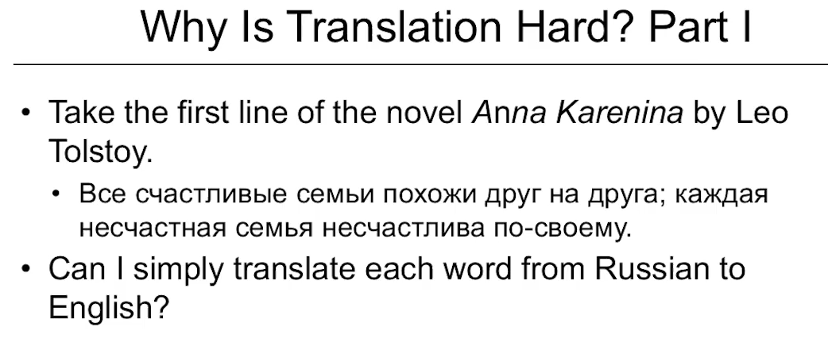

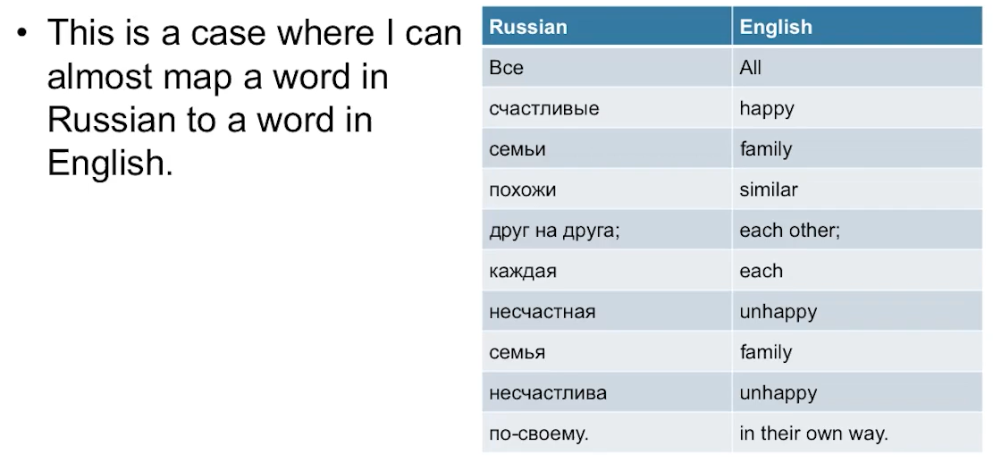

Even though translation might seem simple, it actually involves many **complex language challenges**. To explain this, the script gives an example:

**Example:**

The famous first line from *Anna Karenina* by Tolstoy:  
“All happy families are similar to each other, but each unhappy family is unhappy in its own way.”

This quote, originally written in Russian, shows a few of the core challenges:

**1. Different Alphabets or Symbol Systems**

* English uses the **Roman alphabet** (A, B, C...), but Russian uses the **Cyrillic alphabet** (А, Б, В...).
* So, even before translating meaning, we must **convert symbols** — this process is called **transliteration**.
* For example, the Russian word **"семья"** would be transliterated as **"sem'ya"**, meaning "family".

**2. Word-for-Word Dictionary Mapping Doesn’t Always Work**

* While some sentences have a close **1:1 word alignment** (i.e., one word in the source equals one in the target), **most do not**.
* Example:  
  The Russian phrase might contain **one word**, but the English translation requires **a full phrase** like “in their own way,” which is an **idiomatic expression** (a phrase that doesn’t translate literally).

**3. Words Can Have Multiple Meanings (Ambiguity)**

* Consider the word **"flies"**:
  + As a **noun**, it means the insect (e.g., "There are flies in the kitchen").
  + As a **verb**, it means the act of flying (e.g., "He flies to Paris every month").
* Machine translation must **understand the context** to pick the right meaning. This is called **word sense disambiguation**.

**4. Idiomatic and Cultural Expressions**

* Some phrases don’t make sense if you translate them literally.
  + For example, the English phrase **“kick the bucket”** means "to die."  
    Translating it word-for-word into another language would **confuse readers**.
* Machines need to learn how to translate **meaning, not just words**.

**5. Complex Alignments**

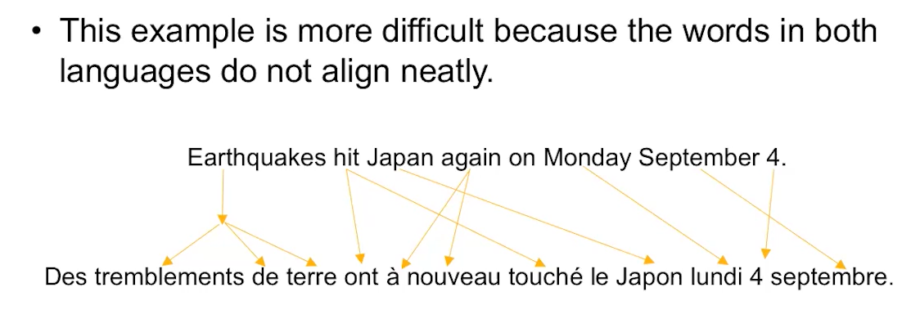

* In more complicated sentences, one word in one language may correspond to **multiple words** in another, or vice versa.
* This is called **alignment** — figuring out which parts of the sentence correspond across languages.

**Example:**

English: "I miss you"  
French: "Tu me manques"  
Literally: "You are missing to me"  
Here, the subject and object **switch roles**, showing that grammar can differ significantly between languages.

**Why This Matters for Machine Translation**

To build good MT systems, computers need to:

* **Identify correct word meanings**.
* **Map words and phrases** between languages (even if grammar is different).
* **Recognize and interpret idioms or metaphors**.
* **Reconstruct fluent sentences** that sound natural in the target language.

These are all **very hard tasks**, even for humans! So, building a machine that can do it well is a huge challenge — but also an incredibly important goal for global communication.

**Key Concepts Recap:**

| **Concept** | **Explanation** | **Example** |
| --- | --- | --- |
| **Source Language (E)** | The original language | Russian, Spanish, etc. |
| **Target Language (F)** | The language you’re translating into | English, Korean, etc. |
| **Transliteration** | Converting alphabets/symbols | Cyrillic "семья" → Roman "sem'ya" |
| **Word Sense Disambiguation** | Choosing the correct meaning of a word | "flies" = insect or action? |
| **Idioms** | Non-literal phrases | "Break a leg" = good luck |
| **Alignment** | Mapping of words/phrases between languages | English: "I miss you" ↔ French: "Tu me manques" |

**General Challenges of Language**

**Summary and Explanation: Why Is Translation So Hard?**

**1. Language Is Complex**

Language isn’t just a string of words—it’s a **web of meanings and relationships**. When we write or speak, we're using context, tone, grammar, and culture to convey meaning. Translation is hard because machines (and sometimes even humans) must **grasp all these subtleties** to generate an accurate translation.

**2. Ambiguity Makes Translation Tricky**

**Ambiguity** means a word or sentence can have **multiple interpretations**. This is common and even used to create **humor or wordplay**.

**Example:**

"Fruit flies like a banana."

This sentence can mean:

* Fruit (noun) **flies** (verb) like a banana flies (joking about flying fruit), or
* **Fruit flies** (insects) like (enjoy) a banana.

In translation, **the system must figure out the correct meaning** based on the sentence’s context. Machines must learn this disambiguation skill to avoid errors.

**3. Language Reflects Culture**

Words carry cultural meanings. For example:

In the U.S., saying “I love a glazed donut with my coffee” is normal.  
But in another culture where **coffee or donuts aren’t common**, this phrase might lose meaning or feel unnatural.

A good translation must **not just swap words**, but **translate cultural meaning**, which sometimes means changing the entire phrase or analogy to fit the target audience.

**4. Word Separation Isn’t Universal**

In English and French, **white spaces separate words**, which helps machines identify them.

Example: “She loves ice cream.” – 3 clear words.

But in **languages like Chinese, Japanese, or Thai**, **words are not separated by spaces**, making it much harder for machines to decide where one word ends and another begins.

**5. Word Order Varies Across Languages**

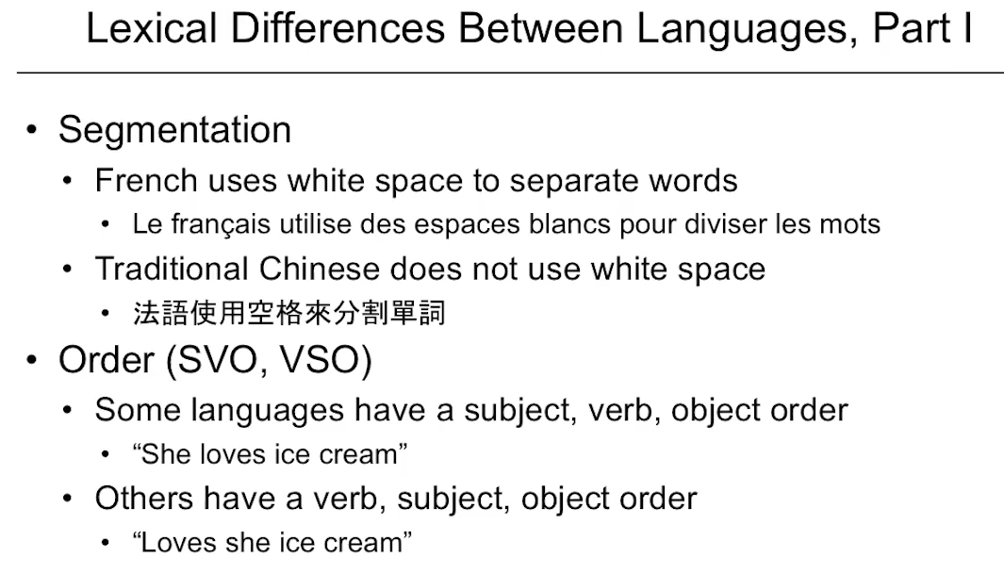

English follows an **SVO** pattern: **Subject – Verb – Object**.

Example: “She (subject) loves (verb) ice cream (object).”

But other languages use different orders:

* **VSO**: Verb – Subject – Object (e.g., Arabic)
* **SOV**: Subject – Object – Verb (e.g., Korean, Japanese)

**Example (SOV)**: “She ice cream loves.”  
Translation systems must **reorder sentences correctly** so the meaning stays intact and the sentence sounds natural in the new language.

**6. Morphology – How Words Are Built**

**Morphemes** are the smallest meaningful units in a language. Some languages use **many morphemes per word**; others don’t.

**Example:**

English: “Anti-dis-establishment-arian-ism”

* A single word made of many morphemes (anti + dis + establish + ment + arian + ism)

Some languages **lack complex compound words**, so a single English word may require **a full sentence** in another language. This creates a challenge in **mapping one word to many** or vice versa.

**7. Referential Density – Use of Pronouns**

English uses **pronouns** (he, she, it) to indicate roles in a sentence.  
Other languages might:

* **Drop pronouns** (as in Japanese or Korean)
* Or have **no exact pronouns** at all

This means machines must infer **who is doing what**, which increases complexity.

**8. Specificity – Words That Don't Translate Cleanly**

Some languages make **distinctions** that others do not.

**Example:**

English: "I know"  
French:

* **savoir** (to know a fact)
* **connaître** (to know a person)

So a translator must choose the **correct version based on context**. Without understanding this difference, machine translation could get it wrong.

**9. Cultural Differences and Expressions**

Languages encode **cultural values and social hierarchies**.

**Example:**

Mandarin: Different words for older and younger brothers  
English: Just “brother”

**Another example:**

English: “I’m sorry”  
Japanese: The equivalent apology often implies deep self-reflection and cultural formality. It would translate into something much longer and more emotional than just “I’m sorry.”

That’s why in subtitles, you might see:

* A **short sentence** in English
* But the **spoken Japanese sentence is much longer**

**What Makes a Good Translation?**

There are **two key goals** in translation:

1. **Faithfulness (Adequacy):** Does the translation **accurately capture the original meaning**?
2. **Fluency:** Does the translated text **read naturally** in the target language?

Both must be present. A sentence that’s faithful but awkwardly written is bad. A fluent sentence that changes the meaning is also bad. Good translation (especially by machines) must balance **both goals.**

**Key Concepts Recap:**

| **Concept** | **Meaning** | **Example** |
| --- | --- | --- |
| **Ambiguity** | One sentence can have multiple meanings | "Fruit flies like a banana" |
| **Cultural Context** | Words reflect culture, not just objects | "Glazed donut" vs. "Cake with tea" |
| **Word Separation** | Not all languages use spaces | Thai: "ฉันรักคุณ" (No spaces) |
| **Word Order** | SVO vs. SOV sentence structure | English: “She loves cake” ↔ Japanese: “She cake loves” |
| **Morphology** | How complex a word is in its parts | English: One long word ↔ Others: Many short words |
| **Referential Density** | Use or lack of pronouns | English: "She eats" ↔ Japanese: "Eats" (subject implied) |
| **Specificity** | Different words for subtle meanings | French: “connaître” vs. “savoir” for “know” |
| **Faithfulness & Fluency** | Must keep original meaning & sound natural | Both are essential for quality translation |

**Problem Structure**

**What’s the Core Challenge?**

We know that translation is hard, but how can we teach a **machine** to do it well?

Over time, different approaches have been developed. These are represented by a model called the **Vauquois Triangle**, which shows a **spectrum** of translation methods from the simplest (word-for-word) to the most sophisticated (semantic meaning).

**1. Direct Translation (Bottom of the Triangle)**

**What it is:**  
This is the **most basic method**: a word-to-word or phrase-to-phrase lookup. Think of using a **dictionary** to translate one word at a time.

**How it works:**

* The system looks up each word in the source language (Language E) and replaces it with the equivalent in the target language (Language F).
* It may apply **some simple reordering rules**.

**Example:**

English: “He eats rice.”  
French: “Il mange du riz.” (simple 1:1)

**Limitations:**

* Breaks down quickly when grammar, word order, or idioms don’t match.
* Example: English has the single word “earthquake,” but in French, it’s a **four-word phrase**: “tremblement de terre.”
* Word alignments can be inconsistent, and **meaning can get lost**.

**2. Transfer-Based Translation (Middle of the Triangle)**

**What it is:**  
This method introduces **syntactic structure**. Instead of translating word-by-word, the source sentence is **parsed** into a grammatical structure called a **parse tree**. That structure is then transformed to fit the grammar of the target language.

**What’s a parse tree?**  
A diagram that shows **how the sentence is built**, such as which words are nouns, verbs, or adjectives.

**Example:**

English: “The blue house”  
Parse tree: Adjective (“blue”) + Noun (“house”)  
French: “La maison bleue” (Noun first, Adjective after)

**Why it helps:**

* It allows the translation model to account for **word order differences**, like Subject-Verb-Object (SVO) vs. Verb-Subject-Object (VSO).
* It recognizes **noun phrases, verb phrases**, and translates **chunks** rather than individual words.

**Limitation:**  
Still struggles with deep **semantic meaning** (what the sentence *really* means), and alignment issues can persist in more complex texts.

**3. Interlingua (Top of the Triangle)**

**What it is:**  
This is the most **abstract** and sophisticated approach. The idea is to convert the source sentence into a **universal meaning representation**, and then generate the target sentence from that meaning.

**Key concept: Interlingua** = a **language-independent meaning format**.

**Why it’s powerful:**

* You could potentially **translate from any language into any other language** using a shared “meaning core.”
* It separates **syntax** (sentence structure) from **semantics** (meaning).

**Example:**  
Imagine a sentence like:

“An earthquake hit Japan on Monday.”

In an interlingua, this might be represented as:

* Event type: earthquake
* Location: Japan
* Time: Monday
* Severity: unknown

No matter what the language, this “frame” (meaning container) stays the same. Then the model can use it to generate appropriate output in English, French, Japanese, etc.

**Tools for Interlingua – AMR (Abstract Meaning Representation)**

**What is AMR?**  
AMR is a **structured format** used to represent sentence meaning. It breaks down the sentence into:

* The **event or action** (e.g., “describe”)
* The **agent** (who is doing it)
* The **object** (what’s being described)
* Other contextual info (time, place, etc.)

**Example:**  
From one AMR frame, we might generate:

* “She described the book.”
* “The book was described by her.”
* “Her description focused on the book.”

These are **different surface forms**, but share **the same underlying meaning**.

**Recap: Why This Matters**

| **Method** | **Description** | **Strength** | **Weakness** |
| --- | --- | --- | --- |
| **Direct Translation** | Word-for-word swap | Simple to build | Fails with grammar, idioms |
| **Transfer Model** | Uses parse trees & grammar rules | Handles syntax better | Still shallow on meaning |
| **Interlingua** | Universal meaning representation | Most flexible and accurate | Hard to build & understand meaning deeply |

**Modern Advances**

Thanks to **neural networks** and **large-scale language models** (like ChatGPT), we're now getting closer to the interlingua approach. These models are trained on **massive amounts of multilingual data** and can infer meaning **implicitly**—sometimes behaving *as if* they had interlingua representations, even if they're not explicitly built that way.

**Approach 1: Direct Mapping**

**Summary and Explanation: A Brief History of Machine Translation**

**Why History Matters in Machine Translation (MT)**

Understanding the **history of machine translation** helps explain:

* **Why early systems failed**
* **Why today’s AI-powered models are so different**
* And how the field **progressed through levels of complexity**, as outlined in the **Vauquois Triangle** (from direct translation to more abstract, meaning-based systems).

**The Early Days: Word-for-Word Translation (Direct Translation)**

In the beginning (1950s), the idea behind MT was simple:

Just **replace each word** in the source language (**Language E**) with its equivalent in the target language (**Language F**) using a **dictionary**.

This is the lowest level of the **Vauquois Triangle** — **direct translation**, with no deeper understanding of grammar or meaning.

**Key Events in Early Machine Translation**

* **1952**: The **first major conference** on machine translation took place at **MIT**, showing early academic interest.
* **1954**: A **demo system** was created that could:
  + Translate using **only 250 words**
  + Follow just **6 grammar rules**

**Why is this important?**  
This was **very limited**—languages have tens of thousands of words, and countless grammar rules. So this system could only handle extremely simple, toy examples.

**1966: "Machine Translation Is Not Possible"**

Because of these limitations, a key report in **1966** concluded that:

**Machine translation couldn’t work.**

This caused **funding and research to drop**, and the field slowed down significantly. This moment is often referred to as the **ALPAC Report**, which essentially said MT wasn’t practical at the time.

**Revival Through Rule-Based Systems (Transfer Approach)**

Even though general-purpose MT was discouraged, **rule-based systems** began to emerge in the 1970s–1990s. These followed the **middle level of the Vauquois Triangle**:

* They used **linguistic rules and parse trees** to analyze and generate text.
* They worked best in **very narrow, focused domains** (e.g., legal documents, technical manuals).

**Example:**

A rule-based MT system for translating technical manuals from English to German in a car manufacturing company.

**Strength:**  
Worked **very well** in those small domains with **limited vocabulary**.

**Limitation:**  
These systems **didn’t work well with everyday language**, which is messier and more ambiguous.

**Key Takeaways from the History**

| **Period** | **Key Idea** | **Result** |
| --- | --- | --- |
| **1950s** | Dictionary-based translation | Too simplistic |
| **1954** | Demo system (250 words, 6 rules) | Showed potential, but very limited |
| **1966** | ALPAC Report → “MT doesn’t work” | Research slowed down |
| **Post-1966** | Rule-based MT in narrow fields | Worked in limited domains only |

**Why It Still Matters Today**

The field of MT has **dramatically advanced** since those early days, especially with the introduction of **statistical** and **neural models** (discussed later in more advanced materials). But understanding this history shows:

* Why translation is hard
* How we’ve moved from **word-based translation** to **meaning-based AI systems**
* And why **context and domain** still matter in translation today

**Approach 2: Statistical Machine Translation**

**When Did This Happen?**

Statistical Machine Translation (SMT) became prominent in the **late 1980s to early 1990s**, marking a **major shift** from rule-based systems to data-driven ones. It allowed translation to move beyond fixed grammar rules and into **probability-based modeling**, which made more flexible, general-purpose translations possible.

One of the first major SMT systems was **IBM’s Candide**, introduced in **1990**.

**What Is Statistical Machine Translation (SMT)?**

**Basic idea:** Instead of hard-coding grammar rules, SMT tries to figure out **how likely** one sentence in one language corresponds to another sentence in a different language—**using statistics**.

It uses two main components:

1. **Language Model**: Predicts how likely a sentence is in the **target language**. (How fluent or natural it sounds.)
2. **Translation Model**: Predicts how likely the **source sentence** maps to a particular **target sentence**. (How accurate the translation is.)

These models are trained on **huge datasets** of human-translated sentence pairs (called **parallel corpora**).

**What Is the Noisy Channel Model?**

This is the **key conceptual framework** behind SMT, inspired by early ideas in **cryptography** (the science of code-breaking).

Think of translation like **decoding a corrupted message**:

* Imagine an English sentence is “scrambled” into another language (like Russian).
* The goal is to figure out the most probable **original English sentence** that could’ve been turned into that Russian sentence.
* This is modeled using **Bayes’ Theorem**, a basic principle in probability.

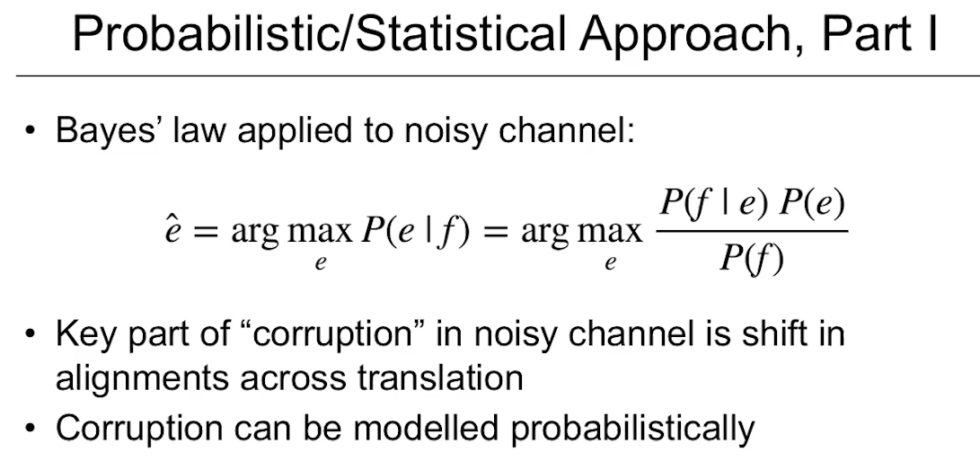

In this metaphor:

* The **target sentence (e.g., French)** is the corrupted output.
* The **original sentence (e.g., English)** is what we want to recover.
* The "channel" (translation process) adds noise, like switching word orders or changing expressions.

**Word Alignments and Probabilities**

To handle translations, SMT systems created **alignment tables**—maps showing how words or phrases in one language line up with those in another, with assigned **probabilities**.

**Example of alignments:**

* English word **“implemented”** becomes **“mise en application”** (3 words) in French → **1-to-many alignment**
* Sometimes **extra words appear** or **words disappear** in translation.
* You can also have **many-to-one** or **many-to-many** mappings.

These alignments help the system decide the **most probable** translation, even when languages have **different structures**.

**Advantages of SMT**

* **Improved translation quality**: SMT could handle **sentence-level translation** in **general-purpose contexts**, not just technical or restricted domains.
* **Less manual coding**: It replaced handcrafted grammar rules with **statistical learning** from real-world data.
* **Scalable**: In theory, more data = better translations.

**Limitations of SMT**

* **Huge human effort required**:
  + Needed **massive amounts of training data** (aligned sentence pairs).
  + Required complex **feature engineering**—manual decisions about which linguistic features to track (e.g., parts of speech, word frequencies, alignment scores).
* **Systems were complex** and hard to maintain:
  + Built from **many disconnected components** (e.g., separate models for alignment, phrase tables, reordering, scoring).
  + Often no one person understood the **whole system**.
  + Fixing one issue could create new problems elsewhere.

**Recap Table**

| **Concept** | **Explanation** | **Example** |
| --- | --- | --- |
| **Statistical Machine Translation (SMT)** | Uses probability models to predict translations | “He eats rice” → “Il mange du riz” with highest probability |
| **Language Model** | Measures how natural a sentence is in the target language | Prefers “He eats rice” over “Rice he eats” |
| **Translation Model** | Measures how accurately source maps to target | Probability of “mange” being translation of “eats” |
| **Noisy Channel Model** | Treats translation as decoding a corrupted message | Reverse-engineering English from scrambled French |
| **Alignment Table** | Maps word/phrase relations across languages | “Implemented” = “mise en application” (1-to-many) |
| **Bayes' Law** | Used to calculate best translation given the input | P(E |

**Why It Matters Today**

SMT laid the **foundation for modern neural machine translation (NMT)**, which came later. Understanding SMT helps explain:

* Why data-driven methods replaced rules
* Why **probability and alignment** are central to translation models
* What weaknesses newer models like neural networks aim to solve

**

The **noisy channel model** is a concept from information theory that was adapted for **statistical machine translation (SMT)**. It treats translation as a **decoding problem**—as if the original sentence in the target language has been **“corrupted” or “scrambled”** into the source language, and the goal is to **recover the original**.

**Core Idea (Simplified):**

**We assume the foreign sentence we see (source language) is a “noisy” version of an English sentence (target language).**  
So, the task is to figure out:  
👉 What **original English sentence** is most likely to have produced this foreign sentence?

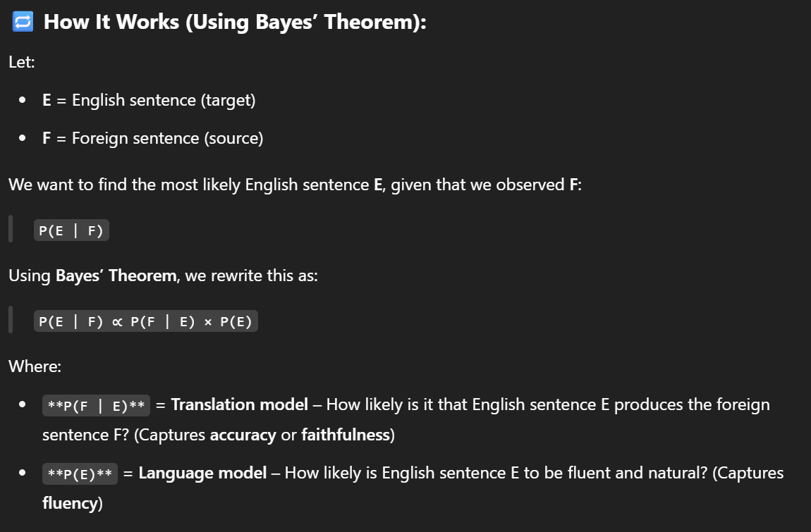

**Approach 3: Neural Machine Translation**

**What’s the Breakthrough?**

The most **recent and transformative advancement** in machine translation came with the rise of **neural networks**, or **neural nets**, starting around **2014**.

A team led by **Ilya Sutskever** (now a co-founder of OpenAI) developed a new kind of system that did something earlier models couldn’t:

It **replaced the complex web of statistical models and manual rules** with a **single powerful architecture** that could learn everything automatically—just by being shown **massive examples** of real translations.

**What Happened in 2014?**

The researchers:

* Built a **neural network architecture** specifically for translation.
* Fed it **10 million pairs of English–French sentences**.
* Let it **train over time**, adjusting internal parameters to learn patterns.

The result?  
The model could **translate at the same level** as highly engineered **Statistical Machine Translation (SMT)** systems—but with **far less human effort**.

**What Makes Neural Machine Translation (NMT) Different?**

Unlike statistical systems (which needed:

* alignment tables,
* language models,
* translation models,
* hand-coded rules),

NMT uses a **deep learning model** that learns **end-to-end**:

* It figures out how to map **input symbols (words, letters)** from the source language to **output symbols** in the target language.

The key parts are:

| **Part** | **What it does** |
| --- | --- |
| **Encoder** | Takes the input sentence (e.g., in Arabic or Chinese) and **encodes** its meaning into a numerical representation |
| **Decoder** | Uses that encoded meaning to **generate the translated sentence** in another language (e.g., Russian or English) |

This process is called an **encoder-decoder architecture**.

**Why “Symbols In, Symbols Out”?**

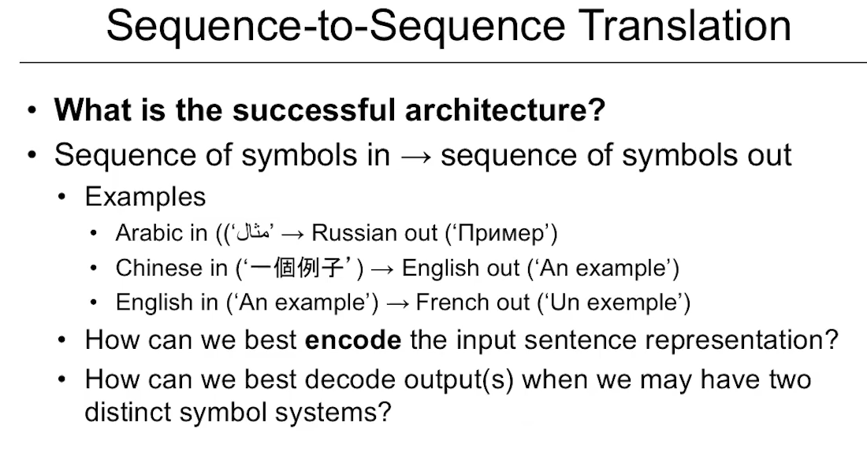

The script refers to “symbols” because:

* Different languages use **different writing systems**—for example, **Arabic**, **Chinese**, and **Russian** don’t share alphabets with English or French.
* So, the model is trained to handle **abstract symbol sequences**, whether they’re letters, characters, or words.

**Example:**

* Input: Arabic sentence (in Arabic script)
* Output: English translation (in Roman alphabet)

The model **doesn’t care about language labels**—it just learns **patterns between symbols** across languages.

**Why Did This Work So Well?**

* NMT could generalize better across language pairs, even **without human-designed alignment tables**.
* It learned **meaning representations**, so it could often infer more fluent and accurate translations.
* It needed **less manual effort** than earlier models, while achieving **equal or better quality**.

This opened the door to tools like:

* **Google Translate’s neural update (2016)**
* **DeepL Translator**
* **OpenAI’s GPT-based multilingual models**

**Recap Table**

| **Concept** | **Explanation** | **Example** |
| --- | --- | --- |
| **Neural Machine Translation (NMT)** | Uses deep learning to translate between languages | Translates English to French using learned patterns |
| **Encoder** | Converts input sentence into abstract meaning | “She loves tea” → vector |
| **Decoder** | Turns that meaning into output in the target language | vector → “Elle aime le thé” |
| **Symbols In, Symbols Out** | Works regardless of alphabets/scripts | Arabic → English, Chinese → French |
| **End-to-End Learning** | Learns everything automatically from data | No need for hand-made rules or alignment tables |

**Encoder-Decoder Architecture for NMT**

**1. Sequence-to-Sequence Models: The Starting Point of Neural Machine Translation (NMT)**

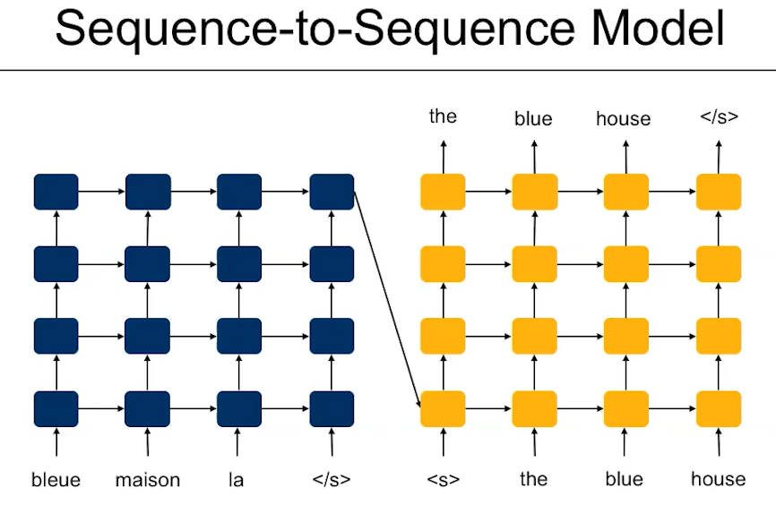

The first big leap in NMT came with the **sequence-to-sequence (seq2seq) architecture**, introduced around 2014 by Ilya Sutskever and colleagues. This model replaces older rule-based and statistical models by using **neural networks** to learn **how to translate sentences end-to-end**.

**How it works:**

* **Encoder (blue blocks)** reads the input sentence (e.g., English) one word at a time and converts it into a **numerical representation**.
* **Decoder (yellow blocks)** takes that representation and **generates the translation** (e.g., French), also one word at a time.

**Example:**

If translating:

English: “The blue house”  
The encoder reads “house,” then “blue,” then “the” (in **reverse order**, as an early workaround). The decoder generates:  
French: “La maison bleue”

**Why reverse order?**

Early models used **Recurrent Neural Networks (RNNs)**, which had trouble remembering long input sequences. Reading the source sentence backward helped reduce this **"forgetting"** problem—so the most important words were fresh in memory when decoding began.

**2. The Attention Mechanism: Solving the Forgetting Problem**

As sentence lengths grew, early seq2seq models struggled to remember the entire input. The solution? **Attention layers**, introduced shortly after the first **seq2seq** models.

**What is attention?**

Attention acts like **a memory and focus mechanism**: at each word in the output, the model decides **which input words to pay attention to**.

**Example:**

When translating “The house is blue” into German, the model needs to know “house” maps to “das Haus.” Attention helps it focus on “house” at that moment.

**Benefits:**

* Solved the long-sentence problem.
* Eliminated the need to reverse input.
* Created **automatic alignment**, similar to what statistical models once had to **manually build**.
* Significantly improved **BLEU scores** (translation quality metric).

**3. Transformers: “Attention Is All You Need”**

The next big revolution came with the **Transformer architecture** (2017), which dropped RNNs altogether. Instead, it relies **entirely on attention mechanisms**.

**Key features of transformers:**

* Use **multiple attention heads** (can focus on different parts of input at once).
* Encode all positions in a sentence **in parallel**, making them **faster and more accurate**.
* Great at learning long-range dependencies.

**Components:**

* **Encoder**: Builds context vectors from input.
* **Decoder**: Generates output using those context vectors and attention.

**Techniques:**

* **Byte-pair encoding (BPE)** helps handle **rare or unknown words** by breaking them into smaller pieces (e.g., "unhappiness" → "un" + "happi" + "ness").
* **Beam search**: Instead of picking the best word at each step, it keeps several options open to **optimize the whole sentence**.

**4. Multilingual and Zero-Shot Translation**

Instead of training one model for each language pair (e.g., English-French), newer systems train **one model for many languages**.

**How it works:**

* Add a **language tag** at the start of the input to indicate the target language.
* Example:  
  Input: [FR] I am hungry. → Output: “J’ai faim.”

**Zero-shot translation:**

* The model can **translate between languages it wasn’t explicitly trained on**.
* Example: If trained on English↔Spanish and English↔Portuguese, it might be able to translate **Spanish↔Portuguese** without seeing examples during training.

**5. Pretraining with Denoising and Back-Translation**

Modern systems use **pretraining and fine-tuning**, especially for **low-resource languages** (those with few translated texts available).

**Pretraining:**

* **Denoising**: The model learns to fix jumbled or masked input.
  + Example: Input: “am I hungry” → Output: “I am hungry”
* Teaches the model to understand grammar and context before translation.

**Back-translation:**

* Translate Language A → Language B, then back from B → A.
* Helps generate **more data for training**, even with limited real translations.

**🔹 6. mBART: A Practical Multilingual Transformer**

**mBART** is a multilingual encoder-decoder Transformer model trained on **25 languages**.

**Process:**

* **Pretraining** with denoising (masking/reshuffling text).
* **Fine-tuning** with smaller data (e.g., 133,000 English–Vietnamese pairs).

💡 Finding: It **performs very well on low-resource languages** but **doesn’t help much** with languages that already have large datasets (e.g., English–French).

**BLEU Score Comparison Over Time**

| **System** | **BLEU Score (↑ is better)** | **Notes** |
| --- | --- | --- |
| Statistical MT | 33 | Hand-built alignment tables |
| Seq2Seq LSTM | ↑ | First neural encoder-decoder |
| Seq2Seq + Attention | ↑↑ | Solved forgetting, improved quality |
| Transformer | ↑↑↑ | Best performance and efficiency |

**Key Terms and Concepts Recap**

| **Term** | **What It Means** | **Example** |
| --- | --- | --- |
| **Encoder** | Converts input into abstract meaning | English sentence → context vector |
| **Decoder** | Generates translated sentence from meaning | Vector → French sentence |
| **Attention** | Lets decoder focus on important input words | Align “house” with “maison” |
| **Transformer** | A fast, parallel model using attention | Replaced slow RNNs |
| **Byte-Pair Encoding** | Breaks rare words into subwords | "unhappiness" → "un" + "happi" + "ness" |
| **Beam Search** | Considers multiple possible outputs | Improves fluency |
| **Zero-shot Translation** | Translate without seeing examples | Spanish → Portuguese without training |
| **Denoising** | Pretraining with scrambled input | Learns to fix sentences |
| **Back-Translation** | Translate both ways to create new data | A → B → A helps training |
| **mBART** | Multilingual transformer model | Pretrained on 25 languages |

**Tools and Techniques: Beam Search**

**What Is Beam Search?**

**Beam Search** is a technique used by machine translation systems (and any AI that generates text) to **improve the quality of generated sentences**. Instead of always choosing the most likely next word at every step, beam search **keeps track of multiple possible sentence paths**, evaluating **how good the overall sentence is**, not just individual word choices.

**Why Not Just Pick the Most Probable Word?**

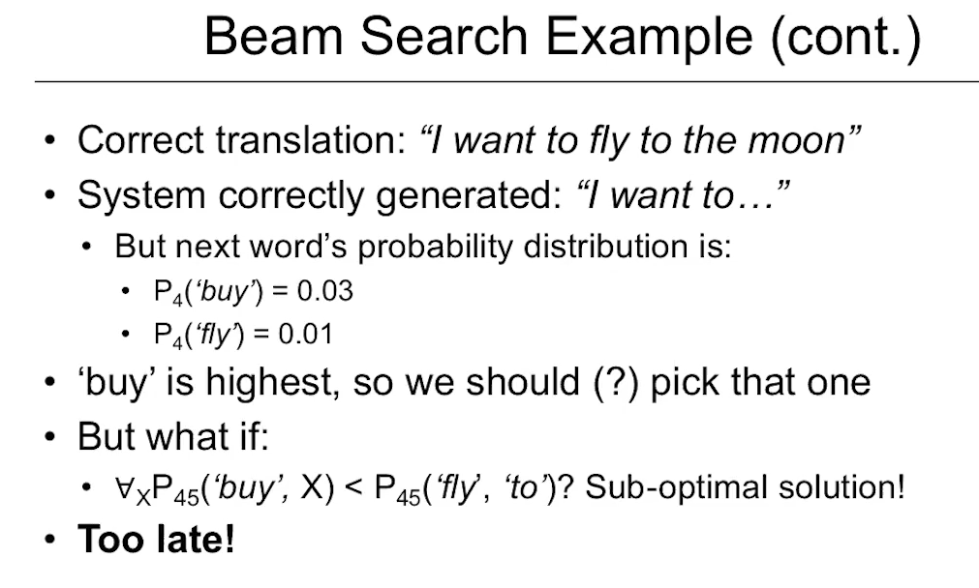

Let’s say a model is generating the English sentence:

“I want to fly to the moon.”

It starts generating words one at a time:

* “I” → “want” → “to”...

Now the next word should be “fly,” but the model thinks **“buy”** has a slightly **higher individual probability** (maybe from training data like “I want to buy…”).  
If the model picks “buy” just because it scores higher *at that moment*, the sentence becomes:

“I want to buy to the moon.” ❌

Now the sentence doesn’t make sense, and the model can’t fix it later.

**Beam Search to the Rescue**

Beam search avoids this by **keeping track of multiple possibilities**, not just the most probable word.

**Key Concept:**

* You define a **beam size** (a number like 2 or 5).
* At each step, the model:
  1. Looks at all possible next words.
  2. Keeps only the **top N sentence candidates** with the **highest total (joint) probability**.
  3. Expands those candidates in the next step.

**Example (Beam Size = 2):**

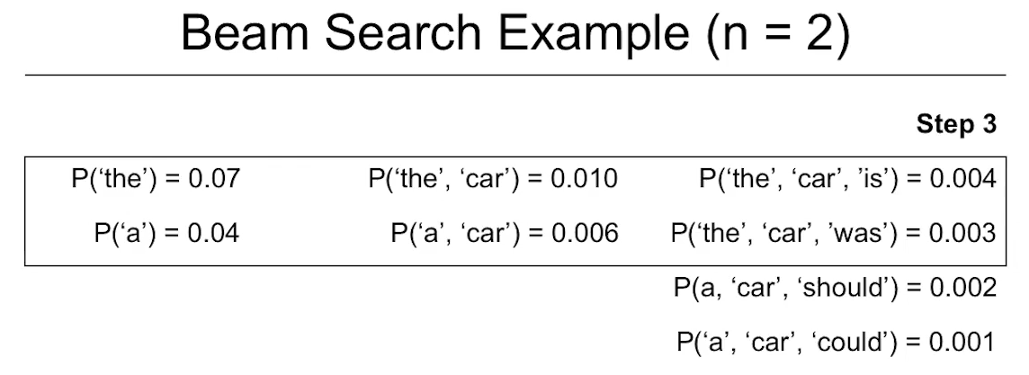

Let’s say the model is choosing how to continue the sentence:

| **Step** | **Candidates** | **Kept** |
| --- | --- | --- |
| 1 | “I want to buy” (0.6)  “I want to fly” (0.4) | ✅ Keep both |
| 2 | “I want to buy a car” (0.55)  “I want to fly to the moon” (0.50) | ✅ Keep both |
| 3 | “I want to fly to the moon” is the **better overall sentence** even if “buy” looked better at first. |  |

This approach helps avoid **early mistakes** that ruin the sentence.

**Beam Size: A Tunable Parameter**

* **Beam size** is a **hyperparameter**—something you set manually.
* A **small beam size** (e.g., 2) is usually **faster** and works well.
* A **large beam size** (e.g., 10) considers more options but:
  + Slows down generation.
  + Can lead to overfitting on high-probability but low-quality paths.

**Trade-off**: Speed vs. Quality

**Where Is Beam Search Used?**

Beam search is commonly used in:

* **Neural machine translation** (e.g., English → French)
* **Text summarization**
* **Chatbots**
* **Speech recognition**
* **Any task where a sequence of words is generated**

It’s especially useful when **you care about the whole sentence**, not just picking the best next word one step at a time.

**

We use a beam size in a machine translation system to improve the quality of the translated sentence by considering multiple possible word sequences at each step, rather than choosing only the most likely next word.

**Training Data Examples**

**1. What Kind of Data Is Needed to Train a Translation System?**

To train a machine translation model, you need **pairs of sentences**:

* One sentence in the **source language** (e.g., English)
* The **correct translation** in the **target language** (e.g., French)

These sentence pairs are called **bitexts**. They're the **core training data** for neural machine translation (NMT) systems.

**2. Sentence Pairs vs. Full Documents**

Even if you're translating documents (like reports or news articles), **the data is broken down into individual sentences** for training.

**Why?**

1. **Computational limits**: Neural networks can’t handle long documents efficiently.
2. **Complex cross-sentence relationships**:
   * **Coreference**: Words like “she” or “it” may refer to something in a previous sentence.
   * **Discourse structure**: Sentences relate in ways like argument-counterargument, examples, or conclusions.

Training on full documents requires complex logic to handle these relationships—**sentence-level translation is simpler and more manageable**.

**3. Where Do Sentence Pairs Come From?**

There are many **existing multilingual resources (corpora)**:

| **Source** | **Description** |
| --- | --- |
| **UN documents** | Translated into 6+ languages by professionals |
| **Canadian Parliament** | Proceedings in both **English and French** |
| **European Parliament (Europarl Corpus)** | Proceedings in multiple European languages |

**Example from Europarl:**

* **French**: *“Nous devons agir maintenant.”*
* **English**: *“We must act now.”*

These datasets are used to train models by giving them **aligned sentence pairs**.

**4. The Challenge of Low-Resource Languages**

Most available data is focused on major languages (like English, French, Spanish).  
But what about languages like Zulu, Kurdish, or Lao?

These are called **low-resource languages**, meaning:

* There aren't many translated sentence pairs available.
* Training a good model is difficult.

**5. Solutions to Handle Data Limitations**

**Back Translation**

* You start with **English-only text** (which is abundant).
* You **translate it into a low-resource language** using a basic model.
* Then you **translate it back to English**.
* You compare the original and the re-translated versions to generate **synthetic sentence pairs**.

This:

* **Expands the dataset**
* **Introduces paraphrased expressions**
* Helps the model **fine-tune and generalize**

**Denoising with Monolingual Data**

* Even if you only have data in one language (e.g., Hindi or Amharic), you can still use it to train parts of the model.
* You **scramble or mask** some words in a sentence and train the model to **reconstruct the original**.
* This helps the encoder and decoder get stronger—like **training them to “repair” language**.
* Through **transfer learning**, this strengthens translation capability even for unseen languages.

**Evaluation**

**1. Why Do We Need to Evaluate Translations?**

When a machine translation model outputs a sentence, we want to know:

* **Is it accurate?** (called **adequacy**)
* **Is it fluent and natural-sounding?** (called **fluency**)

We **can’t rely on humans** to check every result, especially during model training.  
So we need **automatic evaluation methods**.

**2. What Are Reference and Candidate Translations?**

* **References**: Human-written correct translations. Often more than one, since there are multiple ways to say the same thing.
* **Candidates**: Sentences generated by the translation model.

Example:

| **Role** | **Text** |
| --- | --- |
| Reference | "He is going to the store." |
| Candidate 1 | "He's going to the shop." |
| Candidate 2 | "He go store." |

Our goal is to **measure how close the candidates are to the references**, automatically.

**3. Three Ways to Evaluate Automatically**

1. **Word or Phrase Matching**
   * Does the candidate sentence have the same words as the reference?
2. **Semantic Comparison**
   * Does the meaning match, even if the words are different?
3. **Score Prediction Model**
   * Can we build a model that predicts how a human would score the translation?

**4. BLEU Score – The Traditional Metric**

**BLEU (Bilingual Evaluation Understudy)** is the **most widely used** metric.

How it works:

* Measures **n-gram overlap**: checks if short phrases (like word pairs or triplets) in the candidate match the reference.
* Uses **unigrams (1 word), bigrams (2 words), trigrams (3 words), and 4-grams**.
* Includes **brevity penalty** if the candidate is too short.
* Penalizes repeated words to avoid gaming the score.

BLEU considers **both content and word order**, which helps judge **fluency**.

**5. Is BLEU Reliable? What Are Its Problems?**

BLEU is useful for comparing **versions of the same system** (e.g., before and after fine-tuning).  
But it has some limitations:

| **Limitation** | **Example** |
| --- | --- |
| ❌ **Ignores synonyms** | “Tremor” vs “Earthquake” = 0 match |
| ❌ **Bad at adequacy** | “He is tall” vs “He is a cat” might get a high score if words overlap |
| ❌ **Word order bias** | Can fail if sentence structure is different but meaning is preserved |

**6. BLEURT – A Smarter, ML-Based Evaluation Metric**

**BLEURT** = **BERT-based Language Evaluation Understudy for Text**

Instead of counting words, BLEURT uses **machine learning** to **predict how a human would score** the translation.

Key Features:

* Built on **BERT**, a deep language model.
* Uses **pretraining on real data** (Wikipedia) with signals from BLEU, ROUGE, and BERTScore.
* Adds tasks like:
  + **Paraphrase detection**
  + **Text entailment** (does A imply B?)
  + **Back-translation consistency**

So BLEURT **understands meaning and context**, not just word overlap.

**7. Example: BLEU vs BLEURT**

| **Candidate** | **BLEU Score** | **BLEURT Score** | **Comments** |
| --- | --- | --- | --- |
| “Bud Powell was a legendary pianist.” | 100 | High | Perfect match |
| “Bud Powell was a historic piano player.” | Low | Medium-high | Acceptable but paraphrased |
| “Bud Powell was a New Yorker.” | Medium | Very Low | Incorrect meaning |

➡️ **BLEU gives a good score to wrong translations** if word overlap is high.  
➡️ **BLEURT catches semantic errors** and better matches human judgment.

**8. How Do They Compare in Real Evaluations?**

Researchers compared:

* **Human scores** (fluency and adequacy)
* **BLEU and BLEURT scores** on translations in multiple languages

Result:

* BLEURT had a **much stronger correlation** (above 0.9 r-value) with human judgments.
* BLEU is still used (because it’s easy), but **BLEURT is more accurate**.

**Vocabulary Representation and Subword Models**

**The Problem: Vocabulary Representation in NLP**

When processing text with machine learning models—especially in tasks like translation or summarization—there are challenges in how words are represented. The issue is that languages have many words, new ones appear constantly, and models need a way to understand both known and unknown words. To deal with this, we use **preprocessing steps** and **subword models**.

**Preprocessing Steps**

1. **Normalization**: Adjusts text format for consistency.
   * Example: Should “Apple” and “apple” be treated the same?
   * Includes:
     + Lowercasing all text.
     + Removing repeated characters (e.g., “soooo” → “so”).
     + Lemmatization: converting verbs/nouns to their root (e.g., “flies” → “fly”).
     + Unicode normalization: ensuring accented characters are uniformly represented.
2. **Segmentation**: Splits text into meaningful chunks.
   * In English, spaces separate words, but in Chinese or Japanese, there’s no whitespace.
   * Proper segmentation ensures the model correctly understands the sentence.
   * Tools: Regular expressions, rule-based systems, or language models.
   * Tokenization (breaking text into parts) used here must be the same during both training and inference. A mismatch can confuse the model.
3. **Vocabulary Mapping**: Converts text into vectors (numerical format).
   * Models don’t “understand” words; they understand vectors.
   * Challenges:
     + **Word Variants**: “fly” vs. “flies” vs. “flying” – should each have a separate vector?
     + **Unknown Words**: What happens if the model sees a word it didn’t train on?
     + **Vocabulary Size**: Big vocabularies (like 1 million English words) slow down prediction because the model must score every possible word with softmax (a probability function).

**The Solution: Subword Models**

Instead of whole words, break words into **subwords**. This solves:

* **Unknown words**: New words can be composed from known subwords.
* **Vocabulary bloat**: Fewer subwords than full words needed.

**Example:**

“Unbelievably” → “un + believe + ably”

If the model knows “un”, “believe”, and “ably”, it can understand “unbelievably” even if it never saw it before.

**Types of Subword Models**

1. **Byte Pair Encoding (BPE)**
   * Bottom-up method.
   * Start with individual characters and merge the most frequent pairs.
   * Requires:
     + Pre-tokenized input (split into words first).
     + Unicode normalization.
   * Widely used in early subword models.
   * Example: “low”, “lower”, “lowest” → subwords: “low”, “er”, “est”
2. **WordPiece**
   * Developed by Google.
   * Instead of frequency, merges based on likelihood in a language model.
   * Uses underscores to mark word boundaries (e.g., _fe).
   * Used in models like BERT.
3. **Unigram Language Model**
   * Based on probabilities of full subword sequences.
   * Tries to find the best segmentation to maximize overall likelihood.
   * Requires pre-tokenization and consistent rules.
   * Flexible and often used with multilingual models.
4. **SentencePiece**
   * Google’s model that handles everything internally—no need for pre-tokenization.
   * Built-in normalization and segmentation.
   * Can handle raw text (spaces, punctuation, etc.).
   * Used in models like T5, mBART.
   * Great for multilingual models and lower-resource languages.

**Key Takeaways**

* Text must be preprocessed the same way during training and inference.
* Subword models:
  + Help reduce vocabulary size.
  + Prevent errors from unknown words.
  + Allow for more efficient and flexible text generation.
* SentencePiece is a modern go-to solution because it's self-contained and simple to integrate.

**Beginner Analogy**

Think of subword models like LEGO blocks:

* Instead of needing every possible object (word), you just need a good set of pieces (subwords).
* Then you can build any object—even new ones you’ve never seen—using the same pieces.

**

**1. How does self-attention work in a transformer?**

✅ **Correct answer:**

**It adds surrounding context to each token vector, by doing pairwise dot products between each token's query vector and all the key vectors in the same sequence, then using those scores to get a weighted sum of the value vectors.**

**2. What is the role of an encoder in a seq2seq architecture?**

✅ **Correct answer:**

**It builds up contextualized embeddings of the input sequence, to provide useful info to the decoder to correctly transform the inputs.**

**3. What are some language modeling tasks (i.e. pre-training tasks used to create language models)? *(Multiple choice)***

✅ **Correct answers:**

* ✔️ **Given a sequence of tokens, predict the next token**
* ✔️ **Given a sequence of tokens with a masked token in the middle, predict the missing token**
* ✔️ **Given a sequence of tokens with a missing span (phrase), generate the string of tokens to fill in that span**

💡 The movie review task is sentiment classification (supervised), and QA (question-answering) is downstream, not pre-training.

**4. What kind of architecture is used in neural machine translation? *(Multiple choice)***

✅ **Correct answers:**

* ✔️ **Encoder-decoder (LSTM-to-LSTM)**
* ✔️ **Encoder-decoder (transformer-to-transformer)**

💡 BERT and GPT are not typically used directly for translation, as they are either encoder-only (good for classification) or decoder-only (good for generation), not full encoder-decoder pairs.

**Question Answering and Summarization**

**Overview**

The lecture discusses two major **Natural Language Processing (NLP)** tasks:

* **Question Answering (QA)**
* **Summarization**

These tasks often overlap and share similar sub-processes like understanding, retrieving, and generating text.

**Why QA and Summarization Matter (Real-world Use Cases)**

**Question Answering (QA)**

* **Goal**: Provide direct answers to user questions based on documents or facts.
* **Example Use Case**:
  + **Customer Service Kiosk**:
    - Users type or speak a question.
    - The system retrieves the most relevant answer from a pre-defined knowledge base (FAQ).
    - **Advantage**: Users don’t need to search through documents manually.

**Summarization**

* **Goal**: Generate concise versions of long texts.
* **Example Use Case**:
  + **Academic Reading Assistance**:
    - You have 25 research articles but time for only 3.
    - A summarization tool generates 100-word summaries.
    - You skim summaries to decide which full articles to read.

**Different Types of QA**

The script draws an analogy with **school exams**:

| **Test Type** | **Description** |
| --- | --- |
| **Closed-book** | Recall from memory – no context is provided (like some models with limited input). |
| **Open-book** | You can search through texts/resources to find answers (like models with document retrieval). |

**Question Format Dimensions**

Examples from traditional exams, reflected in QA system outputs:

* **Multiple choice** → Classification task
* **Fill-in-the-blank** → Cloze task
* **Short answer** → 1–4 sentences
* **Short essay** → 1–2 paragraphs
* **Long essay** → Multi-page generation (e.g., GPT-style outputs)

**Machine QA Pipeline**

To answer a question, an NLP model must:

1. **Understand the Question**
   * Natural language parsing
   * Intent detection
2. **Retrieve/Understand Context**
   * Pull from documents or memory
   * May require information retrieval
3. **Generate the Answer**
   * Extractive (copy from document) or abstractive (rephrase)

**All three are essential**. Missing any leads to failure.

**What Makes Summarization Hard?**

1. **Identifying Salient Content**
   * Not everything in the document is equally important.
2. **Discarding Irrelevant Content**
   * Remove fluff or tangential data.
3. **Aggregation and Generation**
   * Organize key content.
   * Rewrite and compress meaningfully (like writing an abstract or outline).

Output formats:

* Abstract
* Bullet points
* Full paragraph summary

**Human vs. Machine Summarization Process**

| **Human Summary Steps** | **NLP Equivalent** |
| --- | --- |
| Read and highlight key parts | Salient sentence extraction |
| Discard irrelevant content | Text filtering |
| Paraphrase, rearrange | Sequence generation via transformer |
| Output final summary | Generation with fine-tuned language model |

**Python Coding Example**

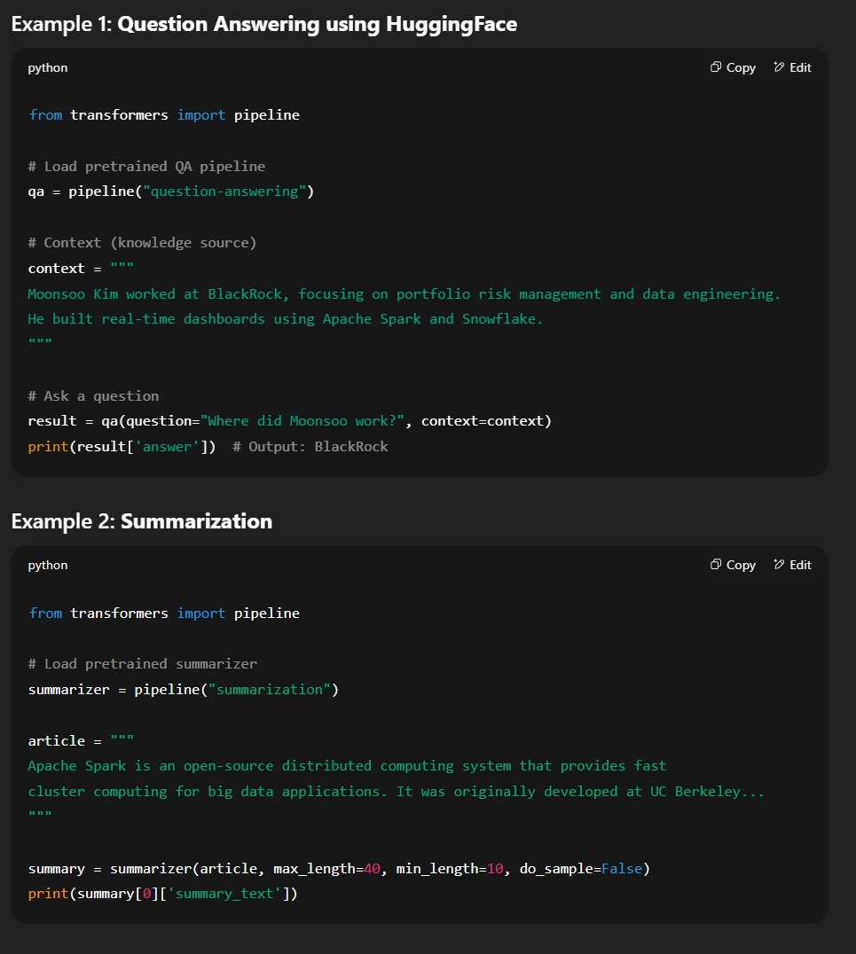

**Overlap Between QA and Summarization**

* **Shared challenges**:
  + Parsing input language
  + Identifying important content
  + Producing relevant output
* Both tasks **require understanding and generating human-like language**, and may share transformer-based architectures like BERT or T5.

**Takeaways**

* QA and Summarization are **core NLP tasks** with growing practical relevance.
* Both require:
  + Language comprehension
  + Content filtering
  + Output generation
* Applications include customer support, academic reading, legal case summarization, medical notes, and more.
* Deep learning models like BERT (for QA) and T5/BART (for summarization) are widely used to solve these challenges.

Let me know if you’d like a visual diagram or model comparison table to go with this summary.

**Question Answering Tasks Defined**

**Why QA Structure Matters**

The speaker emphasizes that **how a QA task is defined directly impacts how we architect the system**. Despite seeming simple ("get a question, return an answer"), QA involves multiple **dimensions and design choices** that shape the difficulty and solution method.

**Core Dimensions of QA Tasks**

**1. Open-domain vs. Closed-domain**

| **Type** | **Description** | **Example** |
| --- | --- | --- |
| **Closed-domain** | System must have **memorized** all relevant information. No external retrieval. | Reading comprehension with a given passage. |
| **Open-domain** | System must **search for information** from a large corpus or the web. | Chatbots like Google Assistant, Bing AI. |

**2. Extractive vs. Abstractive**

| **Type** | **Description** | **Example Dataset** | **Task** |
| --- | --- | --- | --- |
| **Extractive** | Pull answer **verbatim** from the context. | SQuAD 1.0 | Highlight a span of text. |
| **Abstractive** | **Generate a novel** answer using paraphrasing, reasoning, or synthesis. | DROP, Long-form QA | Arithmetic, sentence/paragraph generation. |

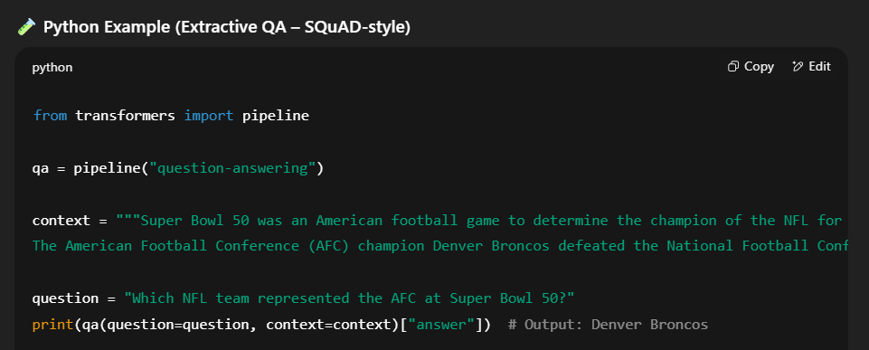

**Examples of QA Task Types**

**Extractive QA: Span Annotation (e.g., SQuAD)**

* Given a **paragraph** and a **question**.
* The model predicts the **start and end token indices** of the answer span.

**Abstractive QA: (e.g., DROP)**

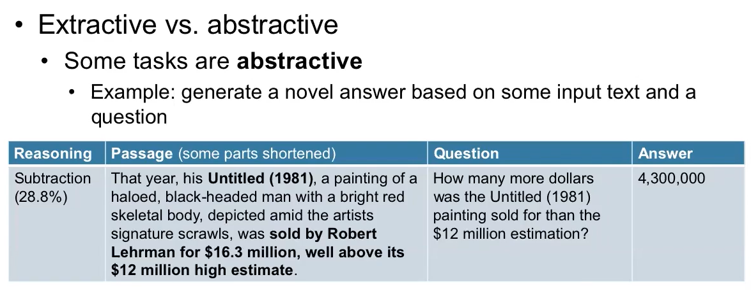

* Requires **arithmetic or synthesis**.
* E.g., "How many more dollars was a painting sold for than its estimated $12M?"
  + Requires extracting both values and subtracting → $4.3M.

**Closed-Domain QA Formats**

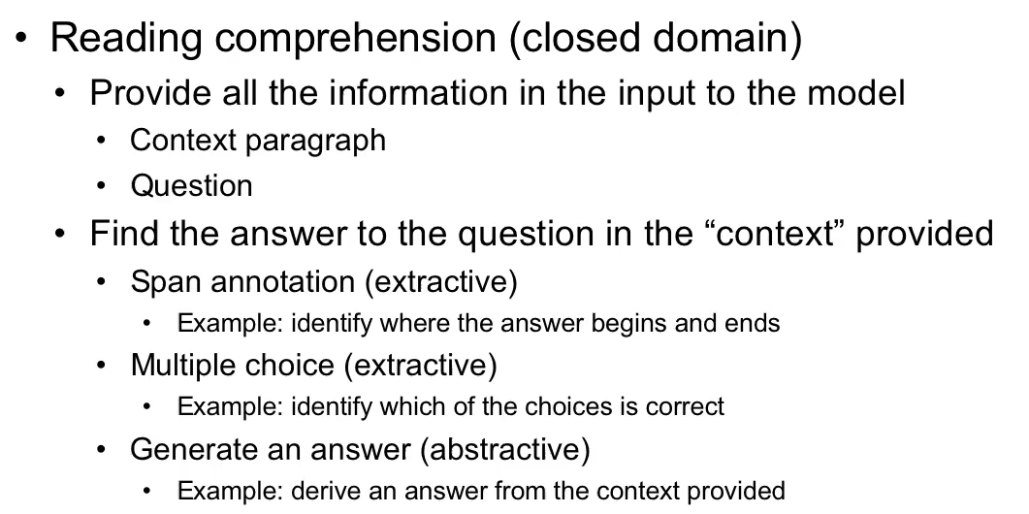

| **Format** | **Description** | **Example** |
| --- | --- | --- |
| **Span Annotation (extractive)** | Extract answer span from a paragraph. | SQuAD |
| **Multiple Choice (extractive)** | Pick best answer out of A/B/C/D → classification with softmax. | RACE dataset |
| **Abstractive** | Answer generation from paragraph, not verbatim. | DROP |

**Open-Domain QA Workflow**

1. **Given a question**, retrieve relevant documents/articles.
2. **Extractive approach**: Find and highlight the answer span.
3. **Abstractive approach**: Summarize relevant info into a few lines or a paragraph.

**Conversational QA (CoQA-style)**

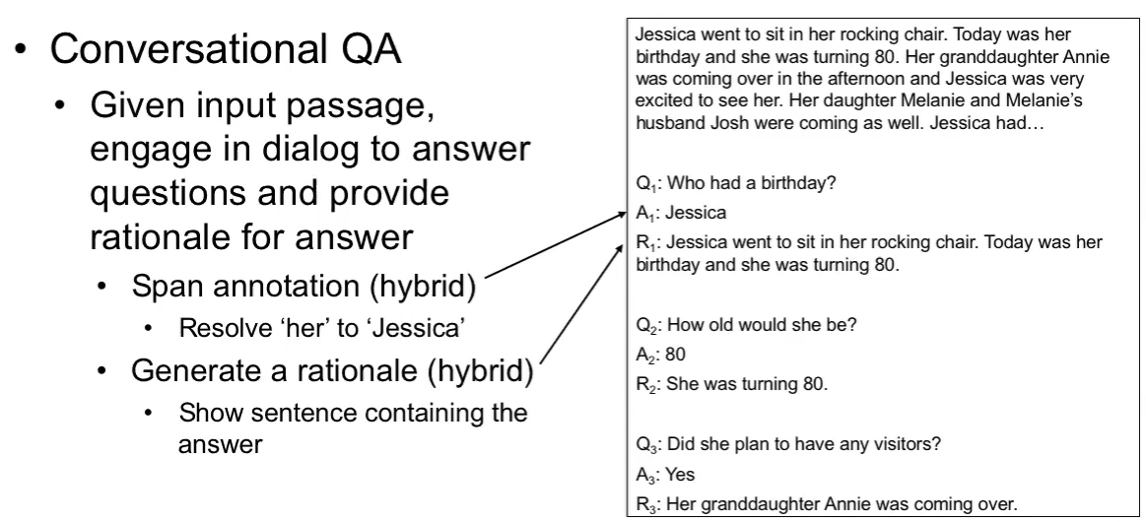

* QA in a **multi-turn dialog** format.
* Context evolves across turns.
* Requires **tracking the conversation** and reasoning across multiple questions.

**Retrieval QA (Dense Passage Retrieval, etc.)**

* QA system uses **dual-tower architecture**:
  + One encoder for questions.
  + One encoder for candidate answers or documents.
* Matching is done using **cosine similarity** in embedding space.

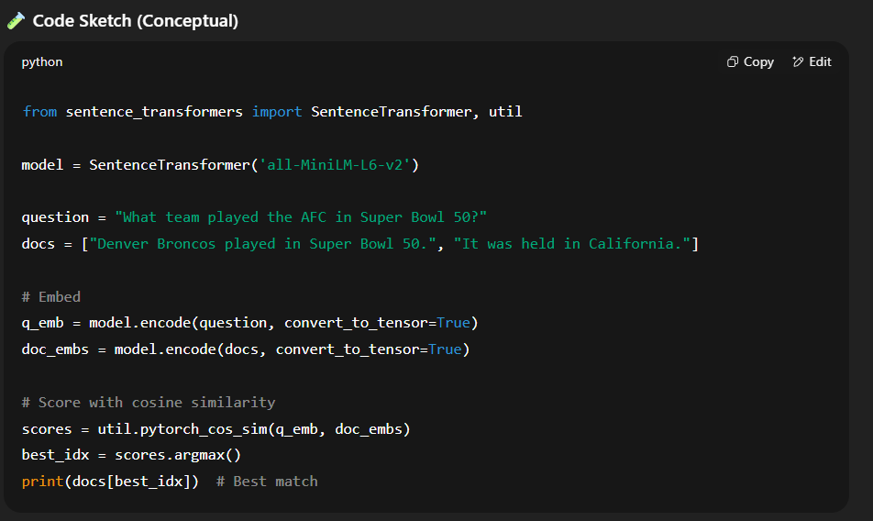

**Long-Form QA**

* **Goal**: Answer in **paragraph form**.
* Requires:
  1. Retrieving multiple relevant documents.
  2. Extracting and aggregating facts.
  3. **Generating a novel coherent paragraph.**
* Enabled by **sequence-to-sequence models** (like T5, BART, or GPT).

**Factoid vs. Non-Factoid Questions**

| **Type** | **Description** | **Example** |
| --- | --- | --- |
| **Factoid** | Answer is a short fact (name, date, number). | "What year was Super Bowl 50?" → "2016" |
| **Non-Factoid** | Requires explanation or reasoning. | "Why did the Broncos win?" → Long paragraph answer. |

Non-factoid QA **blends into summarization** tasks.

**Summary of QA Task Taxonomy**

| **Dimension** | **Types** |
| --- | --- |
| **Domain** | Open vs. Closed |
| **Answer Form** | Extractive vs. Abstractive |
| **Answer Length** | Factoid vs. Non-factoid |
| **Input Type** | Single passage vs. Multiple documents |
| **Interaction** | One-shot vs. Conversational |
| **Reasoning** | Direct lookup vs. arithmetic/synthesis |

**Key Takeaways**

* **QA systems vary greatly depending on the data structure and the question type.**
* Designing QA systems involves:
  + Understanding whether information is **available, retrievable, or must be generated**.
  + Choosing appropriate model types:
    - BERT for extractive
    - T5/BART/GPT for abstractive
    - DenseRetriever for retrieval
* QA is **converging with summarization**, especially in **non-factoid, long-form scenarios**.

**Summarization Tasks Defined**

**What Is Summarization?**

**Summarization** is the task of creating an **abridged version** of one or more input documents, with a focus on **relevance**:

* Relevance to **the original document itself**
* Relevance to a **set of documents**
* Relevance to a **query**
* Relevance to a **topic or angle**

**Types of Relevance in Summarization**

| **Relevance Type** | **Description** | **Example** |
| --- | --- | --- |
| **Document-centric** | What’s central to this document? | Summarize a news article on inflation. |
| **Multi-document** | Common threads across documents. | Summarize 10 articles about a protest. |
| **Query-based** | Summary answers a specific question or query. | “Summarize economic effects of Brexit.” |
| **Topic-based** | Focused on a sub-topic or theme. | “Pull all volcano-related info from a long article about Italy.” |

**Summary Length Constraints**

* Often a **word limit** is specified:
  + E.g., “100 words”, “200 words”
* This influences the amount of detail and number of sentences retained or generated.

**Two Main Types of Summarization**

| **Type** | **Description** | **Method** |
| --- | --- | --- |
| **Extractive** | Select and copy existing sentences from input. | Sentence scoring, filtering, ranking |
| **Abstractive** | Generate new text that rephrases or compresses ideas. | Sequence-to-sequence models |

**Output Formats for Summarization**

| **Format** | **Description** | **Use Case** |
| --- | --- | --- |
| **Headline/Title** | Very short text summarizing main point. | News feeds |
| **Abstract** | Short paragraph summarizing key ideas. | Academic papers |
| **Bullet Points** | Key facts or takeaways. | Meeting notes |
| **Outline** | Structured breakdown of content. | Lecture slides |
| **Timeline** | Chronological ordering of events. | History articles |

**How Extractive Summarization Works**

1. **Score Sentences**: Based on relevance to document, topic, or query.
2. **Rank**: Order sentences by their score.
3. **Select**: Choose top sentences until word limit is hit.
4. **Emit**: Return these as the summary.
   * May or may not preserve original order.

**🧪 Python Example: Extractive Summarization using sumy**

from sumy.parsers.plaintext import PlaintextParser

from sumy.nlp.tokenizers import Tokenizer

from sumy.summarizers.lsa import LsaSummarizer

text = """Italy is home to many historical landmarks including the Colosseum and Mount Vesuvius, an active volcano.

Tourists often visit Naples to explore ruins of Pompeii buried by Vesuvius. In recent years, Vesuvius has shown signs of activity..."""

parser = PlaintextParser.from_string(text, Tokenizer("english"))

summarizer = LsaSummarizer()

summary = summarizer(parser.document, sentences_count=2)

for sentence in summary:

print(sentence)

**How Abstractive Summarization Works**

* Model reads the entire document and **generates** a new, shorter version in natural language.
* This is similar to how humans write abstracts: not copying but **rephrasing and compressing**.
* Powered by **sequence-to-sequence (Seq2Seq)** models like:
  + BART
  + T5
  + Pegasus
  + GPT

**🧪 Python Example: Abstractive Summarization with HuggingFace**

from transformers import pipeline

summarizer = pipeline("summarization")

article = """Italy is home to many historical landmarks including the Colosseum and Mount Vesuvius, an active volcano.

Tourists often visit Naples to explore ruins of Pompeii buried by Vesuvius. In recent years, Vesuvius has shown signs of activity..."""

summary = summarizer(article, max_length=45, min_length=15, do_sample=False)

print(summary[0]['summary_text'])

**Extractive vs. Abstractive Comparison**

| **Feature** | **Extractive** | **Abstractive** |
| --- | --- | --- |
| **Method** | Sentence selection | Sentence generation |
| **Output** | Original sentences | Novel text |
| **Complexity** | Simpler | More complex |
| **Fluency** | Can be choppy | Often smoother |
| **Examples** | TextRank, LexRank | T5, BART, GPT |

**Summary: Key Takeaways**

* Summarization can be **tailored to different goals**: headline, bullet points, full abstract, etc.
* It requires understanding **what is important** and either selecting or rephrasing.
* There are **two main types**:
  + **Extractive**: Good for precision and factual coverage.
  + **Abstractive**: Better for fluency, compression, and paraphrasing.
* Advanced models like **T5**, **BART**, and **Pegasus** have made abstractive summarization more effective.